**Topic Words in Context – Dickinson, the Fascicle and the Topic Model**

Jonathan Ilan Armoza, Department of English, McGill University, Montréal

April 2016

A thesis submitted to McGill University in partial fulfillment of the requirements of the degree of Master of Arts in English.

©Jonathan Ilan Armoza 2016

**Table of Contents**

**Abstracts** . . . . . . . . . . . . . . . . . . . . . . . . . . . . . . . . . . . . . . . . . . . . . . . . . . . . . . . . . . . . . . . . . . **3**

**Acknowledgments** . . . . . . . . . . . . . . . . . . . . . . . . . . . . . . . . . . . . . . . . . . . . . . . . . . . . . . . . . . .**6**

**Introduction** . . . . . . . . . . . . . . . . . . . . . . . . . . . . . . . . . . . . . . . . . . . . . . . . . . . . . . . . . . . . . . . .**7**

**Literature Review**

1. **Emily Dickinson’s Fascicles** . . . . . . . . . . . . . . . . . . . . . . . . . . . . . . . . . . . . . . . . . . . . **11**
2. **Topic Modeling** . . . . . . . . . . . . . . . . . . . . . . . . . . . . . . . . . . . . . . . . . . . . . . . . . . . . . . **18**

**Visualization Description** . . . . . . . . . . . . . . . . . . . . . . . . . . . . . . . . . . . . . . . . . . . . . . . . . . . . **47**

**Analysis** . . . . . . . . . . . . . . . . . . . . . . . . . . . . . . . . . . . . . . . . . . . . . . . . . . . . . . . . . . . . . . . . . . . **85**

**Conclusion** . . . . . . . . . . . . . . . . . . . . . . . . . . . . . . . . . . . . . . . . . . . . . . . . . . . . . . . . . . . . . . . . **132**

**Special Note (How to Use/Online Documentation)**. . . . . . . . . . . . . . . . . . . . . . . . . . . . . . . . **135**

**Appendices**

1. **Technology Description / How to Use** . . . . . . . . . . . . . . . . . . . . . . . . . . . . . . . . . . . .**136**
2. **Topic Model** . . .... . . . . . . . . . . . . . . . . . . . . . . . . . . . . . . . . . . . . . . . . . . . . . . . . . . .**147**

**Bibliography** . . . . . . . . . . . . . . . . . . . . . . . . . . . . . . . . . . . . . . . . . . . . . . . . . . . . . . . . . . . . . .**154**

**Abstract**

**English:**

When Emily Dickinson died in 1886, she left behind thousands of unpublished poems, some of which were bound up in forty small booklets that have come to be known as “fascicles.” Over time and due to decades of publishing strife, these fascicles were split and their poems studied apart from one another. It would not be until Ralph Franklin’s 1981, *The Manuscript Books of Emily Dickinson*, that a wide audience would finally be able to revisit Dickinson’s poems in these arrangements. Since then, several scholars such as Eleanor Elson Heginbotham have looked to uncover thematics, narratives, and discourses that arise from these poems being placed in their originally-intended sequences. Recently, digital humanities scholars have been using the computer science method of “topic modeling” to trace hidden semantic structures within thousands of texts. This method produces a set of topics – lists of words regularly employed together in a corpus – as well as probabilistic weights for each of those topics. However, the outputs of topic modeling are at times unclear and are frequently misunderstood, as they stand separate from the texts it models. To facilitate the connection of topic models to their texts, and to help uncover these hidden, semantic structures in Emily Dickinson’s fascicles, I have designed a highly interactive, computer data visualization called “Topic Words in Context” or “TWiC.” TWiC allows users to move between the big data scales of a topic model to its very words via a set of hierarchical, organizable panels. It employs geometric abstractions, colors, and cross-panel highlighting to give users insight into the multiple relations between words, texts, groups of texts, and their original publication arrangements. Within this writing I describe the fascicle history, topic modeling, previous visualizations of it, and TWiC. I then compare a topic model’s breakdown of several poems in Dickinson’s 21st fascicle with Heginbotham’s discussion of them.

**French:**

Au moment de la mort d’Emily Dickinson en 1886, plus de mille poèmes inédits ont été retrouvés, certains d’entre eux reliés en quarante petits carnets mieux connus sous le nom de « recueils ». Avec le temps et suite à plusieurs décennies de conflits avec des maisons d’éditions, ces recueils ont été divisés et leurs poèmes publiés séparément, hors de leur contexte original. Ce n’est qu’en 1981, à la publication du « Manuscript Books of Emily Dickinson » par Ralph Franklin que le grand public a finalement eu l’opportunité de découvrir les poèmes de Dickinson dans ces agencements. Depuis, ces poèmes ont été étudiés, notamment par Eleanor Elson Heginbotham afin de révéler les thématiques, les descriptions et le discours qui émergent de leur positionnement prévu à l’origine. Récemment, des chercheurs en humanités numériques out eus recours à la méthode de sciences informatiques appelée « modèle de sujet » (topic modeling) afin de retracer des structures sémantiques dissimulées parmi des milliers de textes. Cette méthode génère une série de sujets – liste de mots régulièrement groupés dans une même phrase – ainsi qu’une importance probabiliste pour chacun de ces sujets. Toutefois, les résultats obtenus par la méthode de modèle de sujet sont parfois vagues ou fréquemment incompris puisqu’ils sont positionnés hors du texte qu’ils analysent. Dans le but de faciliter la relation entre le modèle à sujet et les textes d’origine, et de faire émerger les structures sémantiques cachées dans les recueils d’Emily Dickinson, j’ai conçu un outil hautement interactif permettant la visualisation de données informatiques appelé « mots-sujets en contexte » (Topic Words in Context ou TWiC). TWiC permet aux utilisateurs de naviguer à partir de l’échelle de mégadonnées jusqu’à chacun des mots du texte par un ensemble de fenêtres hiérarchiques et mobiles. Par le biais d’abstractions géométriques, de couleurs et de surbrillance simultanées dans plusieurs fenêtres, cet outil donne aux utilisateurs un aperçu des relations multiples entre les mots, les textes, les groupes de textes et leur positionnement prévu à l’origine. Dans ce document, je décris l’histoire des recueils, les modèles de sujets et leurs visualisations précédentes, puis TWiC. Je compare ensuite les résultats du modèle de sujet de plusieurs poèmes dans le 21e recueil de Dickinson avec l’analyse d’Heginbotham en lien avec ceux-ci.

**Acknowledgments**

**Thesis Supervisor: Peter Gibian**, Associate Professor, McGill University

**Thesis Reader: Miranda Hickman**, Associate Professor, McGill University

**Visualization Design Consultants:**

* **Primary Consultant: Stéfan Sinclair**, Associate Professor/Director of the McGill Centre for Digital Humanities, McGill University
* **Secondary Consultants:**
  + **Matthew Milner**, Academic Associate/Assistant Director of the McGill Centre for Digital Humanities, McGill University
  + **Catherine Nygren**, Graduate Student, McGill University
  + **David Mimno**, Assistant Professor, Cornell University
  + **Alan Liu**, Professor, University of California, Santa Barbara
  + **Lev Manovich**, Professor, City University of New York
  + **Benjamin Schmidt**, Assistant Professor, Northeastern University

**Digital Corpus Consultant: Emily Arkin**, Senior Editor for Digital Publication Development, Harvard University Press

**Abstract Translation: Hélène Plamondon**, Architect, Montréal, Québec

**Introduction**

**The Threads of a Tapestry**

It is the work of humanities scholars to trace patterns in language, in narratives, in art, and other cultural artifacts. In the past decade there has arisen a new interest for a few of these scholars, who, living with the fast, technological changes in reading practices brought about by computing have also had a chance to experience its praxis: programming and mathematical modeling. The works of these scholars entail a critical narrative that says that something is missing from past humanities descriptions, or restated, that there is some description of those objects of study that lay beyond our faculties. For them, the vast amounts of data we find ourselves accumulating thanks to computing – or acquiring anew about pre-digital works – in the early 21st century are not merely records for a digital database. Though areas of study like computational stylistics have been around since the 1970’s, a relatively recent resurgence of the use of computation in literary study has been brought about by a few coalescing factors. The first and most influential of these are material and economic. The introduction of faster computing and larger digital storage capacity that could be produced in smaller sizes and in higher quantities resulted in even less expensive computing and storage. Franco Moretti and Matthew Jockers’ work at the Stanford Literary Lab in the mid and late 2000’s on how to do “distant reading” or “macroanalysis” of thousands of texts using computer programs was certainly one of these factors. However, their work and encouragement were perhaps more influential to humanities academia itself. Additionally, though theirs was the most widely read work, there had been many other digital humanities scholars beginning to take advantage of these technological inroads for years, especially from the 1990’s onward. Of course, words and phrases had been countable before computing, and even at the large scales afforded by it for decades. So it was some other related factor that spurred on this change in expectation for scholarship. The capabilities of new computing hardware and computer science to detect hidden structures or unseen patterns in large amounts of information is what spurred on this expectation. And I would argue this is what gave rise to the modern “digital humanities.”

Neuroscientist David Eagleman writes in his *Incognito: The Secret Lives of the Brain*, “As science marches forward with machines that can see what we can’t, it has become clear that our brains sample just a small bit of the surrounding physical world” (Eagleman 77). He cites early 20th century biologist, Jakob von Uexküll, who also noticed this from a different vantage. Uexküll observed that “different animals in the same ecosystem pick up on different signals from their environment” (77). In order to describe this phenomenon generally, Uexküll coined two terms: *umwelt*, the part of the environment you are able to sense, and *umbegung*, the larger reality. Eagleman suggestively quips about the latter, “if there is a such a thing” (77). The comment is not merely a prevarication. Eagleman’s intent is to point out that though there may be a physical world surrounding us, it is generally the conclusion of neuroscience that our brains construct our version of “reality” rather than record it. The rest of the reality that is beyond our senses (e.g. electromagnetic waves outside of the visible spectrum) is there, and yet we exist within, and sometimes depend upon, a version of reality that is only partial. The ramifications of such a conclusion are profound and wide, but from the perspective of digital humanities and unseen patterning in cultures and their objects, it means that this seemingly new expectation is only natural. If a creature or person were to get a sense of an element of a bigger reality beyond its current senses, even through a tool that extends those senses, a new world of understanding would arise. Misunderstanding of that new sense, however, is also quite probable.

Eagleman provides a curious epigraph for this chapter on umwelt: a poem by Emily Dickinson. On a fragment of paper dated to 1877, Dickinson writes, “Incredible the / Lodging / But limited the Guest” (Fr1452A)[1]. For his writing, the meaning is evident, and its selection is a highly cognizant one. The “Guest” of the “Incredible…Lodging”,[2] or the inhabitant of an environment, constructs its reality. The language Dickinson used to convey this concept is at once characteristically sparse and incisive. The power of language to evoke conceptual models of reality[3] is not a recently discovered phenomenon, but the ability to obtain a verifiably comprehensive view of how the components of that language work to do so, is new. In 2003, computer scientists David Blei, Andrew Ng, and Michael I. Jordan published a paper on a heuristic for the comparative analysis of texts in large collections that has become one of the major tools in the digital humanist’s text analysis toolkit. This heuristic, called “topic modeling,” utilizes a generative, probabilistic modeling technique called “latent dirichlet allocation.” It determines the proportional likelihood of word co-occurrence throughout an entire corpus and within each of its texts. When finished, a “model” of the corpus is formed composed of lists of words correlated with varying probability, each list being a separate “topic.”

Emily Dickinson divided and arranged many of her poems into forty hand-stitched booklets, which have come to be known as “fascicles.” After her death in 1886, these booklets as well as fifteen sets of unbound poems and hundreds of other individual works were discovered in a wooden box (or chest, depending on the telling) by her sister Lavinia. We know little about her intentions with their composition. Her niece, Martha Dickinson Bianchi would later describe them as “tapestries” (Bianchi 86), “slender packages” tied with a “single thread” (102). For reasons that will become clear in this writing, Dickinson scholar Eleanor Elson Heginbotham suggests instead that multiple, “discrete and discoverable” threads weave their way through Dickinson’s fascicles (Heginbotham 8). She writes, “Tracing these threads enables a bracing and perhaps more grounded (in Dickinson’s own choices) way of reading the poet” (8). Unfortunately, for more than half a century after Dickinson’s death, the orderings of these fascicle booklets were lost and given little consideration. Their physical and metaphorical threads had become undone due to historical circumstance. Given the sparsity of Dickinson’s often-figurative language, a large body of scholarship has arisen to analyze and critique the individual works of her powerful and influential oeuvre. There has been a small swell of work that has devoted attention to fascicle ordering, particularly since the 1980’s and Ralph Franklin’s forensic reconstruction of those arrangements. However, it has not been until these recent advances in computing that there has been a method so ideally suited to tackle the immense size and resultant, discursive scope of her writings, which – depending on how and what you count as individual works (poems, variants, letters, fragments) – number at 1,789 or more pieces of writing. That method is topic modeling.

There are many issues with exactly how this new umwelt creates a new reality from and impressions of Dickinson’s language – its umbegung. Within the writing to follow I explore this method for text analysis and its suitability for her poems. I also debut a visual and interactive means of exploring the “sensory” outputs of topic modeling that I have developed with the help of a few computing technologies. I will apologize beforehand to Dickinson scholars traversing this writing in hopes of examining Dickinson’s original lineation, handwriting styles, or em dash patterning through a computational apparatus. Though these are avenues of research quite adaptable to methods of large-scale pattern recognition, it is not the aim of the study to follow. In fact, as you will see, topic modeling a digital text is an innately deconstructive and (re)generative process. I do promise, however, that by the end of this writing, the deconstruction that this tool invokes will reveal a much wider expanse of investigation into Emily Dickinson’s fascicle ordering and poetic discourse than was once previously imagined.

**Literature Review**

**1. The Context(s) of Emily Dickinson’s Fascicles**

Over the course of Emily Dickinson’s lifetime less than a dozen of her poems were published, never under her name, and even those were altered by the nineteenth century editorial demands of grammar, punctuation, titling, and capitalization. One very slight alteration of her “A narrow Fellow in the Grass” in Samuel Bowles’ *Springfield Republican* – the addition of a comma and replacement of a dash with a full stop – elicited her complaint: It changed the *meaning* (McNeil 33-34). After her death, a feud over the publication of her manuscripts arose between the families of her brother Austin’s wife, Susan, and his mistress Mabel Loomis Todd. The rights to the manuscripts were divided. They were subsequently published in varying collections, at times edited in similar ways that would have likely evoked Dickinson’s reprobation, notably the initial three volume *Poems* series, 1891-96. Susan’s collection of Emily’s manuscripts was given to Harvard University in 1950, and those works to which the Todds claimed ownership to Amherst College. It would not be until 1955 when scholar Thomas Johnson released his *Complete Poems of Emily Dickinson* that much of the completed poems would all be published together. Johnson’s edition arranged the poems by approximate date of writing and kept Dickinson’s original punctuation, capitalization, and phrasing. This was followed by the 1958 publication of Dickinson’s letters, themselves containing poems that were written to friends and family. The majority of works existed in Susan’s collection: over 1,000 poems, 300 letters, Emily’s herbarium, and personal effects like her bible and other books from her library. Thus Harvard’s Houghton Library and University Press have been responsible for publishing most of the standard Dickinson collections. However, Amherst College maintains over 850 pieces of Dickinson’s writing including several fascicles as well as many rough drafts and fragments of paper on which Dickinson would often scribble poetic lines or ideas.

When R.W. Franklin put out the two-volume compendium, *The Manuscript Books of Emily Dickinson* in 1981, it was clear that there was more to Dickinson’s original manuscripts than even Johnson’s edition had attempted to restore via his addition of a chronology for them. That many of her poems were found in a little, wooden box (or chest) in the form of little booklets, or *fascicules* as Mabel Loomis Todd first named them, was the stuff of both popular and academic Dickinson lore: separate sheets folded (not nested), stacked, and hand sewn together. Franklin went to the painstaking trouble of re-assembling the original manuscript ordering of the poems by examining the alignments of smudges and needle holes on the page. Franklin’s volumes included 1,148 loose manuscript and fascicle poems. This work has continued, the latest of which is Franklin’s 1998 *The Poems of Emily Dickinson: Variorum Edition* which expands beyond the poems of *The Manuscript Books* to include the full 1,789 known, complete Dickinson poems. Just as many modern collections have done, Dickinson’s editors had been arranging her poems by their apparent thematics: death, flowers, God, etc. But with the ability to assess the fascicle poems in their original order, more scholars began to question the insight that had been offered when looking to singular poems and comparing them against other, thematically-close if not chronologically-close, Dickinson poems.

Ruth Miller’s 1968 *The Poems of Emily Dickinson*, was the first major work to treat the fascicles seriously as a potential structuring element for Dickinson’s poetry. Though she did not have the precise fascicle ordering, she argued that each book was arranged as a quest narrative.This was followed by Martha O’Keefe’s brief article “Primal Thought” in 1979, where she shows how Dickinson placed opposing “primal” words on opposite fascicle pages. William Shurr’s 1983 *The Marriage of Emily Dickinson: A Study of the Fascicles* was the next attempt to take a comprehensive, look at fascicle ordering, arguing that, when considered in fascicle order, the poems appear to address the phases of a “marriage.” Shurr’s work is the first, comprehensive post-Franklin accounting of the poems that considers Johnson’s chronology and Franklin’s fascicle ordering. In addition to the biographically based, critical narrative of Shurr’s monograph, its indices and appendices offer a concise summary of Dickinson’s project.

The critical work that Franklin enabled can be divided between those that have attempted to treat the entirety of the fascicles or singular ones. The inherent structuralism in this criticism is woven together by evidence biographical, psychological, sociological, and by the way the fascicles themselves are examined and compared. Without going into too much detail here, I will offer a listing of both types of critical works as examples of past approaches to the fascicles in order to situate my examination of them. I will be addressing some of these in greater detail in my own fascicle analysis to follow. Those who, in varying ways, have addressed the entirety of the fascicles (in chronological order) include M.L Rosenthal and Sally Gall’s *The Modern Poetic Sequence* (1983), Paul Gallipeo’s *The Amherst Fascicles of Emily Dickinson* (1984), Martha O’Keefe’s *This Edifice* (1986), Robyn Bell’s *Emily Dickinson’s Bookmaking* (1988), Sharon Cameron’s *Choosing Not Choosing* (1992), Dorothy Oberhaus’ *Emily Dickinson’s Fascicles: Method and Meaning* (1995), and finally Eleanor Heginbotham’s *Dwelling in Possibilities* (2003), a monograph to which my work owes much credit.

Those works listed above that have attempted to examine the entire collection often relent to addressing just a few of the fascicles. Even if the fascicles did not contain some 800 poems with which to compare, the difficulty of Dickinson’s poems are already a high enough barrier. For instance, Heginbotham begins her own observations of paired poems by focusing on fascicles 8 and 21. Much like the other oeuvre-wide Dickinson criticism, *Dwelling in Possibilities* explicitly hopes to act as a sort of primer or guide for looking at the fascicles further. This synecdochic hope can be seen in the works that address single fascicles. Without being exhaustive, William Doreski writes on fascicle 27 in his “Exchange of Territory” (1986), John Gerlach on fascicle 39 in his “Bolts, Hounds, the Variorum”(1994), Daneen Wardrop on fascicle 16 in her “Emily Dickinson and the Gothic in Fascicle 16” (2002), and so forth. Though I will not list the contents here, the recent *Dickinson’s Fascicles: A Spectrum of Possibilities* (2014), edited by Heginbotham and Paul Crumbly, also features a collection of essays of both types of criticism.

After more than two years of work between institutions, the “Emily Dickinson Archive” at [edickinsonarchive.org](http://edickinsonarchive.org) was launched in the fall of 2013. It contains a fully indexed and searchable database of Emily Dickinson’s poem manuscripts, the majority of which are from Harvard University’s Houghton Library and Amherst College.[4] These are text-searchable and encoded in TEI.[5] Images of each of the manuscripts including any extant variants or drafts of poems are available in high resolution for close examination. All of the previously established indexing schemes, (e.g. Johnson’s and Franklin’s) are referenced in the metadata in addition to established dates of authorship). Directly reflecting the original publishing feud between the Dickinson and the Todd descendants, work on the archive was at times contentious as previous conflicting assertions of final authority on the definitiveness, refinement, and boundaries of the collection were brought up anew. However, a deal was struck where digital copies of all materials would be shared amongst the partners. The archive also notably leaves aside poetic scraps and fragments from Dickinson’s late life that exist outside of Franklin’s archival work, as featured in Marta Werner’s online archive “Radical Scatters.” At the time of release it was argued by Werner and Michael Kelly of Amherst College (both on the archive’s advisory board) that the initial collection of materials largely reinforce the authority and predominance of Franklin’s work, which, like Thomas Johnson’s initial volumes, had been done with the support of Harvard University Press.

The other notable and early example of singular fascicle criticism that Heginbotham cites as influential in the field of fascicle studies is an analysis of fascicles 15 and 16 found within M.L. Rosenthal and Sally Gall’s 1983 *The Modern Poetic Sequence.* This book faced its own set of skeptical scholars when first released two years after Franklin’s volumes. Ironically, Franklin had placed himself in the skeptical camp when it came to interpretations of the fascicle poem ordering as intentional or aesthetic. In conjunction with the Neil Freistat edited *Poems in their Places* (1986), Heginbotham looks to how Rosenthal and Gall speculate that sequences and collections of poems operate, particularly when the intent of the author-arranger is not explicitly known. The latter pair move from the conjecture of intentional sequence to how Dickinson’s poems amongst each other in sequence as well as how fascicle books seem to stage their own sequences – giving certain fascicles an unfinished or draft-like quality. Freistat gives this idea the name “contexture” or “the poem that is the book itself” (Freistat 1). This type of identifying, contextual and sequential inquiry is one I directly address in my own analysis of Dickinson’s fascicles. Heginbotham likens the unique patterning or character formed by the poems of each fascicle as a “thumbprint” (Heginbotham xii).

The fascicles are what Heginbotham aptly calls “Dickinson’s own context” (Heginbotham viii). Her work’s central premise is that “context shapes interpretation” (xi). An author’s context is limited to the information they had available to them at the time of writing. We might draw a larger historical or cultural circle around the author and draw conclusions from that context, but from a purely spatial (or formalist) stance, this is incorrect. If we have no access to the conceptual model(s) in the author’s mind that created the texts at certain points in time, then what we have left is the text – be it a draft, a letter, or finished work. As much as it makes sense to say that the author is a product of their time and place, it is also not entirely reasonable to presume the *degree* to which the historical texts of an author’s time, or even in author’s library, are responsible for at least partial shaping of a particular writing. Rather, the reverse must be insisted upon. If we can uncover the evidence of that responsibility, then we can know more about the author’s conceptual model of her world. Thus, the fascicle books, a set of unfinished houses or not, are the architectural structure from which we can understand Dickinson’s oeuvre. They are a set of artistic presences or contexts that may not contain or structure the entirety of Dickinson’s intents. But they do contain distinguishable *and* arranged clues as to what those might have been as they were conceptualized and encoded into the set of words of the collection.

Heginbotham’s writing walks the fine line of asserting intentionality and not in the fascicle books’ arrangement. For the fascicles, Heginbotham feels comfortable commenting only on the “artistic presence” implied by the ordering rather than a biographical one (Heginbotham ix). And though she decides that she must take the stance that they are ordered by an “intentional artistry”, she hesitates to consider the forty books as one large “architectural structure” (ix). This stance makes sense. To consider the fascicles as composing a larger architectural structure could be like considering several unfinished houses as one completed project. I say *could* because we just don’t know how Dickinson regarded the state of completion of her works.

Juxtaposing the fascicle order with the unbound state of the fifteen sets, for instance, one could only speculate. However, for the purposes of the work to follow I will presume precisely the opposite stance – that there is a definitive architectural structure within the fascicles – and carve away from that antipode towards Heginbotham’s position. As you will see, this initial view is necessary for the comprehensive, mathematical premise to follow. My project since 2014 has been to see how a computer-aided assessment of Dickinson’s fascicles might uncover those thumbprints for us, and even more detail. I would hypothesize, given the polysemy of Dickinson’s poetry that has been uncovered by her readers, scholars, and biographers since they were first published, that there are likely many thumbprints and patterns of those prints throughout the fascicles. So the question is, then, given the immensity of the work – over 800 poems in the fascicles and nearly 1000 other poems not selected for arrangement in fascicle form – how can we decode Dickinson’s context? How does that context provided by fascicle ordering influence readings of those poems? And could I do so in a systematic way?

**2. Topic Modeling and the Humanities**

**Topic Models**

The problem of a topic model for humanities’ usage – in the humanities’ present state of knowledge production – is definitional; it is epistemological. What is a topic model? This is a question that is posed again and again when the method is introduced in order to analyze large collections of texts. It bears some reflection here. Topic modeling is a method that has been popularized within the fields of machine learning and digital humanities over the past decade as something capable of extracting surface-level, but unseen *semantic* patterning. But merely posing the two sub-disciplines of machine learning and digital humanities in the same sentence when referencing the usage of topic modeling is problematic. For the purposes of a digital humanities discussion, however, I want to stress that describing this method and its outputs is not a trivial matter, and not simply because it involves the additional complexities of mathematics and computer science.

According to one of its foremost progenitors, David Blei, a topic model is “a suite of algorithms that aim to discover and annotate large archives of documents with thematic information” (“Introduction to Probabilistic Models” 1). A topic modeler takes a digital corpus and outputs several files that contain information about the corpus, its text, and its words.[6] After just a bit of time spent with the output of a topic modeler though, it becomes apparent that the topics are not necessarily always semantic. A topic is a list of correlated words from the corpus that is assigned a probability. More formally, it *is* or *is modeled as* “an infinite mixture over an underlying set of topic probabilities” (Blei, “Latent Dirichlet Allocation” 1). Each text then is a “finite mixture” of those underlying topics. So in a topic model, a text could be 30% topic 1, 5%, topic 2, 20% topic 3, etc. The modeler is supplied a list of parameters that help define the model, but one of the most immediately relevant parameters is the number of topics. Choosing the appropriate value for that parameter is one typically based on experimentation with the corpus being modeled. The most popular (and basic) form of topic modeling is what is considered within the realm of machine learning as an “unsupervised” method of learning about a data set. This means that the program learning about the data set is not given any or much information about the data set it is about to examine. Instead, the program approaches the data blindly and, using its custom algorithmic capabilities for pattern learning, builds categories about that data based on its characteristics. In the case of a topic modeler, the program is determining potential sets of words that tend to be used within the same context, and alongside those, relative probabilities of those topics occurring in the texts of the corpus. Relative probabilities of those words potentially appearing in that topic are inferred as well. These are the “mixtures” mentioned by Blei in the above articles. Though the methods by which those determinations are made are also of import, what is most important for the scholar unfamiliar with the mathematics behind these methods is that these determinations are *probabilistic* and the output is also very much shaped by the input parameters. (I will be using a modeler that utilizes the methods “Latent Dirichlet Allocation” and “Gibbs Sampling.”) So what is needed for more definitive analysis is experimentation by fine-tuning of those parameters on a corpus-by-corpus basis, and comparing the topic outputs from those parameters.

To their credit, Blei and David Mimno have made many inroads to introducing this method to the humanities, particularly literary study, and have stood ready to help scholars utilize it. Blei’s 2012 entry in the *Journal of Digital Humanities* is a good instance of these collaborative phenomena that began with joint research on humanities usage of the method with Mimno and the Stanford Literary Lab. In that particular article, Blei envisions an experimental methodology: the humanist builds a “statistical lens that encodes her specific knowledge, theories, and assumptions about texts. She can then use that lens to examine and explore large archives of real sources” (“Topic Modeling and Digital Humanities”). Both men (in addition to many other computer scientists) continue to introduce new methods, contexts, and complications for the method, as its possibilities and implications reach far beyond the basic form of topic modeling described thus far. It can be used on a set of images for instance, or it can be made more complex and sensitive with the consideration of topic hierarchies and publication dates. Modelers can also be chained, with one used after another on a data set in order to produce far deeper and more meaningful understandings of that data. These richer methods are not the subject of this writing, but will in the future demand considerable attention if the usage of topic modeling is to proceed beyond its current basic form of usage in the humanities.

In addition to the program’s creator, Andrew McCallum at University of Massachusetts, Amherst, Mimno supports the most popular and accessible topic modeler, MALLET (“MAchine Learning for LanguagE Toolkit”). This is a Java-based, command-line accessible program that allows for eased processing and modeling of a digital corpus. It has a large set of parameters that allow users to shape the model and the types of output files. MALLET is regularly updated and because of the remarkably (but now regular) collaborative spirit of open source projects, issues with the program and questions about it can be reported on its [github.com](http://github.com) code repository[7] or to Mimno directly. To proceed further with the discussion of topic modeling’s potential for Dickinson’s fascicles, I must discuss MALLET’s inputs and outputs, the implications of which will be quite critically remunerative.

MALLET requires a directory of .txt files, each encoded in a particular character-encoding scheme (most typically UTF-8 or Unicode Transformation Format using 8 bit units for each character). Each text will be divided by the modeler into a set of recognizable “tokens” or separate words, normalizing them by switching them to lowercase, stripping away punctuation and whitespace. Before even getting to the primary modeling tasks, humanities scholars will recognize the problematics of the above transformations. Dickinson scholars have come to understand the importance of capitalization, punctuation, and spacing in her writings. Certainly, given such fragility, the aforesaid transformation is not only unpalatable, it could be considered destructive and reductive. At the very least, qualitatively, in this move to a form with which the topic modeler will proceed there is a loss of information. And though it is not the aim of my own work to recover meaning from the fascicles, this loss could be reduced with the development of a topic modeler that did not perform those transformations. MALLET allows control of the form of the tokens somewhat via the usage of a parameter that takes in a series of characters that symbolize the order/potential order and types of characters a token can maintain. In computer science this is what is known as a “regular expression,” and is something that a few programming languages use to validate the contents of a series of characters, which in programming languages are called “strings.” For instance, for my model, I give MALLET the regular expression, “\p{L}[\p{L}\p{P}]*\p{L}”. Though white space is stripped – and I will explain the needs for its removal below – this expression tells MALLET that tokens can take the form of any letter followed by zero or more series of letters followed by punctuation followed by a letter. Thus, it preserves tokens with internal punctuation.

A brief aside concerning the phenomenology of words would do here. Like many or most digital-analytical methods, pattern recognition of the words of a digital text explicitly arises from their encoding into digital form. It is important to understand that while we as natural (or human) language users think of words as complex fields that hold orthographic, phonetic, discursive, and semantic value, the word of a digital text is merely a series of numbers called “characters” in a prescribed character encoding format (in this case, I noted it would likely be the format UTF-8). These characters are held together in a data unit called a string that is understood and used by high level programming languages like the one used to create MALLET: Java. The digital text itself sits in another format, a file format. So that is all a word is to a typical program: a series of numbers.[8] And when a program looks at a digital text, for its concern that is all a text is: a series of numbers encased in a hierarchy of prescribed data formats. With that explanation we can move on to topic modeling’s next deconstructive move for textual study.

In this form of topic modeling, the human-generated order of those tokens – the order that we see as meaning-making – is dismissed. MALLET considers each text a bag of unordered words. For its assessment, what is important is that those words *exist* in the same text, not when or in what order they occur within it. Of course, for us the order of words is paramount, but for this probabilistic analysis it is not relevant. One could process sequences of words together in an effort to maintain this order. However, it has been noted in analyses of the frequency of multiple sequences of words or n-grams that once the size of the word sequence increases, the probability of it reoccurring in the same text or even in a collection of texts drastically diminishes the measurable phenomena. And thus, it would also diminish meaningful analysis of a probabilistic accounting of words. A similar detrimental effect on the model would be incurred by introducing patterns of white space in coincidence with words. If the string normalization for each word were not enough of an alteration, surely the dismissal of the ordering of a text’s words would render the object of study less meaningful. As it turns out, the reply to this conclusion is more mixed than that presumption predicts. Given their popularity, topic models have of course, proven to be useful. Though over-optimistic humanities interpretation of its outputs is a real danger, topic modelers do indeed return lists of words that are linked if not semantically, then by some linguistic characteristic. In the next section of this writing, we will see a method by which its human-generated contexts can be recovered and juxtaposed with those lists. But just glancing at these lists and deriving a thematic label for them is problematic. It can depend on the hermeneutical and cultural perspective of the scholar (e.g. formalist vs. deconstructionist), but as Blei and Samuel Gershman have labeled this activity in one paper, interpretation of a topic model in this way is much like “reading tea leaves” – that is to say there is a lot of guesswork (“Reading Tea Leaves: How Humans Interpret Topic Models”).

There have been a few useful, metaphoric descriptions of the algorithmic processes behind topic modeling. One of them is Matthew Jocker’s “LDA Buffet,” where he poses authors as taking plates full of topics in varying amounts from a range of chafing dishes and using these helpings to construct their novels. However, I want to get a bit closer to the actual algorithm here to give an idea of how topics are determined – or what really happens, how topics are generated. Topic modeling uses what is known as Bayesian probability and inference. Bayesian probability is a bit different than the typical frequentist probability where with a coin flip you always will have a one out two chance of getting heads or tails. In Bayesian probability we use previously known information or “priors” to infer the unknown probability of events – or hidden variables – within that data. In the case of the coin, you would say something like, “Given the results of 10 coin flips, what is the probability that another coin flip will result in heads?” More formally, if the set of those 10 coin flips is represented by B, and the next coin flip being heads represented by A, you would say, “What is the probability of A given information B, or P(A|B)?” Similarly, a topic modeler’s set of known information from which to draw probabilities is the digital corpus. Presented to the modeler are parameters like the number of topics, number of sampling intervals, as well as statistical variables alpha, beta, and gamma, which are called “hyper-parameters.”[9] The program starts with the given number of topics and from its prior information begins sampling words using the Gibbs sampling technique in order to build those topic word lists. It takes one word and another and asks, “Do these co-occur in the same text? Yes? Okay, let’s keep them in the list. No? Okay, let’s throw away one word and try another.” From this information, the program can make Bayesian assessments like, “Given the existence of these words in a text, what is the probability of this word occurring in that text as well?” Thus the words themselves are associated with probabilities. And over a number of iterations (sampling intervals, the number of which may be supplied by an optional parameter), the topics grow in an evolutionary manner until you have a list of topics the size of which you first entered, each of which has an established probability of existence in a text which form that mixture or probability distribution.

There are a few assumptions that the modeler makes for this premise of a text composed of a finite mixture of topics, each of which is composed of a set of infinite mixture of words. The program acts as if this is the way texts are created. The author picks a set of words and number of topics and starts creating interesting mixtures of topic words. Each topic is composed of an “infinite” mixture in that the size of the text is variable, and each topic actually contains *every* word in the corpus. It’s just that certain words have a much higher probability of co-occurrence and therefore are more probable, or in other words, are more relevant to that topic. Typically when you see a topic word list, you will just be seeing the top then to twenty topic words. This can be altered via another optional parameter for MALLET so that any number of topic words can be revealed. By looking at the word weights though, it becomes obvious that many of those words even in the top 100 are not so meaningful for the topic or general semantic/linguistic field. Since the probability given for a word will never be zero (even if in practical terms, it is), many words will be given a default low probability. Such a low probability is given to topics that are not likely to occur in a text as well. These can be filtered out to determine the statistically relevant shapes of the topics and of the texts.[10]

MALLET’s output files are frequently misunderstood or just not used, and they warrant discussion as well. An understanding of them can reveal the full richness of the model as well as the flaws or imperfect results that can occur from parameters that are not fine-tuned to the corpus being modeled. There are four important files to consider when examining a topic model. The first is the topic keys file, which contains the unique IDs assigned to each topic, the probability/weight of their occurrence in the corpus, and the list of the top n[11] topic words of a topic (MALLET’s default is the top twenty). The second is the topics file. This contains the topic mixture (or distribution) of each text in the corpus as well as the unique file ID assigned to that text. These two files, and really much more the first than the second, are what you typically see or expect when the outputs or a topic model of a corpus are displayed/featured. (In fact, the corpus topic distribution featured in the first file is really just an averaging of the text topic distributions found in the second.) You have the lists of topic words themselves that compose each topic and perhaps how prevalent they are in the corpus. However, the next two files in addition to the second add what I would describe as an explicit hierarchy between the texts, topics, and words. The third file is the state file. This file gives an accounting of all words in each text in the original, human-generated order in which they occur and indicates from which topic each word is derived. This file is a special feature of MALLET and is not part of the standard topic modeling suite of algorithms. The fourth file is the topic word weights file, in which the probability/weight of every word in every topic is given. Two immediate problems can be resolved from these latter files: first, a human-generated order *can* be re-established for the examination of a topic model, and second, quite importantly, we can also understand the importance or prevalence of a particular word in a topic word list. Both serve as a corrective for the “tea leaves” approach for interpreting models and yield a more informed means of topic evaluation.

**Visuals**

One of the first tools for programmatic text analysis commonly associated with the rise of the new phase of computational textual analysis, a.k.a. the “digital humanities,” is the 2010 release of the Google Books “Ngram Viewer.” This online web app allows for searching through several corpora scanned by Google across hundreds of years of print and across multiple languages. The “Ngram Viewer” displays a trend line of search terms entered into it (Figure 1), as a function of the percentage of instances of the terms in its collection over a given date range. The viewer utilizes several search mechanisms that allow for a Boolean search of terms as well as linguistic filtering (e.g. looking for a noun form of a word instead of its verb form). It has faced criticism over concerns about the quality of the OCR (Optical Character Recognition) of the scans and dates of the books within its database. Legal restrictions have also prevented Google from allowing users to see the original book contexts of those trend lines.

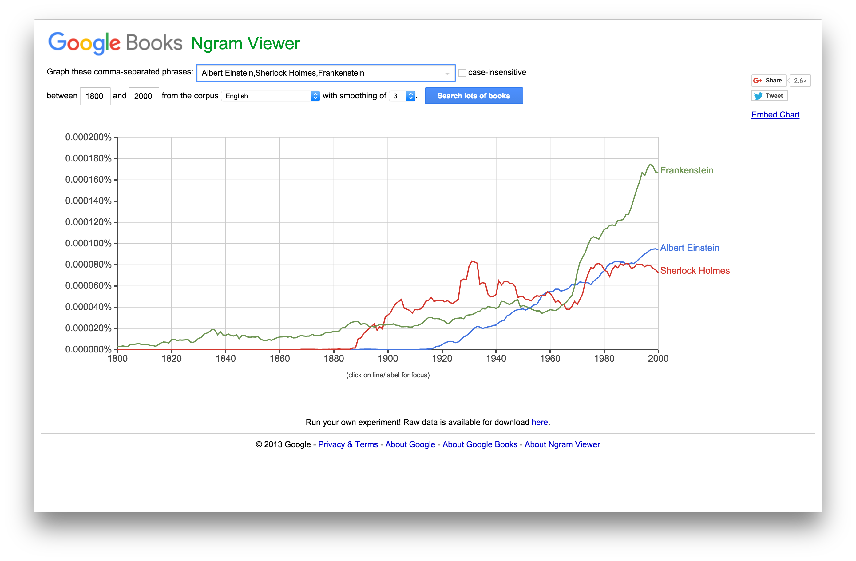

Figure 1. Google’s “Ngram Viewer” (<books.google.com/ngrams>) gives users the ability to search through word and phrase usage of the millions of scanned books in Google Books’ corpora (Orwant and Brockman, “Ngram Viewer”).

You can see from this somewhat basic visualization the beginnings of interests and concerns in digital humanities research. Above, what is featured is a series of counts of the occurrence of a search term, each of which are connected via the somewhat misleading connection of sloped line segments. The implicit premise of the above visualization is that instances of these search terms have changed over time, and implies that the number of occurrences is tied to a change in the number of occurrences in a previous year. With no recourse to the in-text contexts however, the ability to investigate and verify those trend claims is nullified. So what the “Ngram Viewer” produces are views of *potential* broad historical trends in the language use of printed books. This provides a map (or *model*) with points of interest for further investigation.

Turning to another prominent suite of programmatic text analysis web apps, Stéfan Sinclair’s “Voyant Tools,” (<voyant-tools.org>, Figure 2) we find a similar view among its near thirty different text analysis tools. In several views, the relative and raw frequency of occurrence is featured as one means of assessing the “prominence” of words and phrases in a text. Its “Word Trends” tool features trend lines over the evenly divided segments of the processed text indicating word frequency and collocation, that is, words in close proximity. Similar to the visualization of frequency over time of the “Ngram Viewer,” this is one of the first views available to users of the suite.[12] Another initial view is one called the “Corpus Reader” that highlights occurrences of searched-for terms over the space of the text. Corpus word frequency tools “Cirrus” and “Words in the Entire Corpus” are also among the initial views in “Voyant.” Below we are looking at occurrences of “whale” (singular), “ahab”, and “ishmael” over the course of Herman Melville’s *Moby-Dick; Or The Whale* – terms are normalized via lowercasing.

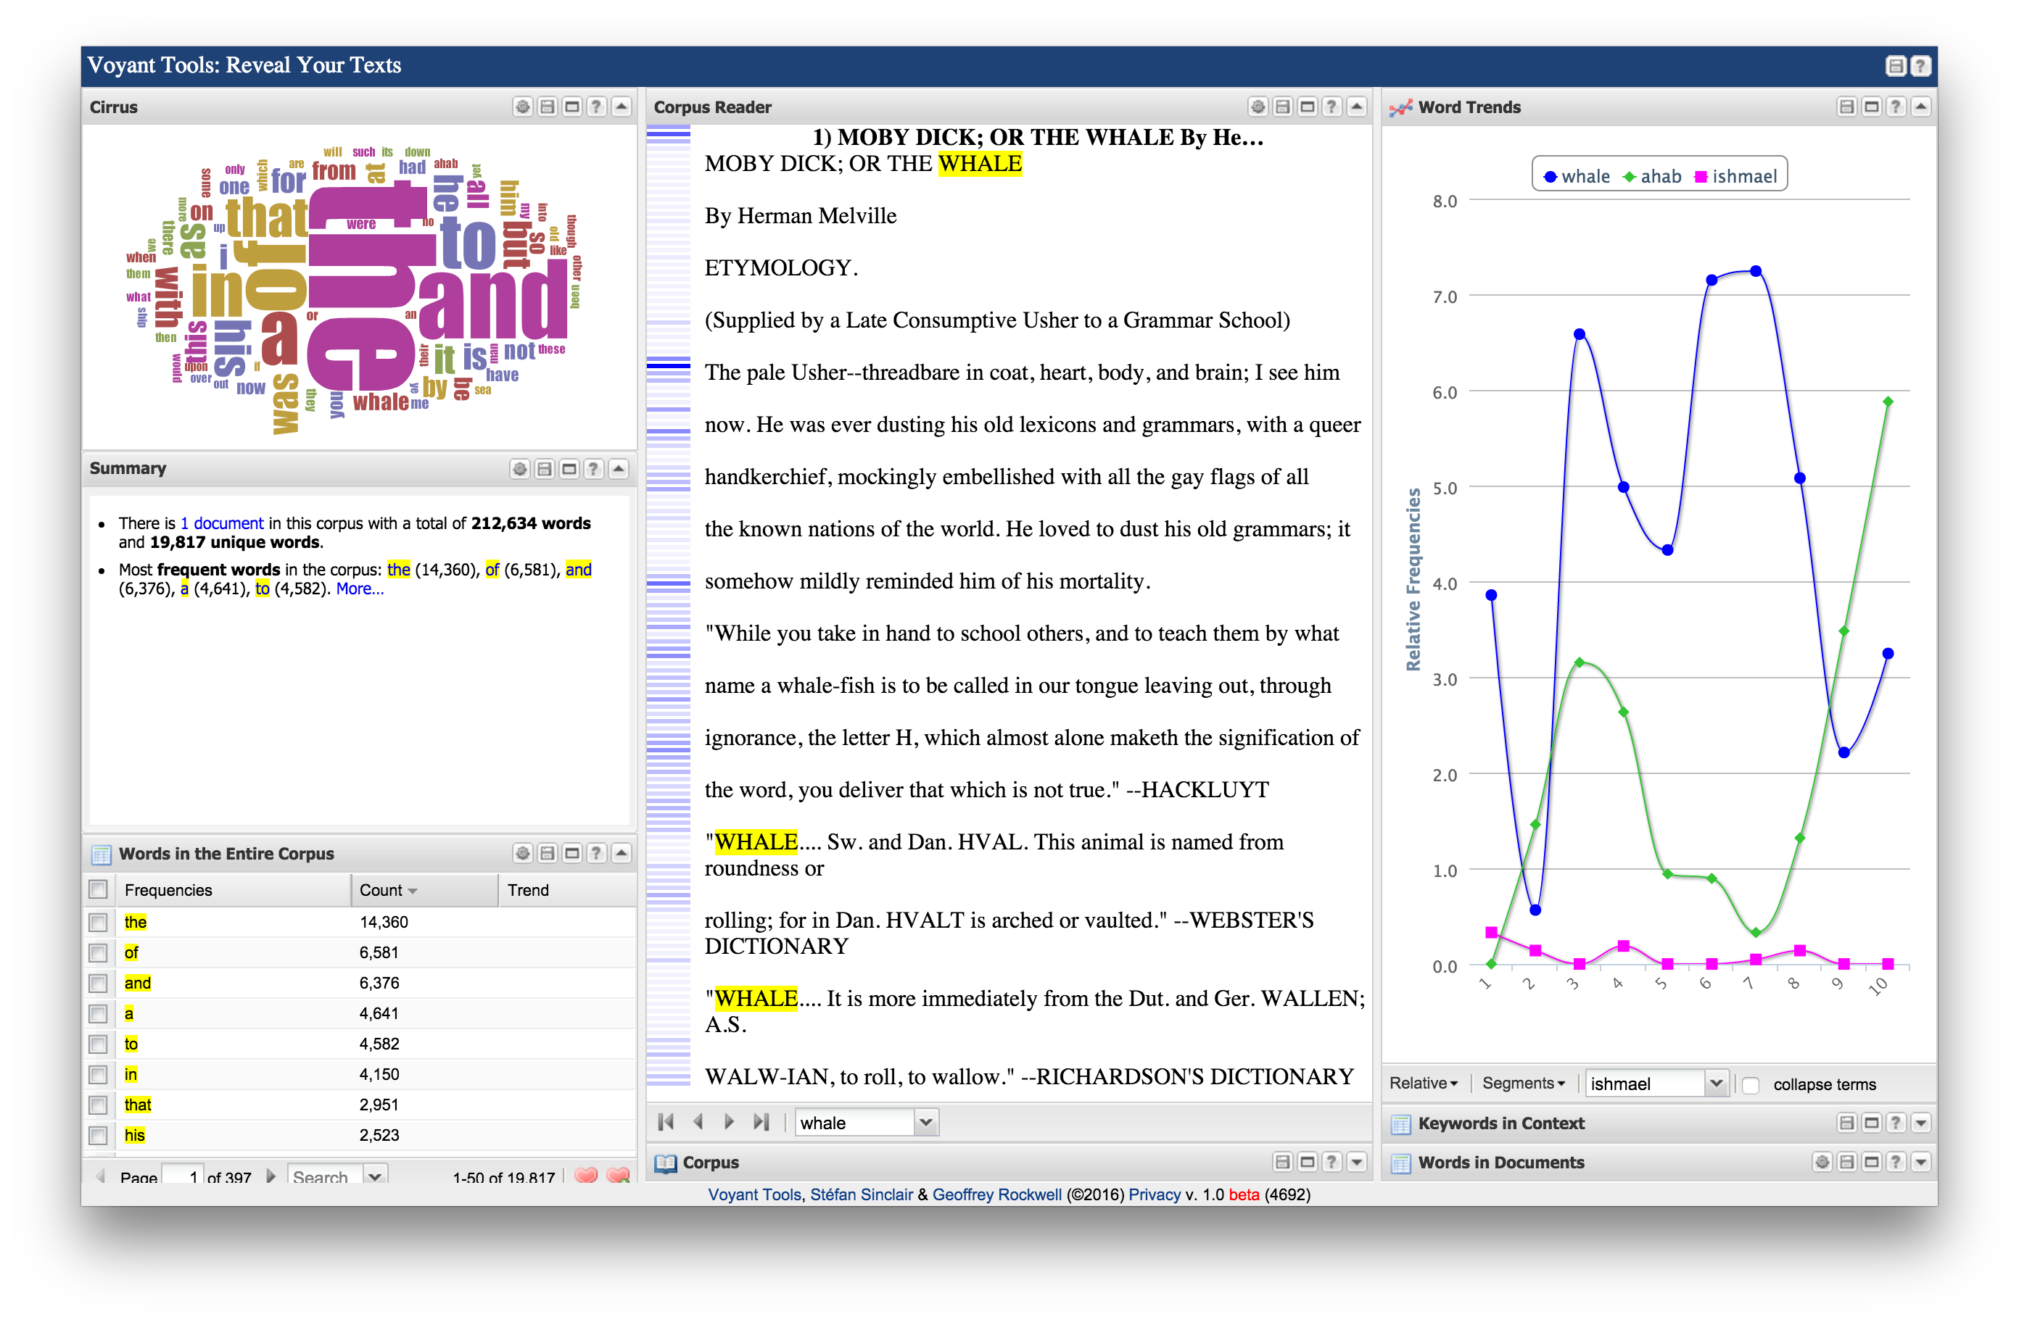

Figure 2. Stéfan Sinclair’s “Voyant Tools” (<voyant-tools.org>) is an Internet-based suite of text mining tools. It brings several different perspectives of word usage and relative word frequency in texts into view at once. Here it looks at Herman Melville’s *Moby-Dick* (Sinclair, “Voyant Tools”).

Looking at the screenshot above, only two views, including the “Corpus Reader,” are not entirely devoted to frequency or collocation. Another key concern for quantitative assessment of word use in texts for digital humanities has been maintaining a more-traditional qualitative perspective, and to this end, one remedy has been the reunification of statistical metadata about texts with the original, human-generated contexts from which those counts arise. See for instance the tool in “Voyant Tools” called “Keywords in Context” or “KwiC” in Figure 3. This view enables users to see the in-sentence contexts of the searched and counted terms.

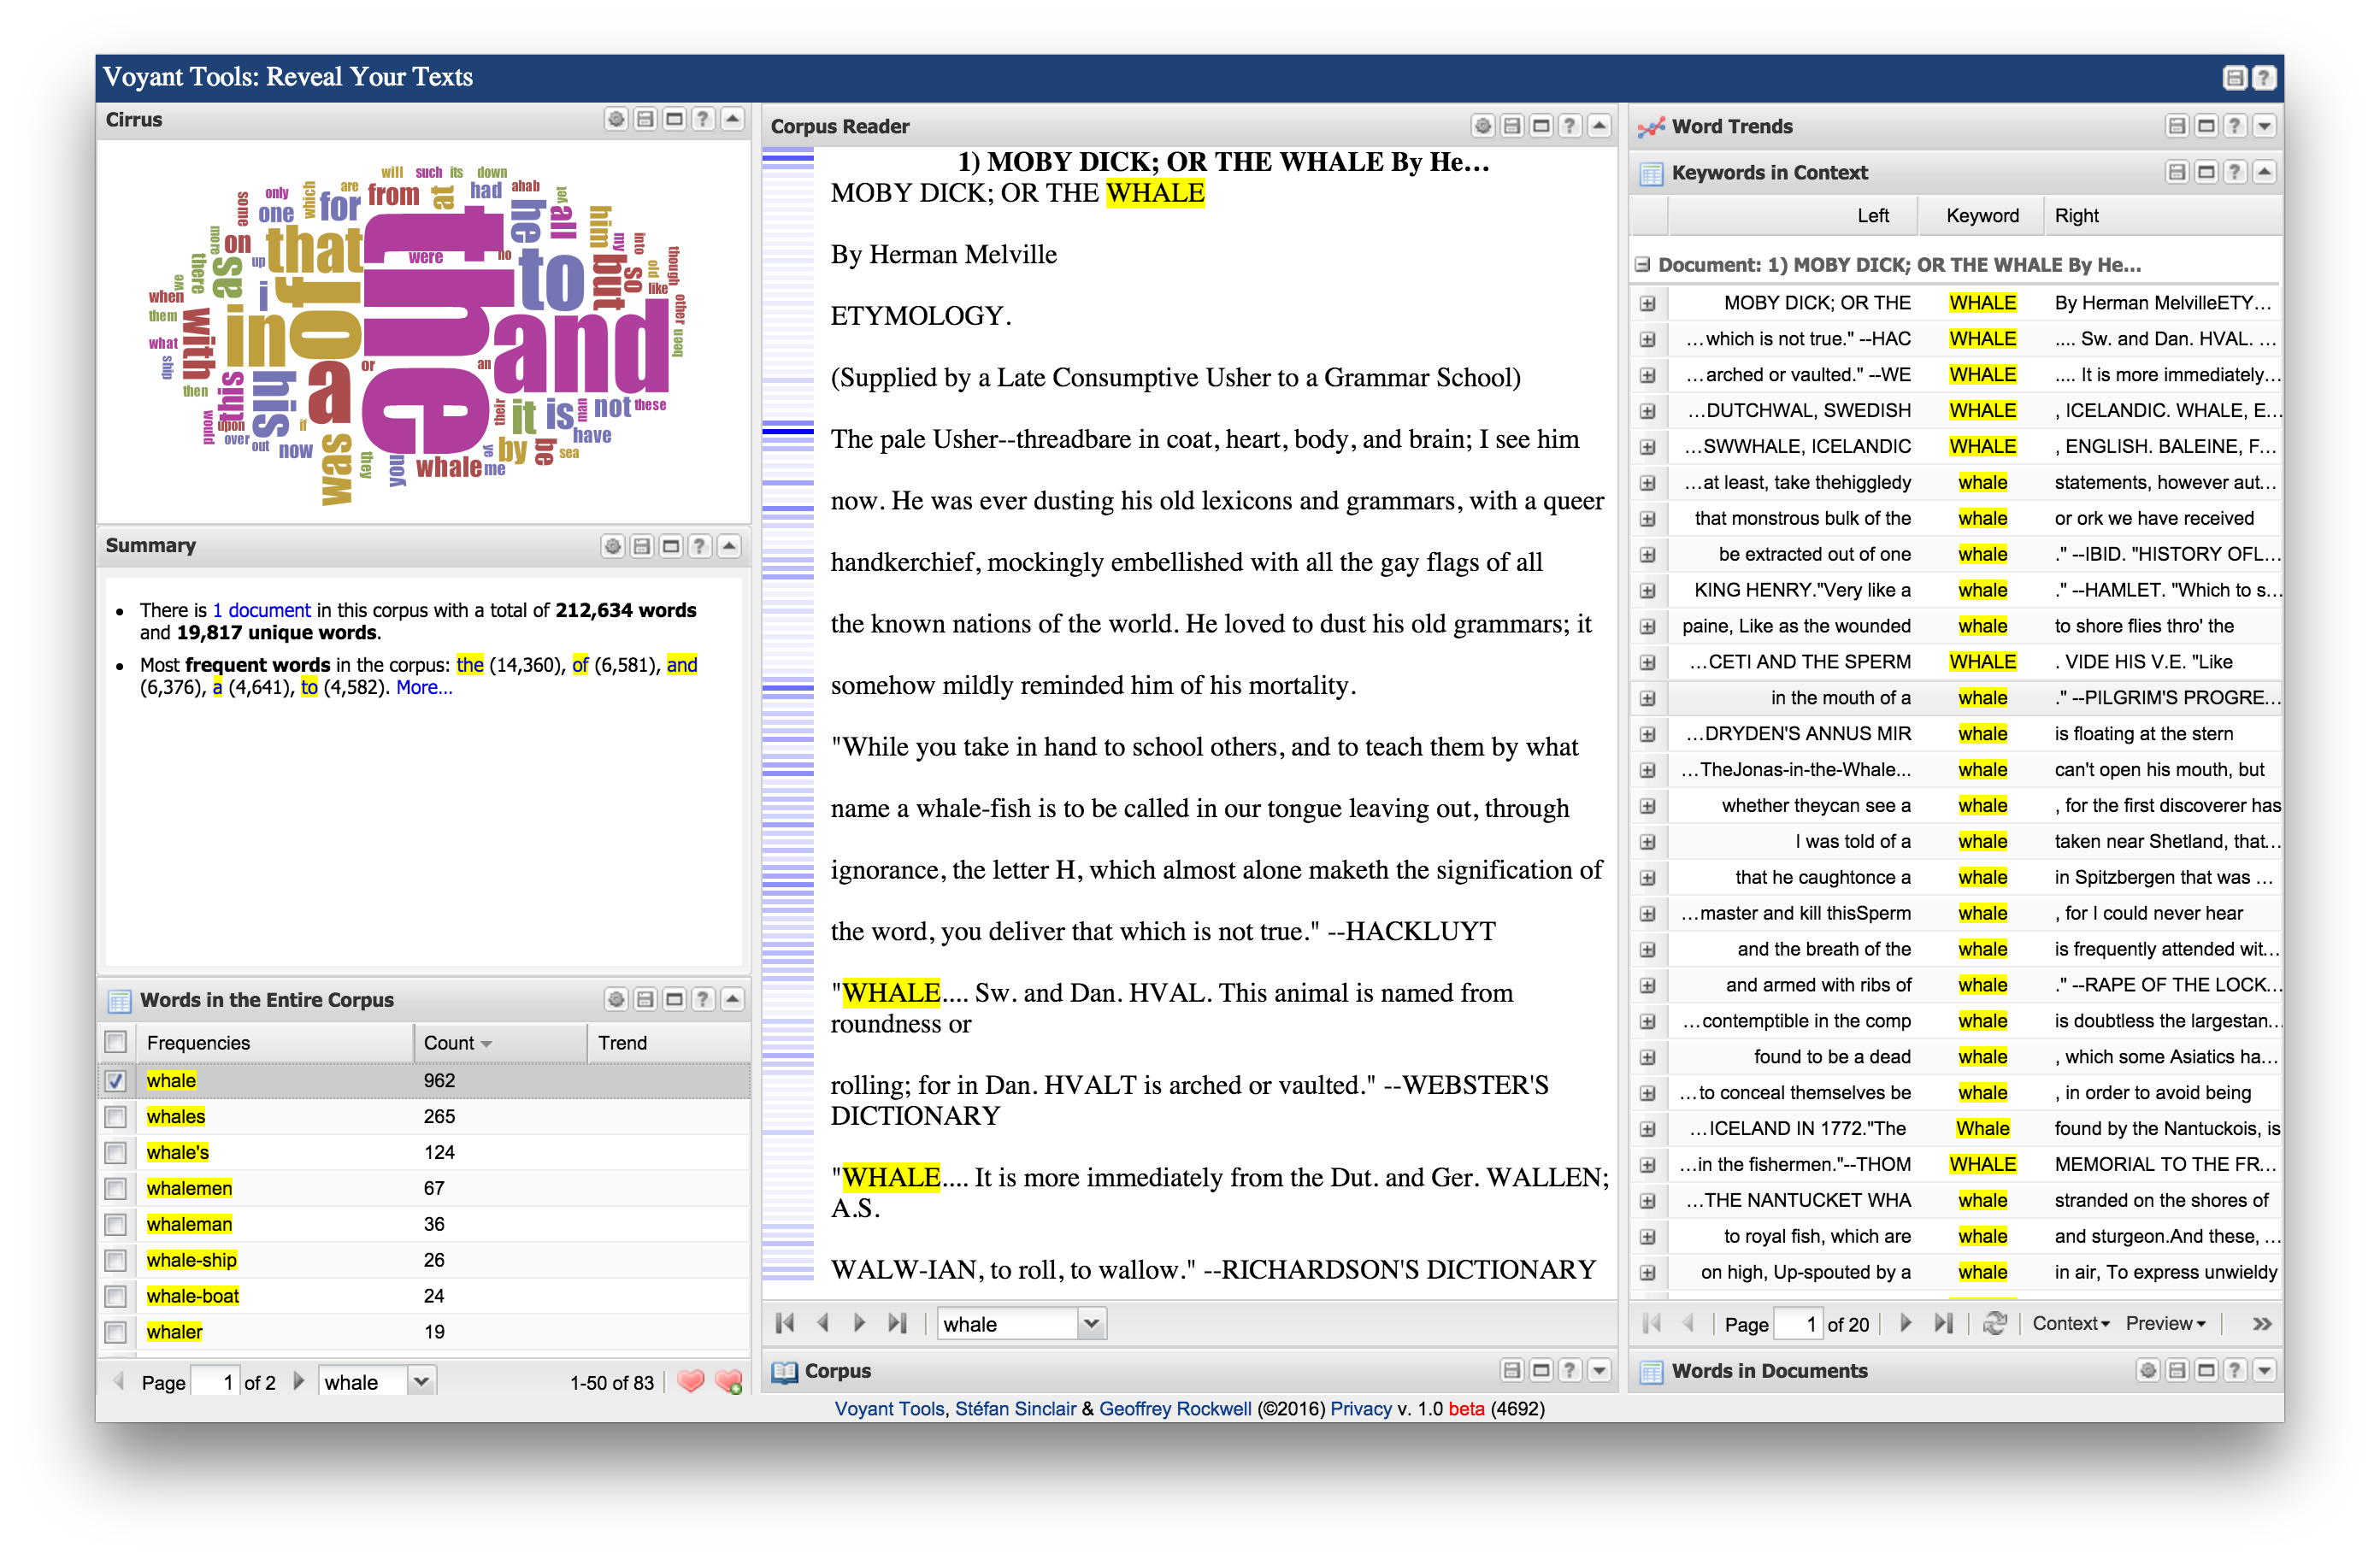

Figure 3. Above, “Voyant Tools” introduces a view on the right called “Keywords in Context” that gives the in-sentence context of word usage. Above are all uses of “whale” in *Moby-Dick* (Sinclair, “Voyant Tools”)*.*

However, as the counts that are derived from the digital corpus are what separate this form of analysis from a traditional close reading of a text – with or without the advantage of KwiC as a computer-based concordance – many digital humanists using this form of inquiry are interested in the opportunities for interpretation/analysis that arise from that statistical accounting of words, and from recognition of the patterns that emerge from those opportunities. The network graph view of word frequency (Figure 4) in “Voyant’s” tool “Links,” for instance, reveals collocate clusters. Below is a view of Melville’s “Bartleby the Scrivener: A Story of Wall Street” in “Links.” The nodes of the graph represent the most frequent words with the size of the node indicating its relative frequency and the edges or links indicating a collocate relationship.

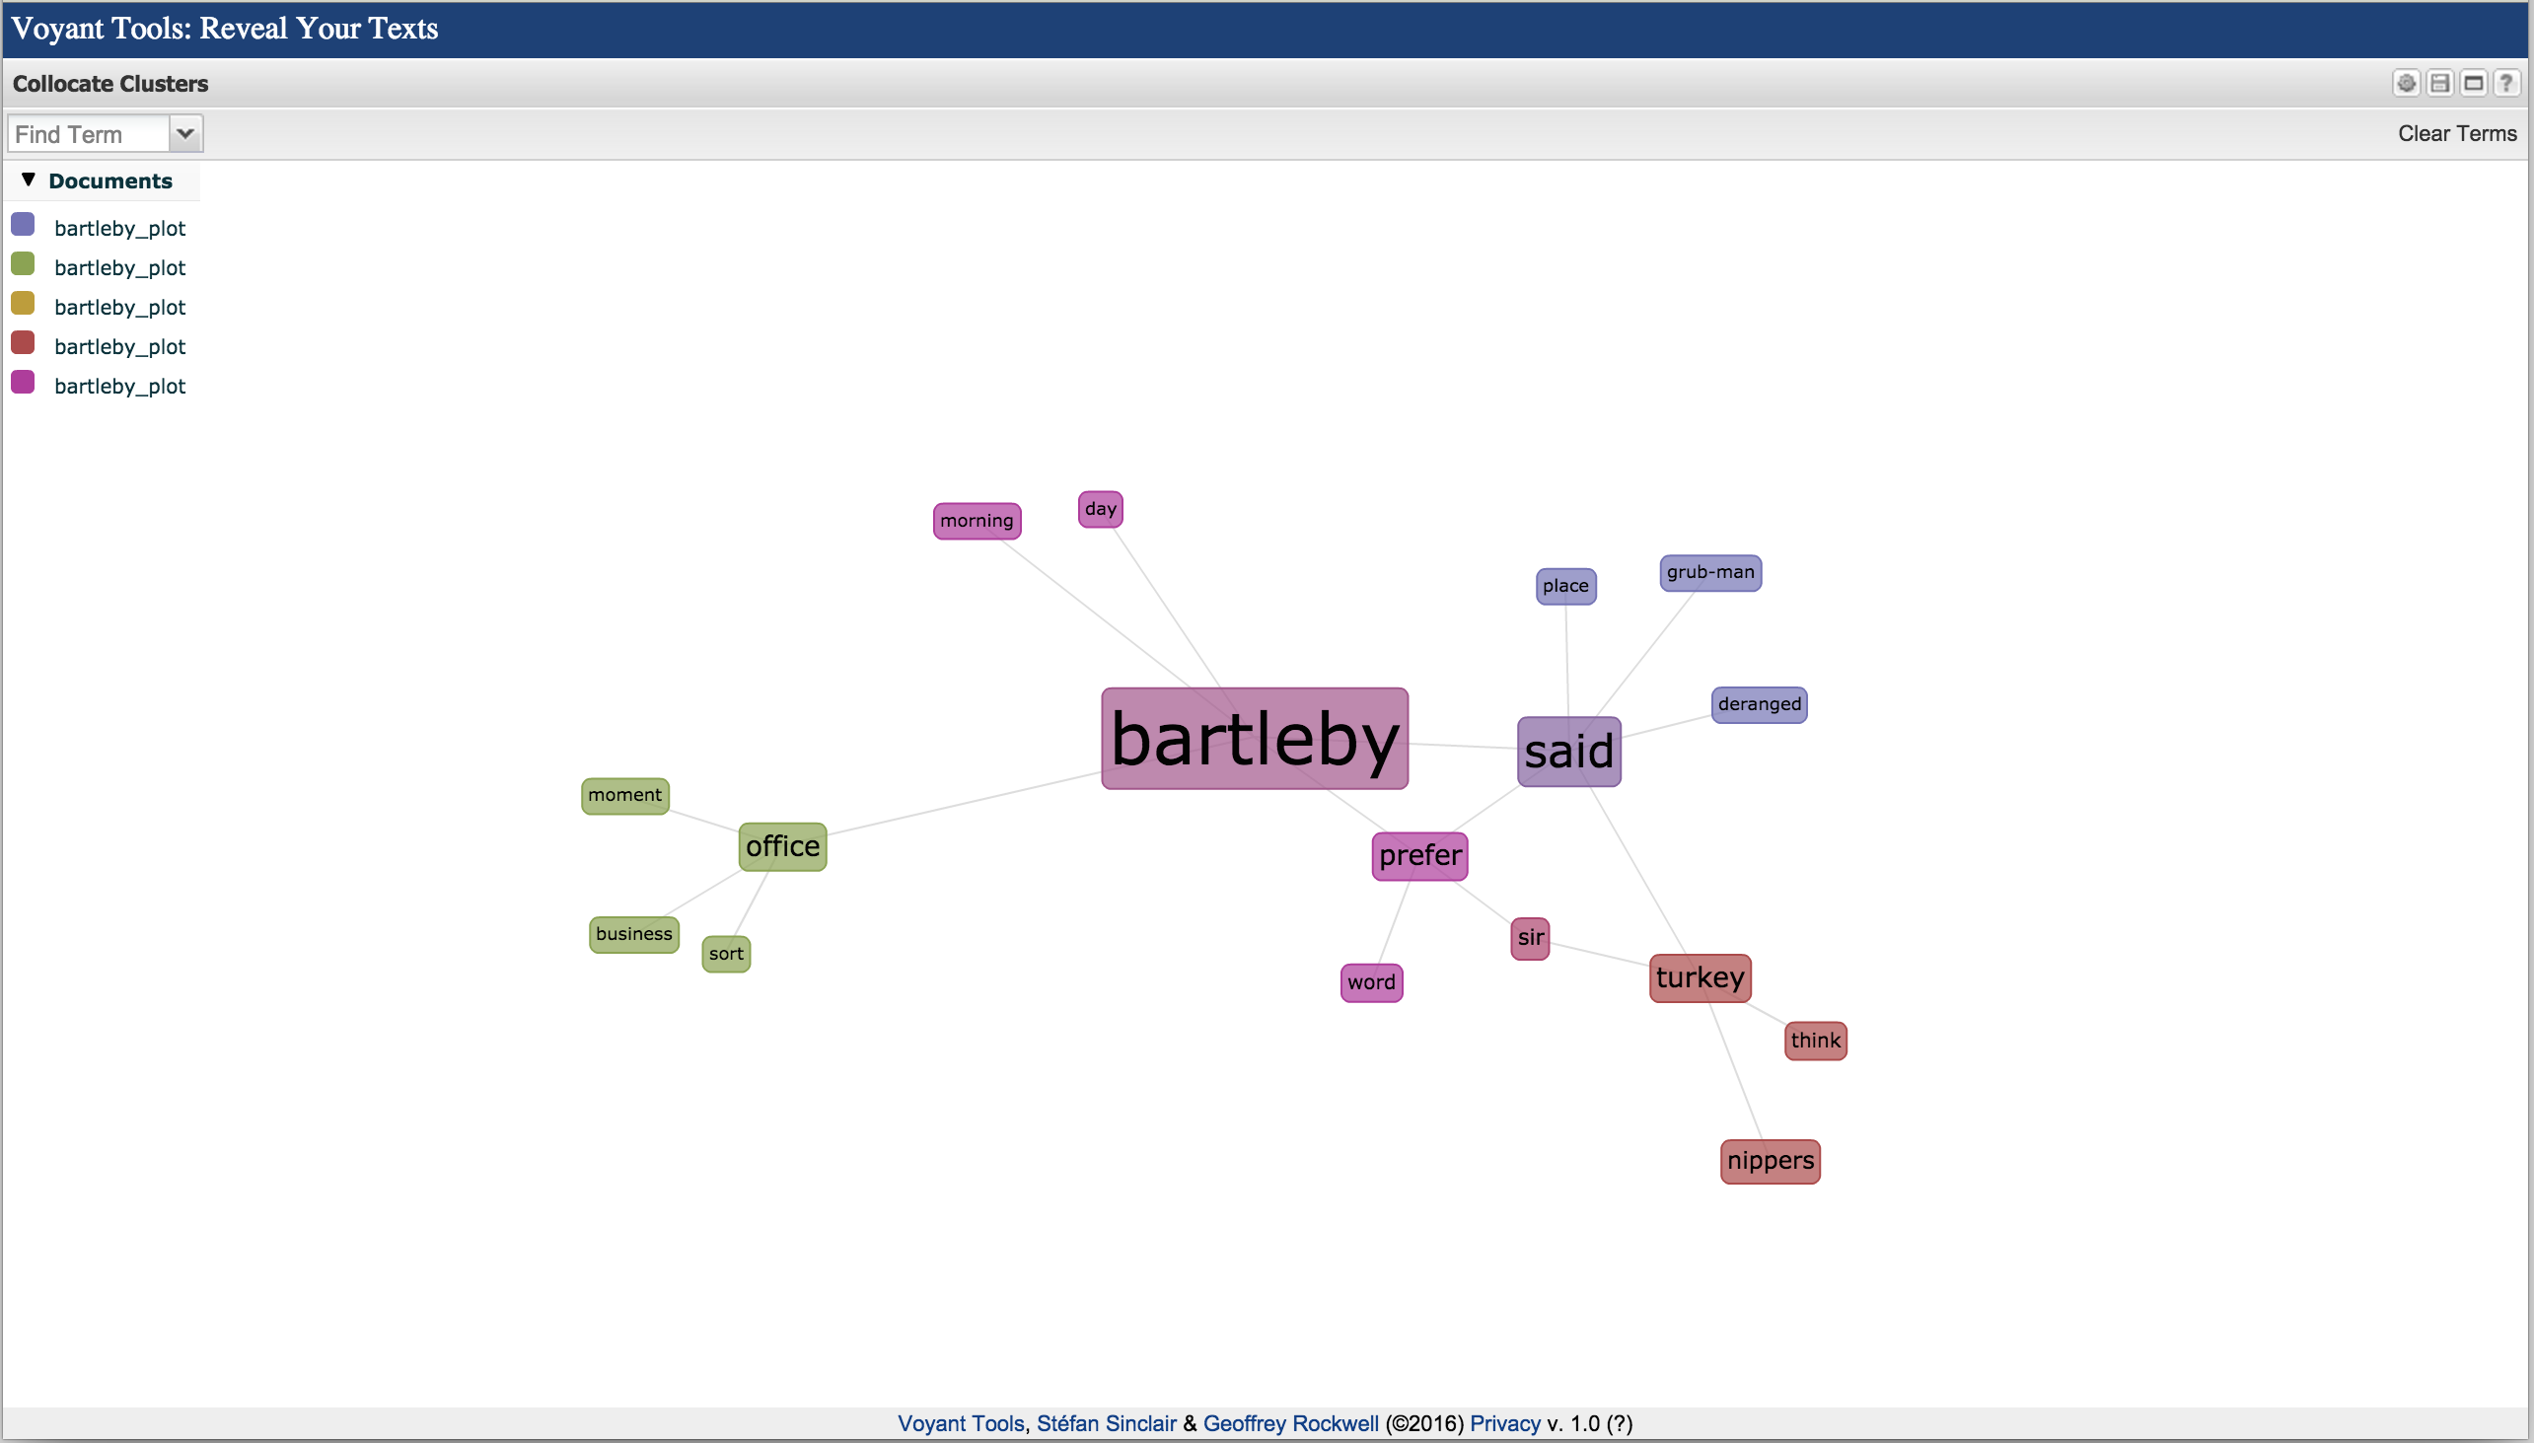

Figure 4. “Voyant Tools” visualizes the words of a version of Herman Melville’s “Bartleby the Scrivener” that has been divided into five pieces based on its dramatic arc. High frequency words of the story parts are networked, and put into spatial relation with other words frequently located near them in the texts (Sinclair, “Voyant Tools”).

Such visualizations have been attempted for displaying topic models. The above view appears somewhat anemic in size – a purposeful choice. Network graphs, if properly weighted and highlighted/colored, appear to strip away all but the “core” elements of a text, leaving visuals that can be simultaneously revelatory *and* misleading, since one must still rely on a return to the text to account for things like in-context usage and polysemy. One need not look far from the forming digital humanities canon, however, to see the power of network graphs when applied to large collections of texts or larger data sets.[13] Taking a look at Jockers’ 2013 *Macroanalysis*, we find a “Cirrus” word cloud similar to the one in “Voyant Tools,” this one with word sizes based on their probabilistic weights in a topic model (Figure 5).

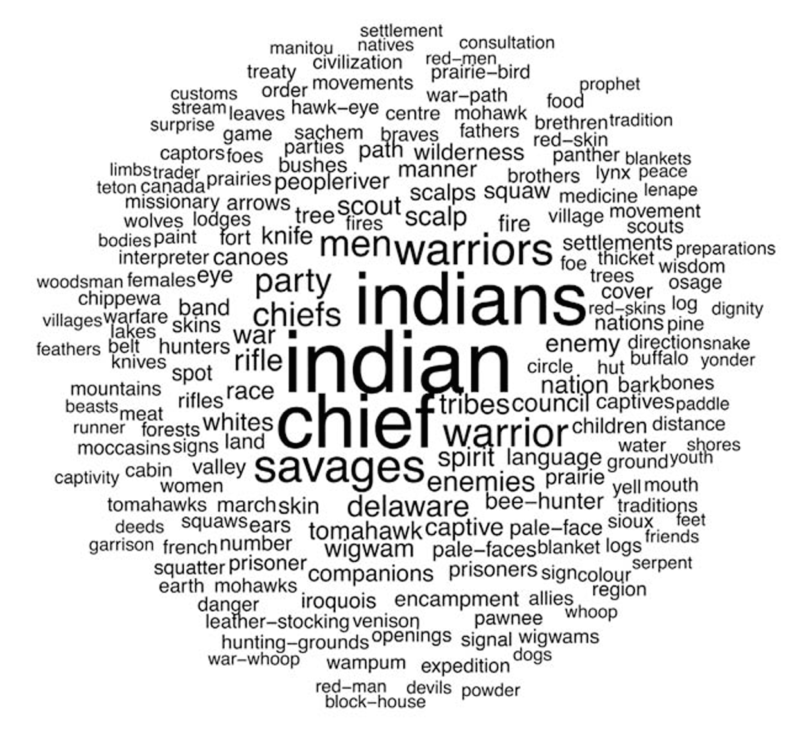

Figure 5. A word cloud from Jockers’ *Macroanalysis* of a topic labeled “Native American.” This comes from a topic model of 3,346 digital books in Stanford Literary Lab’s collection. Words are sized by their in-topic probabilistic weights (Jockers 126).

The results of topic modeling visualization methods have been mixed. On the one hand they do ostensibly display the data from the produced model, but they also mask the link between the method – LDA topic modeling in this case – and the visual. Jockers uses the much-travelled word frequency cloud above to demonstrate the word weights in one particular topic. However that dimension is the only one featured in the visual, and given the difficulty in determining precise word sizing, the word weight relationships are somewhat lost. They are also set apart from the texts in which they occur. There are a few ways of overcoming those information gaps. One would be to visualize this data as it occurs over a time-like axis as they occur in a text, like the continuous trend lines like in the “Ngram Viewer” or like in “Voyant Tools” – why I have included them above. Or a bit more realistically, topic weights of texts can be displayed in the discrete counts of a bar graph, the unit on the time/text space axis in either referring to discrete segments of a text. However, all of these methods show a view of the model that is missing a context: the geometric structure of the data itself, the relation to other topics, and/or the situation in relation to the text itself from which the model was derived. Part of the reason for this de-contextualizing omission in Jockers’ image is for the sake of the intended humanities audience, and Jockers apologetically admits as much. But you can see this flaw (or intentional oversight) in two comments he makes concerning the method and results of topic modeling. At one point he states of LDA, “We needn’t know how long and hard Joyce sweated over Ulysses to appreciate his genius, and a clear understanding of the LDA machine is not required in order to see the beauty of the result” (Jockers 124). And in another, “It is not difficult for a human interpreter to make sense of the word clouds and to assign labels to the themes represented by these algorithmically derived word lists” (125). While this form of interpretation can emanate from good intuition,[14] this is also unfortunately what Blei refers to when discussing tealeaves**.** Jockers adds as a footnote, that this initial pass at topic interpretation lacks the potential granularity that a model with more topics or slightly different parameters might produce. And indeed, models with too few topics may produce topics that contain confusingly merged thematics; those with too many can produce the opposite effect: split ones. Another worrisome possibility is that this form of modeling does not always generate lists of words that are meaningfully related to some semantic or thematic “field” within the texts, and will produce what are essentially noise, or “junk” topics. Much work has been done to determine the appropriate amount of topics to suggest to the modeler as well as to determine when topics may be filled with noise.[15]

Ted Underwood has done extensive work with topic models and has experimented with ways of effectively visualizing them He has made regular postings on the method and its limits on his blog, “The Stone and the Shell.” In 2012, Underwood and Michael Simeone produced a series of blog posts discussing visualizing topic models, experimenting with network graphs, principal component analysis (PCA), and highlighting schemes for either.[16] This was followed by a collaboration between Andrew Goldstone and Underwood producing a topic model of the *Publications of the Modern Language Association of America* (*PMLA*), the journal of the Modern Language Association of America. While Underwood and Simeone focused on developing visual distinctions between the correlations of topic existence in documents, Underwood and Goldstone shifted the focus to see how topics were proportionally altered or extant over the time of the publication’s existence. Below are a few figures from these studies, each of which highlight various visualizable aspects of topic models – varying statistical relationships between the probability distributions of topics and proportional topic presence over time in texts.

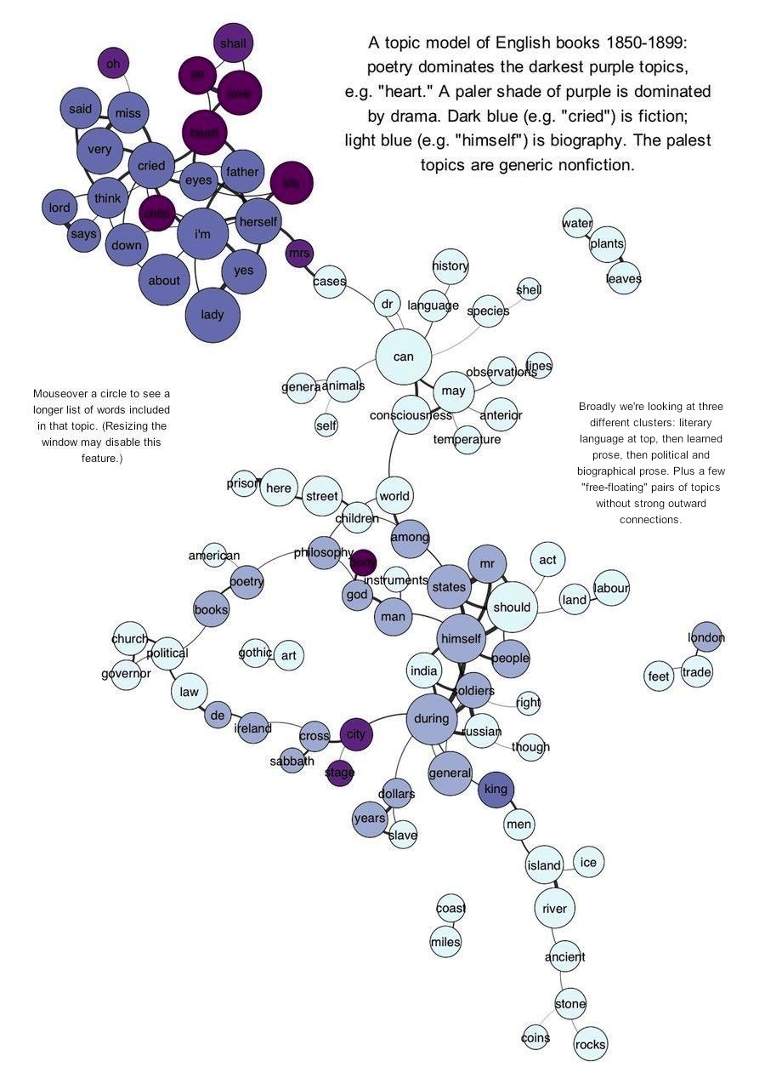

Figure 6. A topic model of late nineteenth century British books put into network form. The top words of each topic are labeled on each node of the network. Connections are made via high-probability, co-occurring words across topics (Underwood, “Visualizing topic models”).

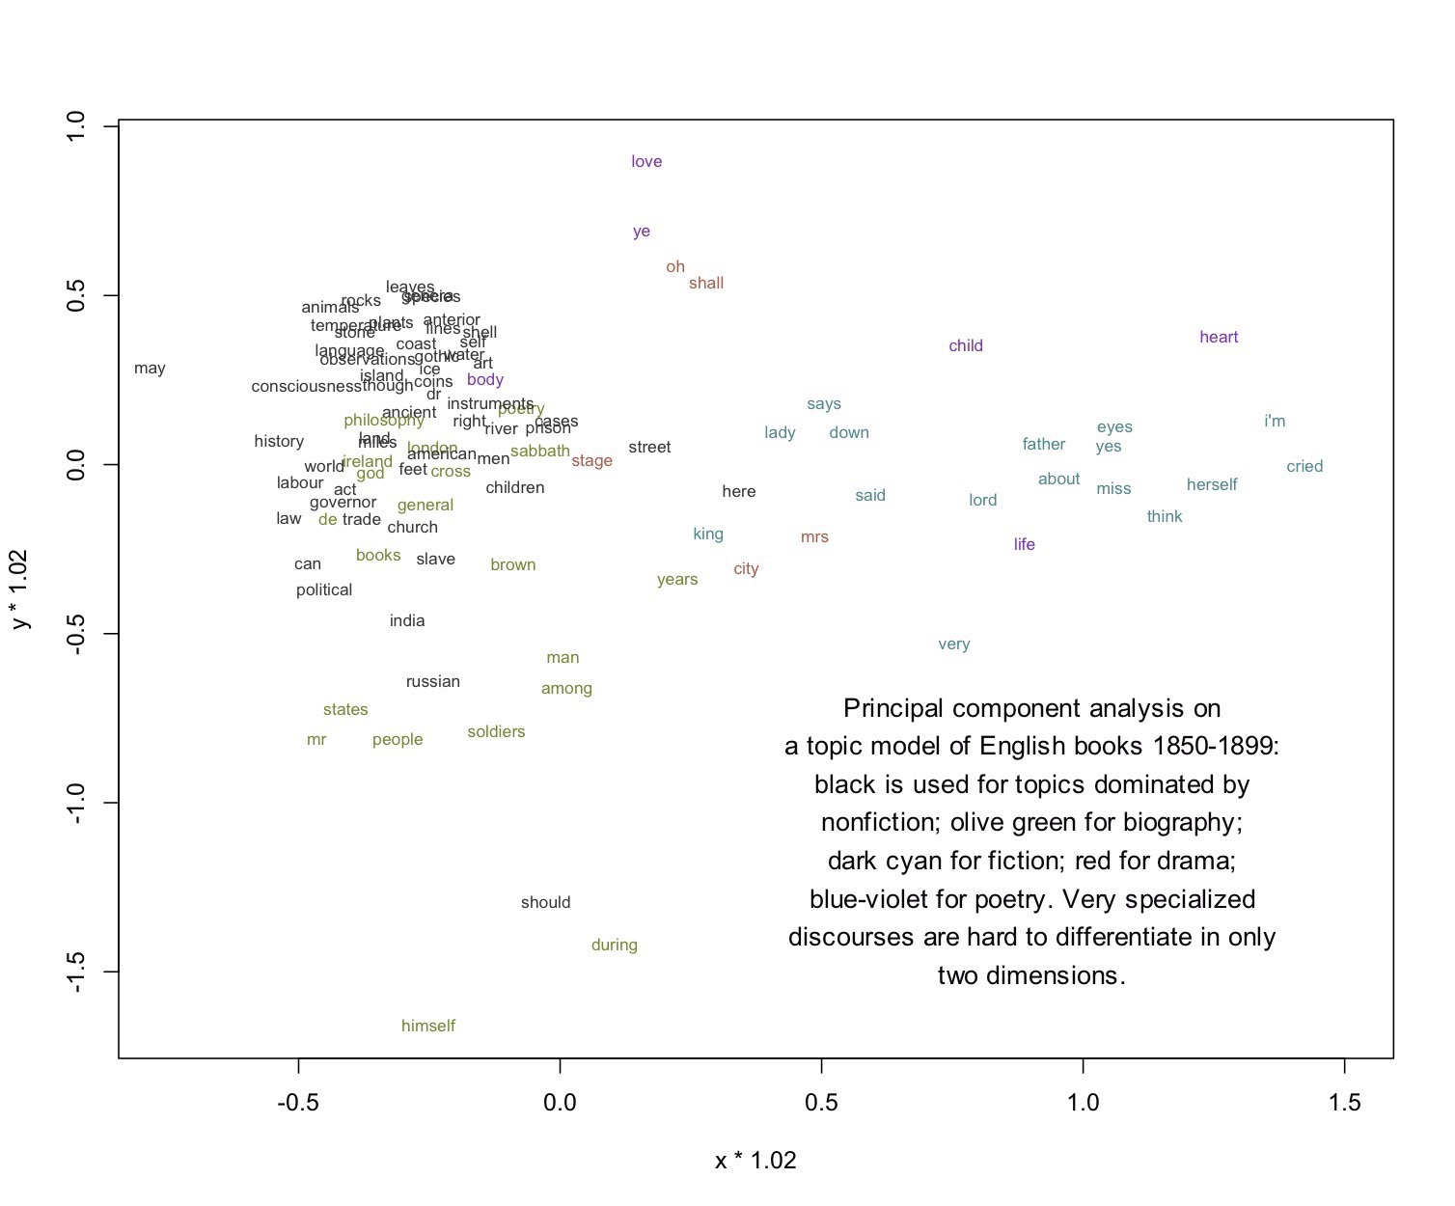

Figure 7. “Principal Component Analysis” (PCA) offers another visual take on topic modeling Underwood’s corpus (see Figure 6). There are relatively few topics (or distributions) and they are high-dimensional figures (e.g. all words of a corpus per topic, only some significantly weighted). PCA performs dimension reduction in order to highlight and cluster topic words that are similarly dominant – a sort of topic-overlap “shadow” (Underwood, “Visualizing topic models”).

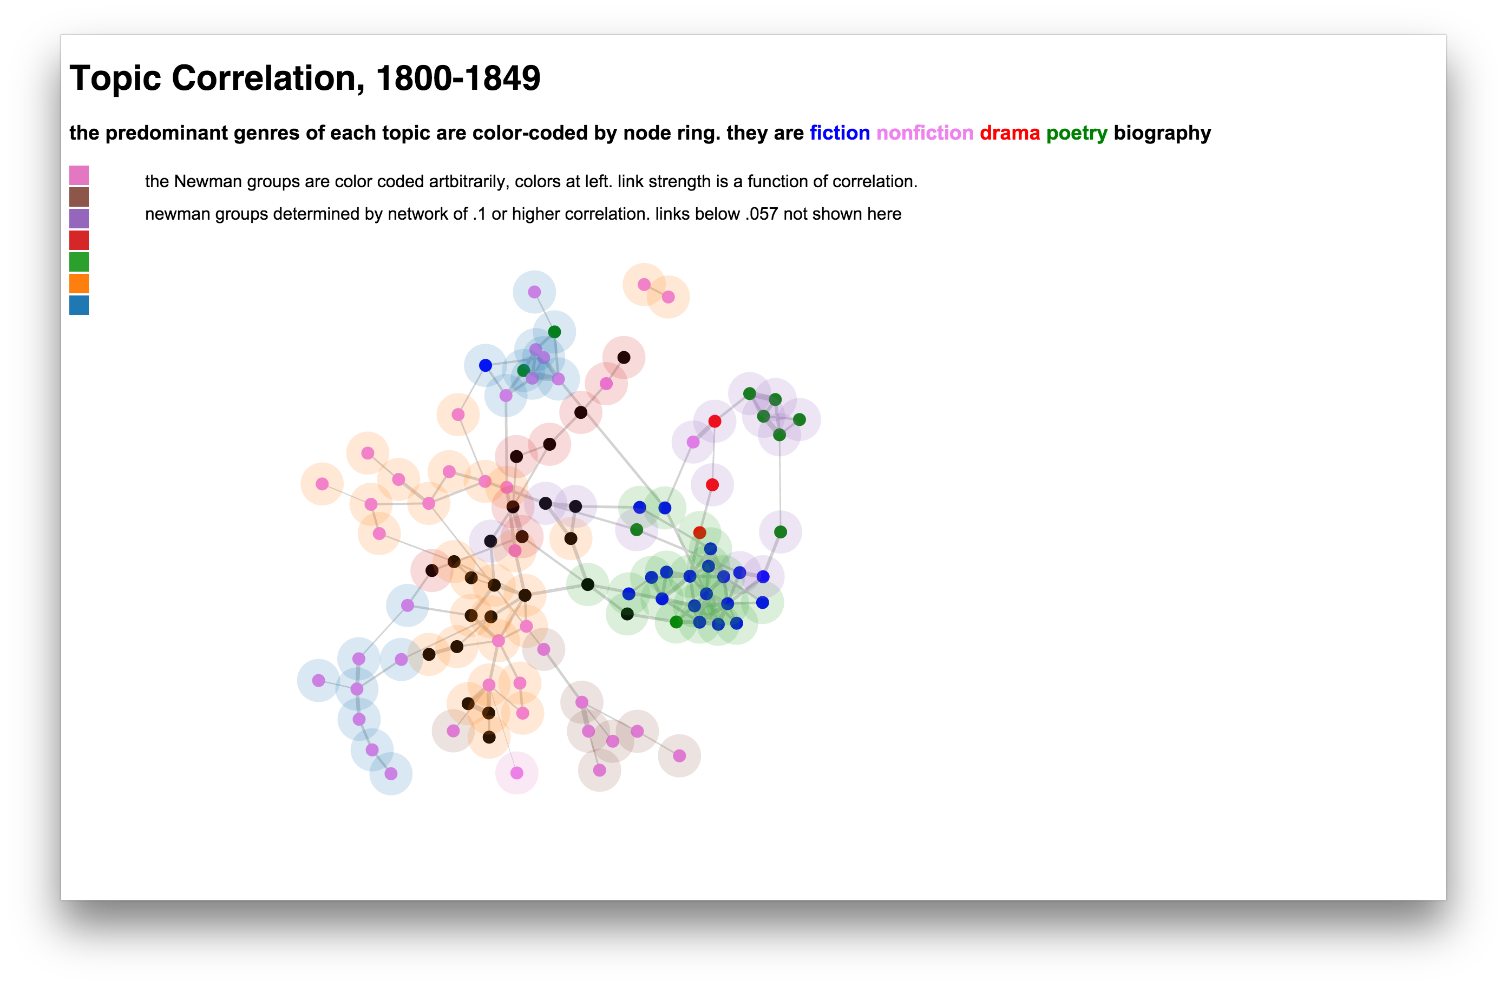

Figure 8. The topics of a topic model are put into a network, linked by the strength of statistical correlation measure between the probabilistic weights of their topic words (Simeone, “Visualizing Topic Models with Force-Directed Graphs”).

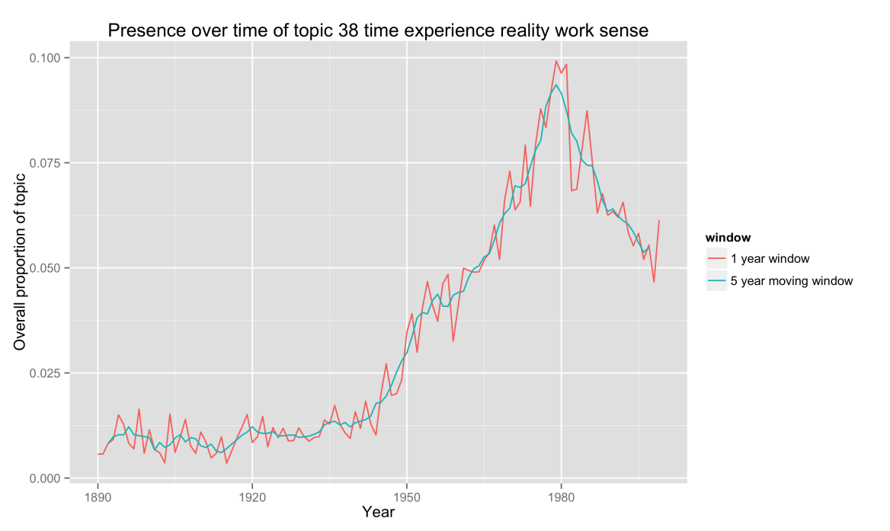

Figure 9. Pictured above is the proportional presence of a topic over time in issues of *PMLA* (Goldstone and Underwood, “What can topic models of PMLA teach us about the history of literary scholarship?).

I make note of these cases of topic modeling visualizations in order to highlight the ability of researchers to shift focus in what at first seems to be the very finite and well-defined data set that is a topic model. One of the key takeaways that Underwood et al. have stressed is the error-prone nature of the method, despite its ability to mine these potentially helpful categories about a collection of objects. This nature applies to both the results as well as the appropriateness of the method for the corpus. On Underwood’s initial post regarding the visualization of topic models, Ben Schmidt provided some commentary reflecting the appropriateness of topic models and how interpreting them visually is effectively attempting to interpret data in a high-dimensional space that soon exceeds human capacity. For this reason he feels that other techniques of multidimensional scaling may be more appropriate, to partially flatten the model and give access to points of interest within it. To illustrate how misleading topic models can be, particularly because of the problem of merged, split, and junk topics, Schmidt famously produced a topic model of the latitude and longitude measurements noted in nineteenth century shipping logs.

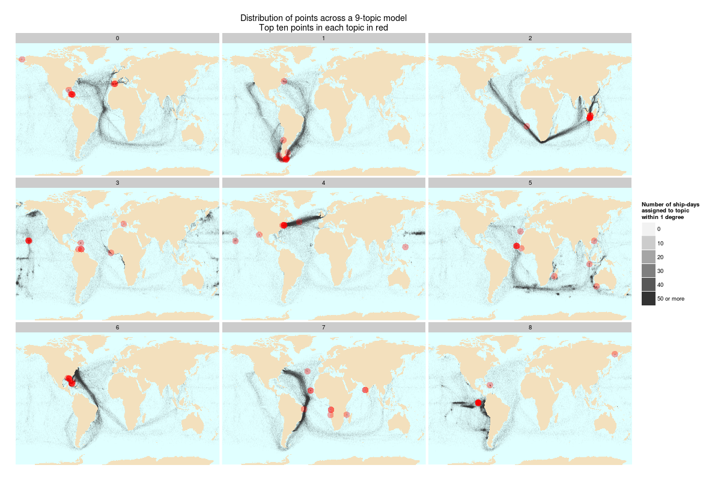

Figure 10. Pictured above is a topic model of the coordinates of nineteenth century shipping logs by Ben Schmidt. Topic distribution – usually thought of as semantically-connected words – are spread back over the world map in more understandable, two-dimensional form, allowing Schmidt to highlight the pitfalls of topic modeling (Schmidt, “Words Alone: Dismantling Topic Models in the Humanities”).

With the inherent, low dimensionality of map coordinates Schmidt iteratively demonstrates the problematics of topic models. Notably, in topic 4 of Figure 10 we can see an instance where multiple shipping routes are conflated. The confusion between US-English trade routes and Pacific whaling grounds seems obvious on the map, but it’s important to recall that these collected longitude/latitude pairs reflect what would otherwise be the prominent words of a topic in a topic model of texts![17] Schmidt's example illustrates why the semantic semblances often drawn from topic word lists are highly problematic. Indeed, it is hard to eliminate the confusion and erroneous conclusions that can be drawn by sole use of visual inspections of topics. Mimno, among others, has done some work to test the human capacity to assess a topic’s semantic coherence and the viability of programmatic assessment of that quality. In addition, a recent promising paper of a team from Macquarie University, Google, and University of Edinburgh also has demonstrated an algorithmic means by which word order may be re-introduced (or at least paralleled) to a topic model to produce more accurate – and thus more semantically coherent – topics that are closer to the original human-generated text than ever before.[18]

I would like to continue this tightrope walk of quantitative and qualitative assessment, and suggest that document- or text-assessment instead of the previous topic-based assessment can be a powerfully informative way of addressing semantic coherence and simultaneously also address topic-based avenues of interest like topic-document correlation. This is not a new route of investigation. In fact it is at the core of Blei’s premise for humanities usage of topic models. Take for instance a visualization workflow for a “navigator of the documents” of topic models as suggested by Alison Chaney and Blei in Figure 11.

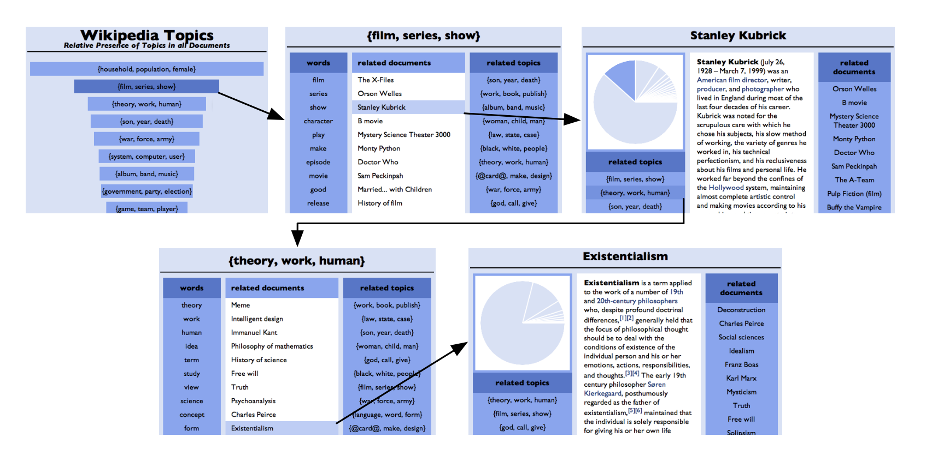

Figure 11. A prototype flowchart of a navigational user interface to connect topics with the texts they represent (Chaney and Blei, “Visualizing Topic Models”).

What Chaney and Blei suggest is that, instead of just mining for tangible meaning within the distributions built by Bayesian inference, a re-insertion of the human-built and ordered texts (that provided the prior information for the model to be formed) is necessary for extensive human navigation and proofing of that model. Elijah Meeks, who has moved from a PhD in history to a renowned expert in humanities visualization, has made it clear that the usefulness of visualization techniques may also be demarcated by field of specialization (Meeks, “The Value of Network Visualization”). Like Blei and Chaney show concern, the qualitative assessments of visualizations that tie more closely to their original objects of study can often produce more readily accessible findings for the complex models produced about those objects. Meeks produced the suggestive and familiar network graph in Figure 12 to specifically address this assertion for topic models.

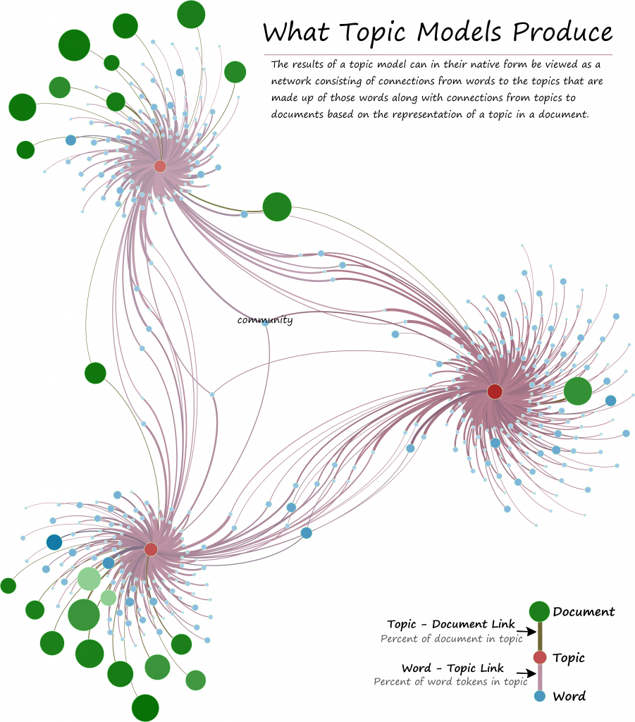

Figure 12. Elijah Meeks diagrams the outputs of a topic modeler and makes the argument that striking visuals that allow viewers to easily demarcate relationships in the data better allow for connections between topic models and their texts (Meeks, “Neotopology”).

A few recent visualizations have moved in these directions as well. David McClure has developed a rich visualization of topic model-like data called “TextPlot” that calculates density functions of the closeness – and thus relationships between – a text’s words. This forms a visualizable, calculable radius surrounding the prominent words of a text (McClure, “(Mental) Maps of Texts”). What is produced is a sort of conceptual map, or what McClure claims is closer to the “cognitive experience” of reading the text. In Figure 13 is an example of a graphed set of topic-like, word density functions that produce the network visualization of the prominent words of Tolstoy’s novel, *War and Peace*, in Figure 14. While McClure aims at something closer to a traditional, qualitative assessment and produces beautiful, semantic-associative visuals for consideration, “TextPlot” has much in common with the networks of Underwood, Simeone, and Goldstone. However, McClure’s method moves us closer to that text time, or experience of reading the object being modeled.

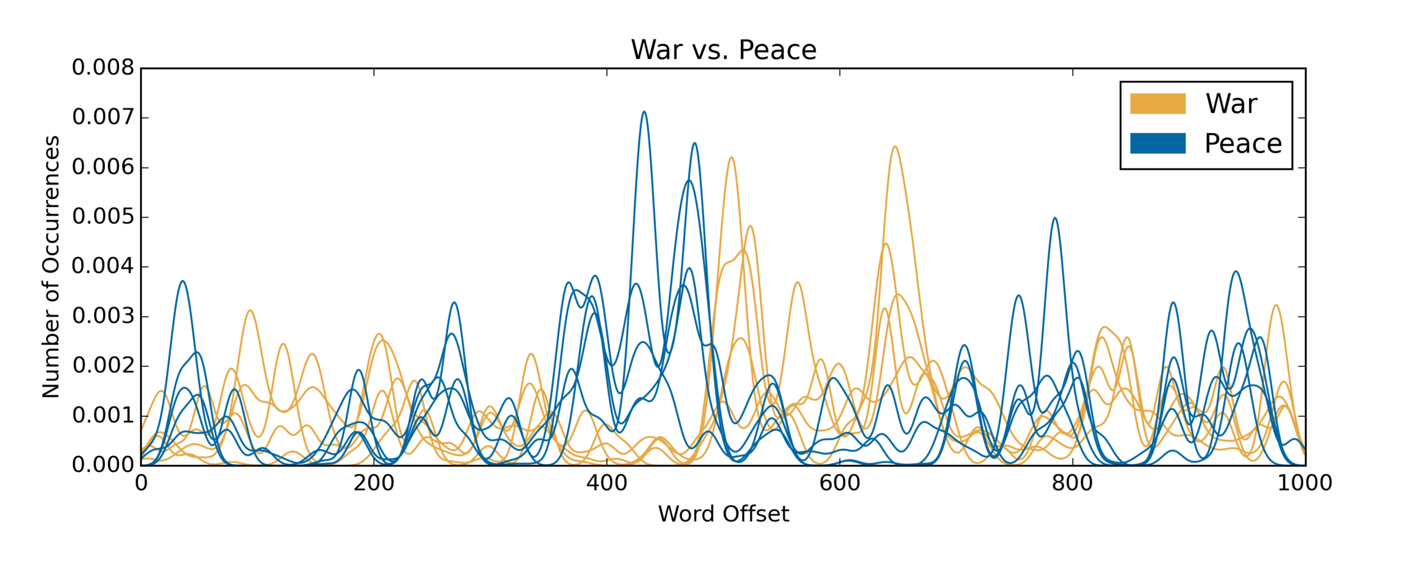

Figure 13. “Kernel Density Estimates” (KDE) of lists of words labeled “war” and “peace” as they exist across the words of Leo Tolstoy’s *War and Peace* (McClure, “(Mental) Maps of Texts”).

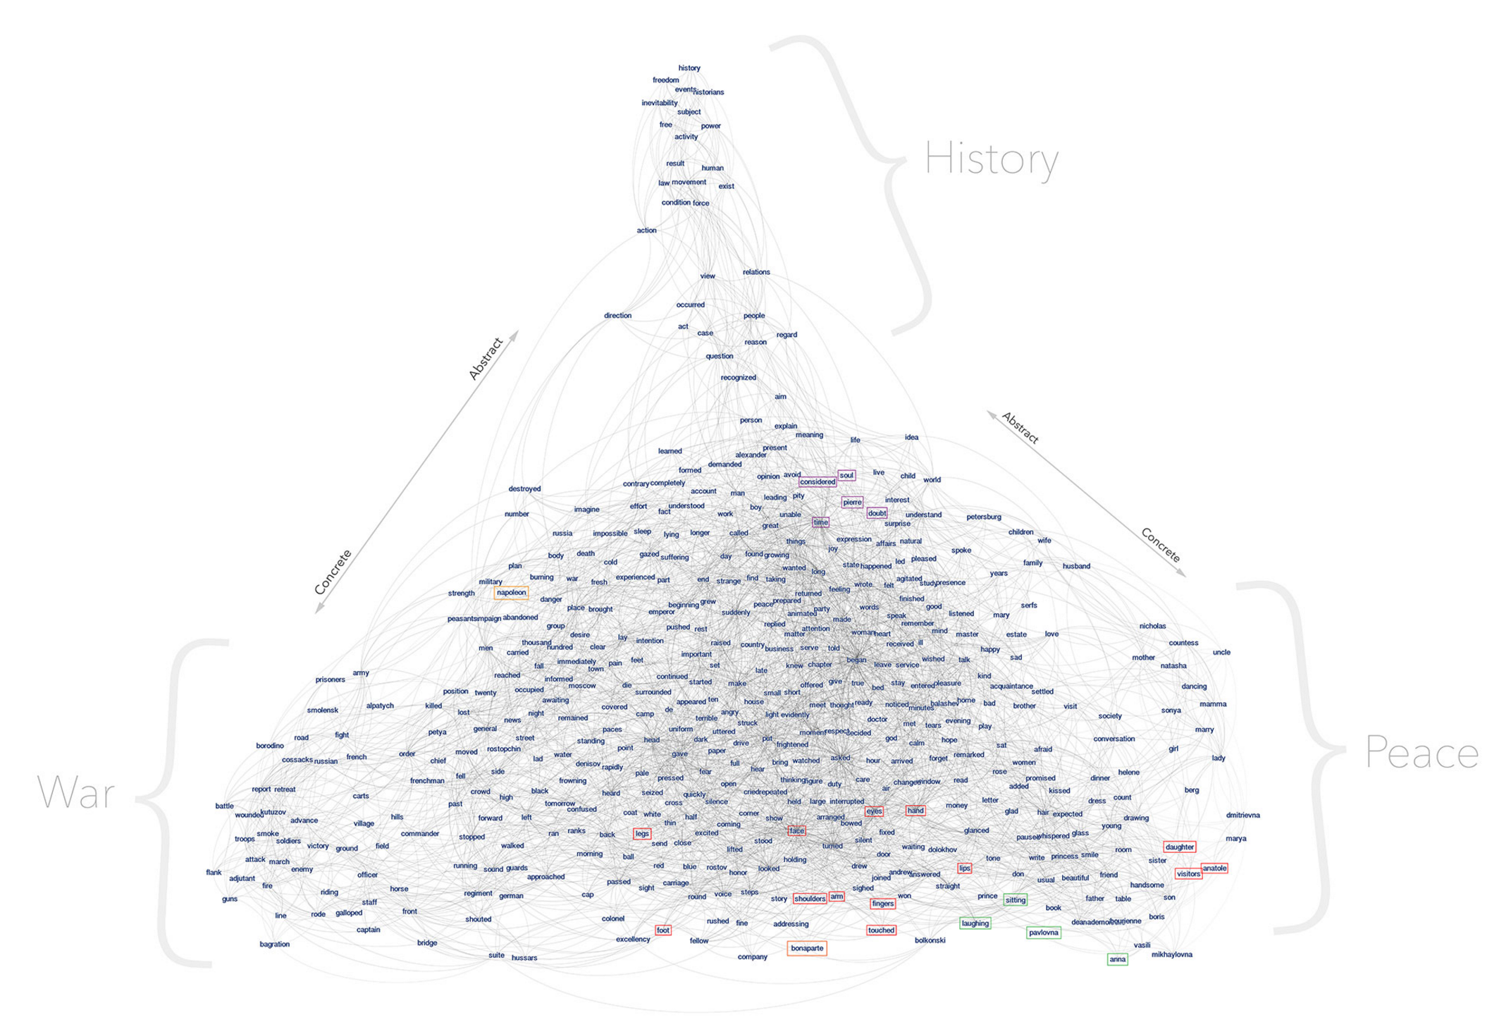

Figure 14. Strongest of connected words in these KDE lists of words from *War and Peace* put into network form to spatialize their connectedness (McClure, “(Mental) Maps of Texts”).

Another visualization by Eric Alexander and Joe Kohlmann called “Serendip” moves closer to what Blei and Chaney had envisioned in their 2012, “Visualizing Topic Models.” Developed around the same time as my own topic modeling visualization, which I will be discussing in the next section, “Serendip” uses the documents and weights of the topic model to produce a navigable, topic distribution hierarchy in what is more like an analysis suite or workbench in the style of “Voyant Tools” than a standalone visual. It features three views: “CorpusViewer,” “TextViewer,” and “RankViewer,” addressing corpus-level topic distribution, text-level topic distribution, and topic-level word distribution respectively. In the figures below, grid and bar plot-like visuals are used in conjunction with trend lines for topic distributions.[19]

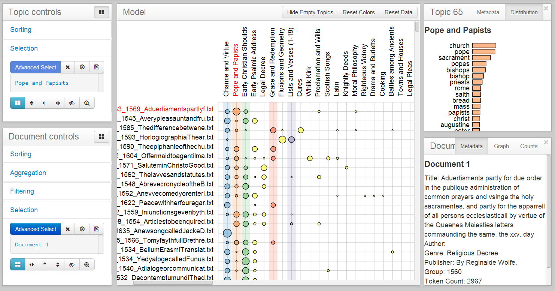

Figure 15. The “Corpus Viewer” of “Serendip” shows topic-predominance across the texts of a topic model, the distribution of words, and metadata of those texts (Alexander and Kohlmann, “Serendip”).

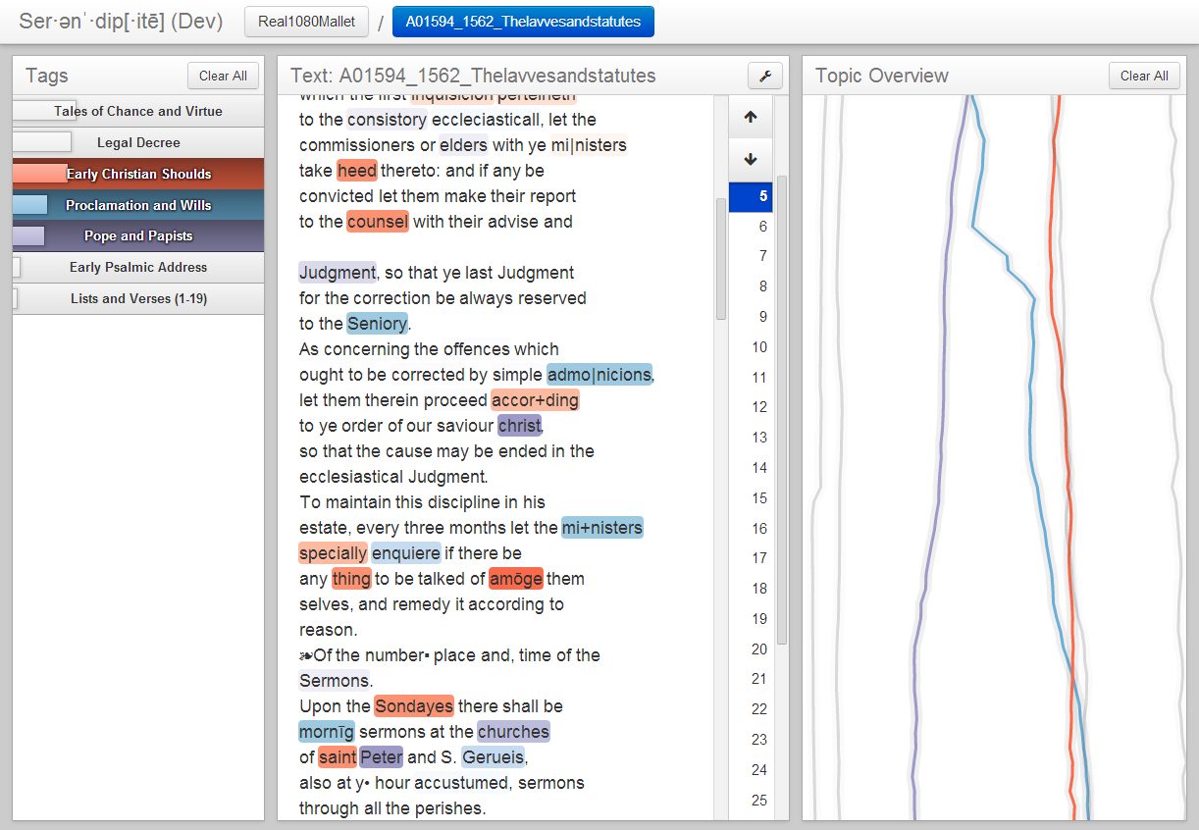

Figure 16. The “Text Viewer” of “Serendip” allows for labeling and coloring of topics and topic words in a text, alongside vertical trend lines of topic distribution as they travel through a text, much like McClure’s kernel density estimates (Alexander and Kohlmann, “Serendip”).

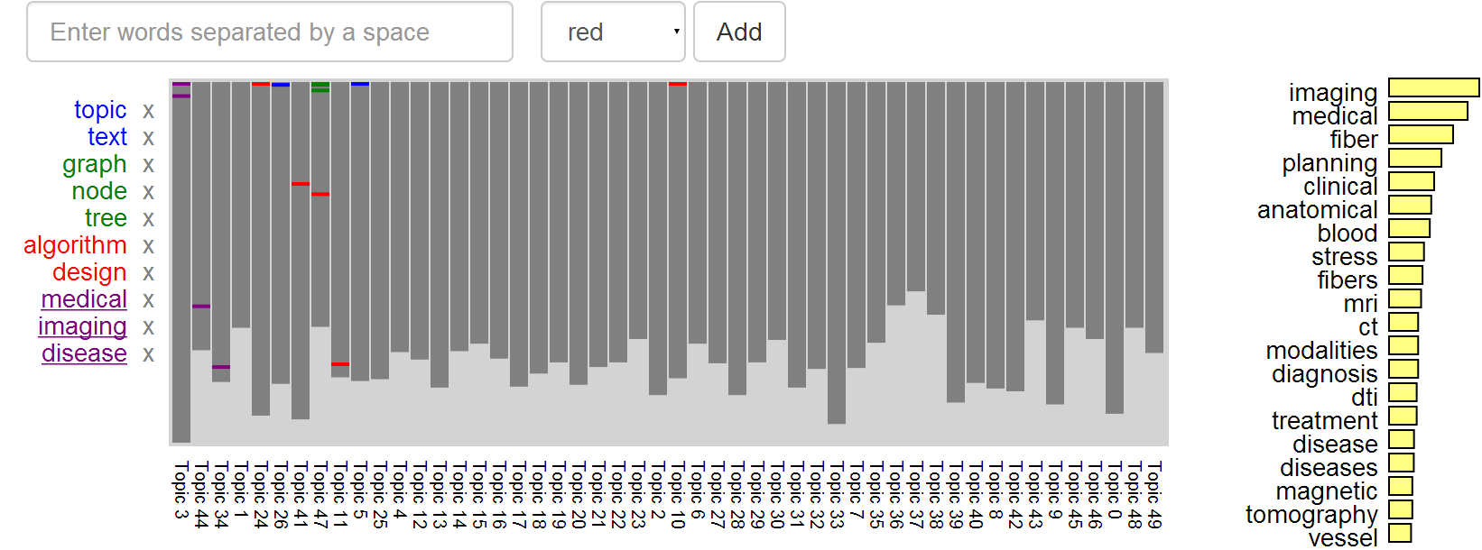

Figure 17. The “Rank Viewer” of “Serendip” shows users the word weight-ranked, distribution of the topic words that are present in each modeled text (Alexander and Kohlmann, “Serendip”).

Though here the views are not immediately juxtaposed and thus the relationships between the levels of the data hierarchy are a bit harder to connect, “Serendip” provides a large step forward in the direction of humanistic topic model assessment. One other key aspect of “Serendip” that you will also notice is the introduction of data from the state file into visual form via colored topic words. As I will show in the next section of this writing, the additions of a comprehensible hierarchy, and of visual relationships between the texts of a topic model and its topics, are all necessary aspects of such humanistic topic model assessment, as is the re-contextualization of its topic words.

**Visualization Description**

**Topic Words in Context ­– or “TWiC”**

The question how best to view a topic model is a partial and misleading one. As Chaney’s prototyping for a topic model visualization suggests, while one activity for examining a topic model is to derive distinct, quantitatively significant patterning of topics/topic words, getting to these patterns remains a question of *exploration*. As Pete Rorabaugh and Jesse Stommel et al. have pointed out, “play is critical inquiry” (Stommel). A topic model is, in all its parts, a set of probability distributions: lists of numbers that represent probability. So how might one explore and play in a set of number lists? One solution, as we have seen is to insert those numbers into a comparative, visual relationship like a network diagram. But there is one important piece missing, and that is the re-establishment of the object of study in visual relation to the model itself. That is to say, before one gets to presenting and analyzing statistically significant relationships in the model as those most representative of the topics/texts of the model, those relationships should be understood in context(s) of those texts. Though the output of a modeler like MALLET is a set of flat files, there is an inherent, spatial hierarchy in that data based on both the statistics of the model and the objects of study.

For these ends I have designed a workbench-like data visualization for topic models that I call “Topic Words in Context”[20] – hereafter abbreviated “TWiC”[21]. The front end of TWiC is a multi-window environment designed in “D3” (or “Data-Driven Documents”), a JavaScript graphics library designed to enable the development of data visualizations in web browsers. Its components utilize several JavaScript and Python libraries.[22] The primary idea of TWiC is to visualize (1) the topic word lists, (2) the placement of topic words in the contexts of the original writing, and to juxtapose such a view with mathematically established relationships between (3) texts of similar topic composition, (4) clusters of texts of similar topic composition and (5) the average topic composition of the entire model itself. In addition to these five panel views, TWiC also includes (6) a mouse-focus-contextual panel that displays metadata about these virtual “objects” in the model that the user of TWiC is currently examining.

**The Journey to Visualization**

TWiC started out with a small revelation. Glancing at the many options provided by MALLET, I came across this optional output called the “state file.” Again, inside of this file is the in-text location and topic with which each word of the modeled corpus is associated. Given all that I have discussed so far with regards to the data of topic modeling and the scholarly work that has been accomplished thus far with this text mining method, the topic state file sounds rather elementary and banal. But it was curious that it seemed not many if any major pieces of scholarship had utilized the contents of this file. So concerned by the patterns of big data that the topic model displays, it seemed as if it had been overlooked by many humanities researchers – a conception later affirmed anecdotally by Ben Schmidt, whose work on topic modeling and nineteenth century shipping logs were mentioned earlier. Though a view of this textual data might appear noisy at first, I wondered what it would look like and what conclusions could be drawn from being aware of topic words in their author-placed contexts, away from the generalist nature of the topic word lists. I began with the idea of giving each topic a unique color. I studied the contents of all of MALLET’s output files carefully, and via Python script produced a view of an Emily Dickinson poem that looked something like the image below. I chose one of my favorite poems, “Because I could not stop for Death” for this experiment (F23.1, Fr479A).[23]

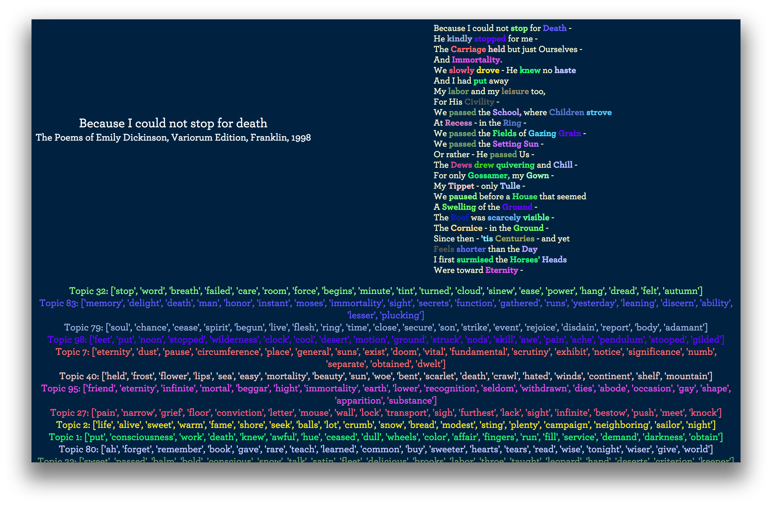

Figure 1. Topics words colored and placed into their poem contexts in Dickinson’s “Because I could not stop for Death” (F23.1, Fr479A). Color coordinated topics (word lists) for this text are set in descending order of topic weight below the poem.

What was obvious was that one could attempt a form of close reading from this perspective, and like a cheat sheet, the most “important” words of the poem were already highlighted for the close reading critic. You would only have to decide why they were important. And in the traditional fashion of topic model interpretation, you could glance at the topic word lists that I provided below the poem in descending order of their importance (or prevalence) in the poem as estimated by MALLET. There was some metadata missing that would be able to answer important questions for this in-text topic view. For instance, “How important are these topics to the poem?” And, as I would find out later, “How important are the topic words being used in the poem to the topic (a.k.a. topic word list) itself?” There are some visual strategies – which I will briefly employ in the following analysis section – to help answer this information. I could increase the size of the fonts proportionally to the hyperparameter estimates (which I have and will continue to refer to as topic distribution weights)[24] given for the topics. I could simply list those figures near the topics and topic words, or with something like a mouseover tooltip or popup window that would display upon clicking them. However, even with that information on display it was clear that since the topic modeler generates these topics with the entire inputted corpus in mind, what would be necessary would be to somehow provide a visual link between the topic words of the individual texts and the corpus-wide probabilistic weights that inform their placements in these “bags of words” – what MALLET considers a text to be composed. Again, if you prefer to think of this from the more human perspective of that formulation, you would flip the understanding of text creation: the texts generate the model and not vice-versa. But the heuristic of the topic model proceeds with the reverse, if counterintuitive, presumption.

I produced a few prototypical images of these visual relationships, and will insert them below to document the progression of the ideas present in what would be the current form of my topic modeling visualization. What you will see through this progression is that what became clear as to what was needed were three basic design elements: (1) iconic representations of the texts and topic model data since what was to be visualized would be large in scope, (2) visual representation of the relationships between those icons, and (3) multiple views or panes containing those visuals to depict the multiple scales at which the relationships were present.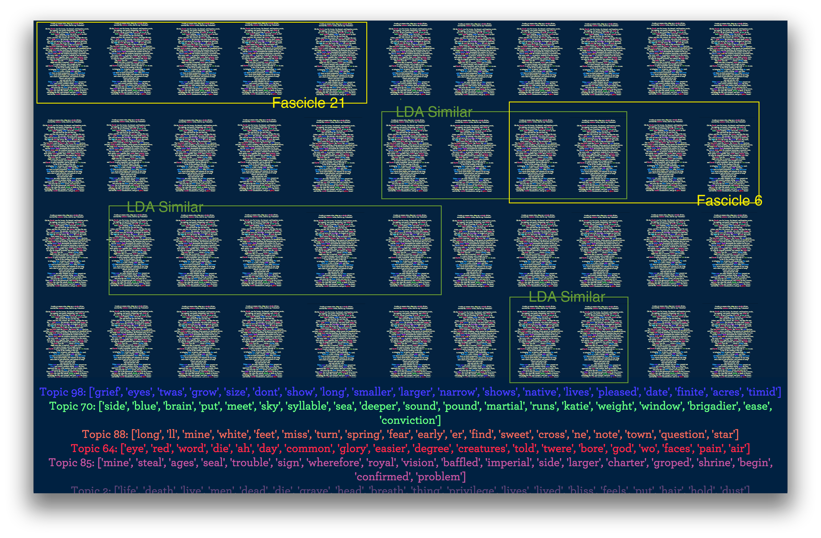

Figure 2. Shrunken versions of poems with topic words highlighted like Figure 1, but grouped with colored boxes highlighting their similarity in the topic model (“LDA similar”) and their grouping by Dickinson’s fascicle arrangement. The ranked topic list below is still in view as well.

I corresponded with David Mimno and shared these views with him, and he encouraged me to continue on this path. In order to do so, I would have to rethink and reshape some of the visual concepts in play above. The first of these would be the focus of Figure 2: how to represent large amounts of individual texts with their topics/topic words also on display. From the view above it’s clear that text scaling is not the answer, as individual words eventually become pixels if one were to zoom out enough. Also in conflict is the relative ease with which texts are grouped above, their fascicle and model groups are a bit too conveniently aligned for how they might actually be organized when the topic modeler gave its perspective.

**Data Shapes**

What follows in this section is a visual evolution of what would eventually become the final iconic representation for topic-modeled texts in TWiC: the “topic rectangle.” In fact, what would emerge from this work is the groundwork for the JSON (JavaScript Object Notation) files output by TWiC’s server-side Python script which interprets MALLET’s output files, as well as the internal data-object model in TWiC’s JavaScript code. Topic rectangles would serve as an example of how to program the graphical objects that TWiC users interact with in its panels – what are known in its JavaScript code as “data shapes.”

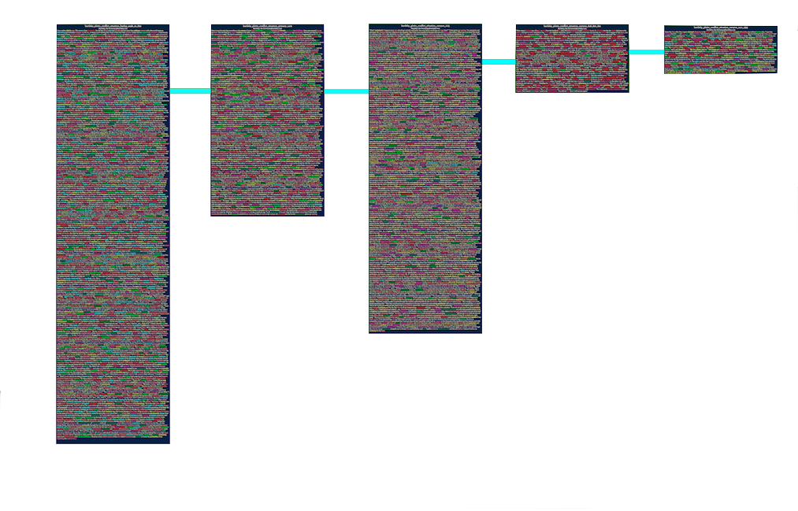

Figure 3. Full prose texts with their topic words highlighted, and linked together by a colored line. The slightly longer example text above is actually Herman Melville’s “Bartleby, the Scrivener”, divided into uneven parts. These were visualized in network form with the “Links” tool of “Voyant Tools” in the previous section.

The first thing to point out about a view like Figure 3 will seem redundant: you cannot visualize thousands of texts, let alone long texts on one computer screen, unless it is unusually large. However, sitting with this point of difficulty for awhile allowed me to also realize that we cannot view all of the relationships embedded in topic model data in one screen, let alone one layer of it: its modeled texts.

 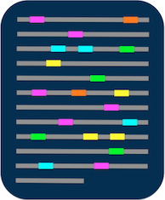

Figure 4. Prototype icons of individual texts: texts with/without topic words highlighted.

If that is the case, let’s start at the bottom and work our way up. The first thing that is needed is a miniaturized and informative iconic representation. Dickinson’s poems are small enough to actually fit entirely into an icon – and I went back and forth with the decision to represent the full poems in icon form. The icons in Figure 4 were the first version of a topic rectangle. Gone are the words and in their place a series of colored and non-colored lines, representing topic words and non-topic words respectively.

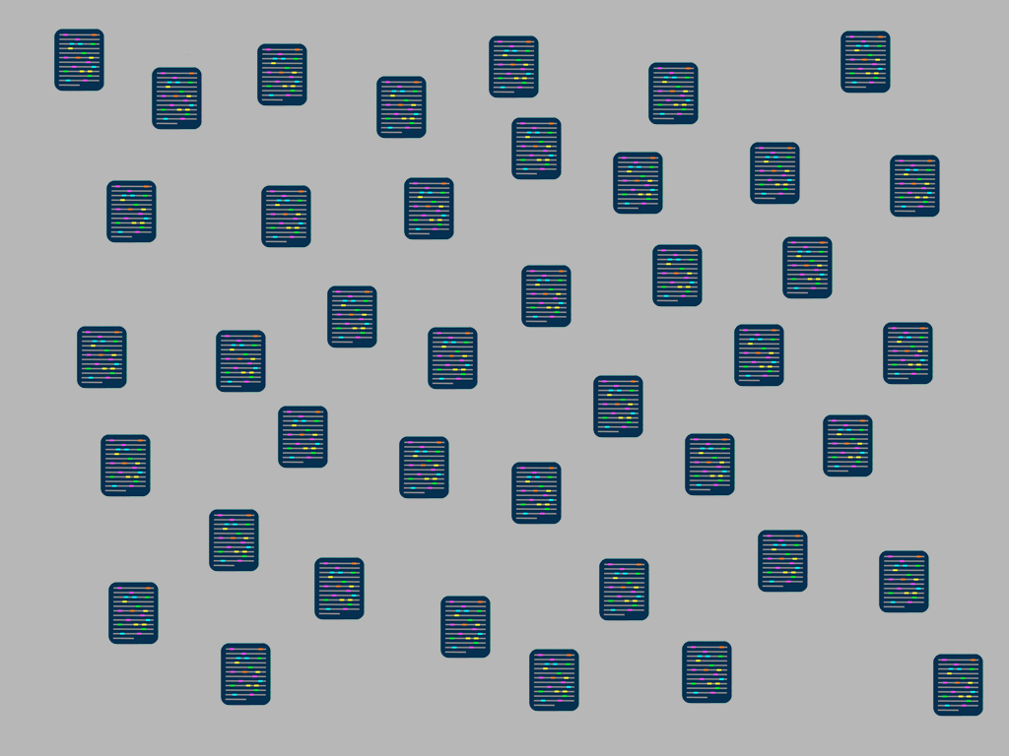

Figure 5. With the typical data set (text collection) of a topic model, it is likely that thousands of such icons would need to be displayed on screen at once.

Even using these icons reveal issues with displaying many of them at once. Above in Figure 5 are a few dozen text icons and their information is already beginning to become unidentifiable. What happens when we try to put hundreds or thousands of them on the screen at once?

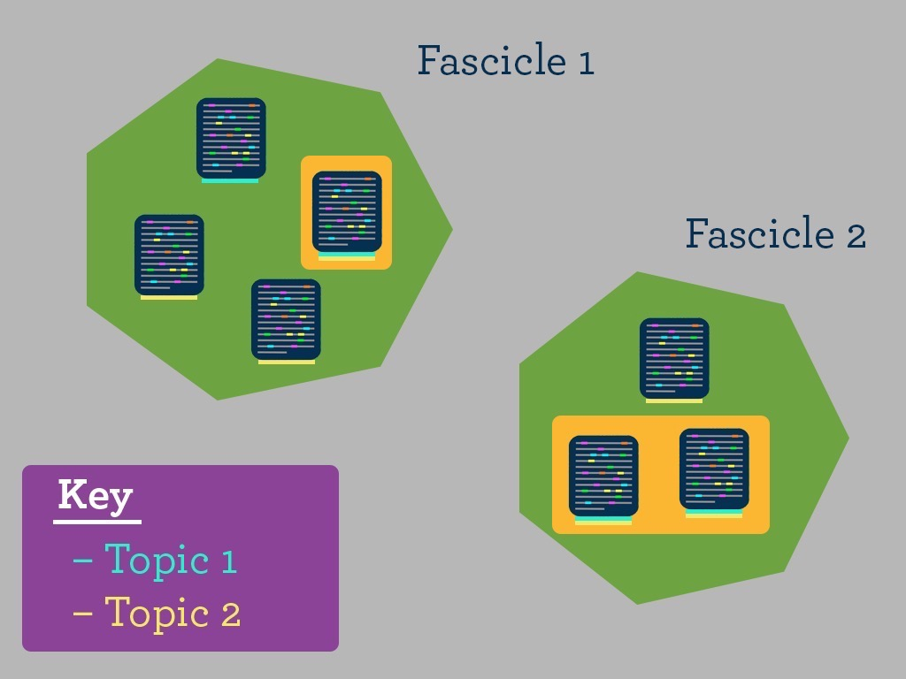

Figure 6. A first experiment of a highlighting scheme that shows multiple groupings in one place, including shared topics and fascicle (original publication arrangement) clustering. Fascicle clustering serves as the primary organizing element. Topic highlighting is secondary.

The first step to seeing how we can solve that problem is to group them. This is because if they are enveloped in some sort of cluster shape, we can zoom out and obscure the actual text icons, temporarily replacing the iconic representations with a single shape. But like I mentioned earlier, text clustering along multiple dimensions of connection is not always possible – *unless* you devise a scheme in which those dimensions are put into a hierarchy of importance. In Figures 6-8, you can see a clustering scheme that features the fascicle identities of hypothetical Dickinson poems. It then relates topic connections within those fascicles, and further (Figures 7-8) relates the inter-poem and inter-fascicle connections made by a hypothetical literary critic.

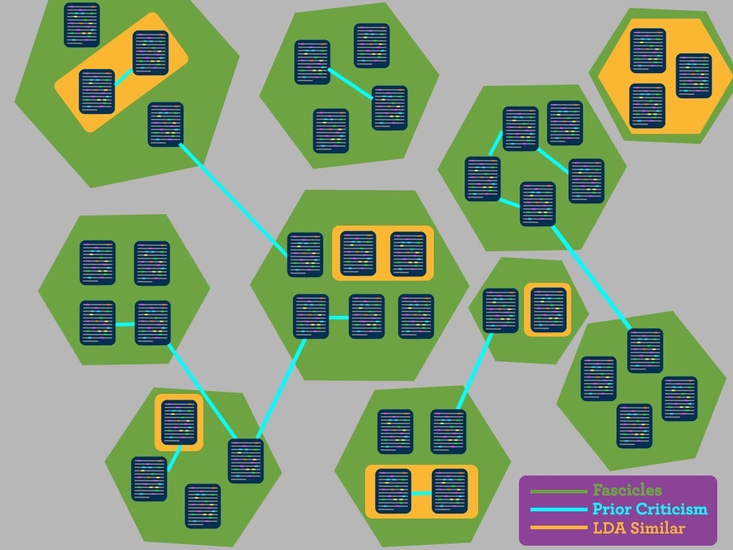

Figure 7. Adding a further link to the groupings, one that describes how prior criticism has linked the texts in the topic model and fascicles.

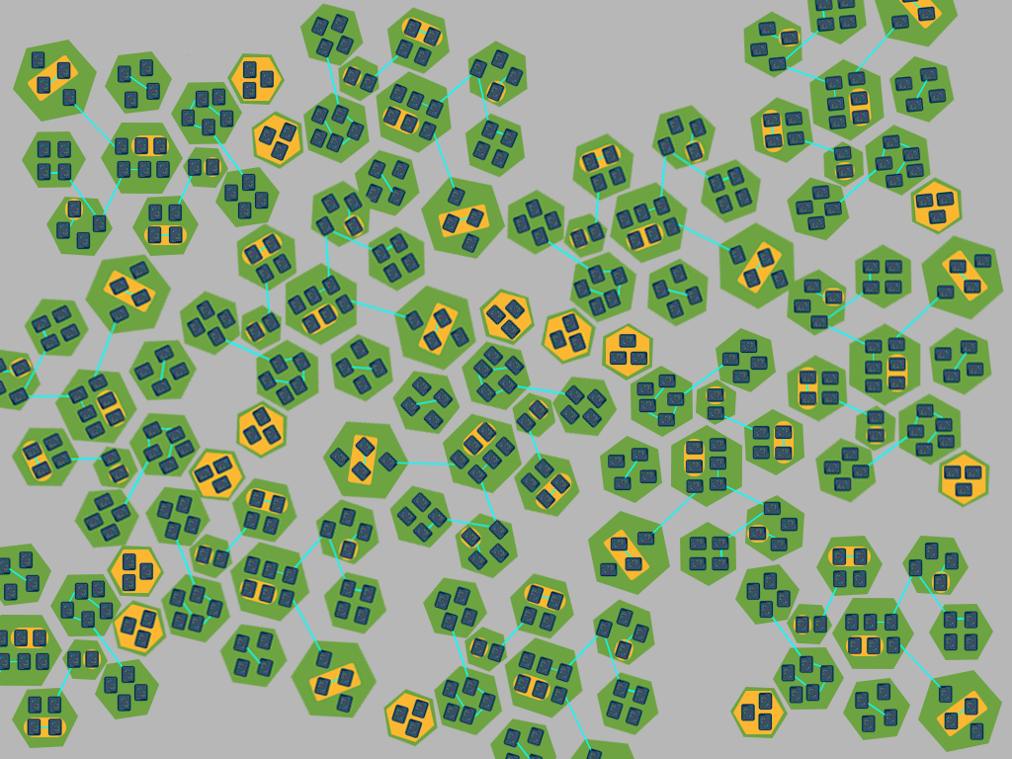

Figure 8. A view of hundreds of clusters of texts on one screen has the same visual limitations as viewing thousands of texts on one screen.

These sorts of views favoring fascicle groupings do and would work, but what if we wanted to consider all of Dickinson’s poems, bound and unbound, before making assertions about the topics within the fascicles. There are certainly many poems in the unbound sets as well as singular pieces, variants, and paper fragments, all of which may have informed the writing of fascicle poems as well as the construction of those booklets. I decided to construct a visualization less specialized (partially also to build something that could be used with other text collections), and one that favored the data relationships found in the outputs of the topic modeler.[25]

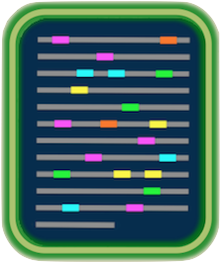

Figure 9. Instead of linking texts to their topics by groupings, rings around the text icon can display not only one prevalent topic, but also many topics.

The beginnings of the final text-icon or “topic rectangle” can be seen in Figure 9 above. Since TWiC would favor the topic model relationships, I moved to show not only a preview of the colored topic words in the text icon, but also the top n topics of each text in the form of rectangular rings surrounding the text icon. Once I had that idea in place, I constructed a D3 preview of what these might look like in the form of a network, each shape linking to one another by some hypothetical relation I had yet to fully realize. The view below in Figure 10 shows topic rectangles with the full poem text.[26]

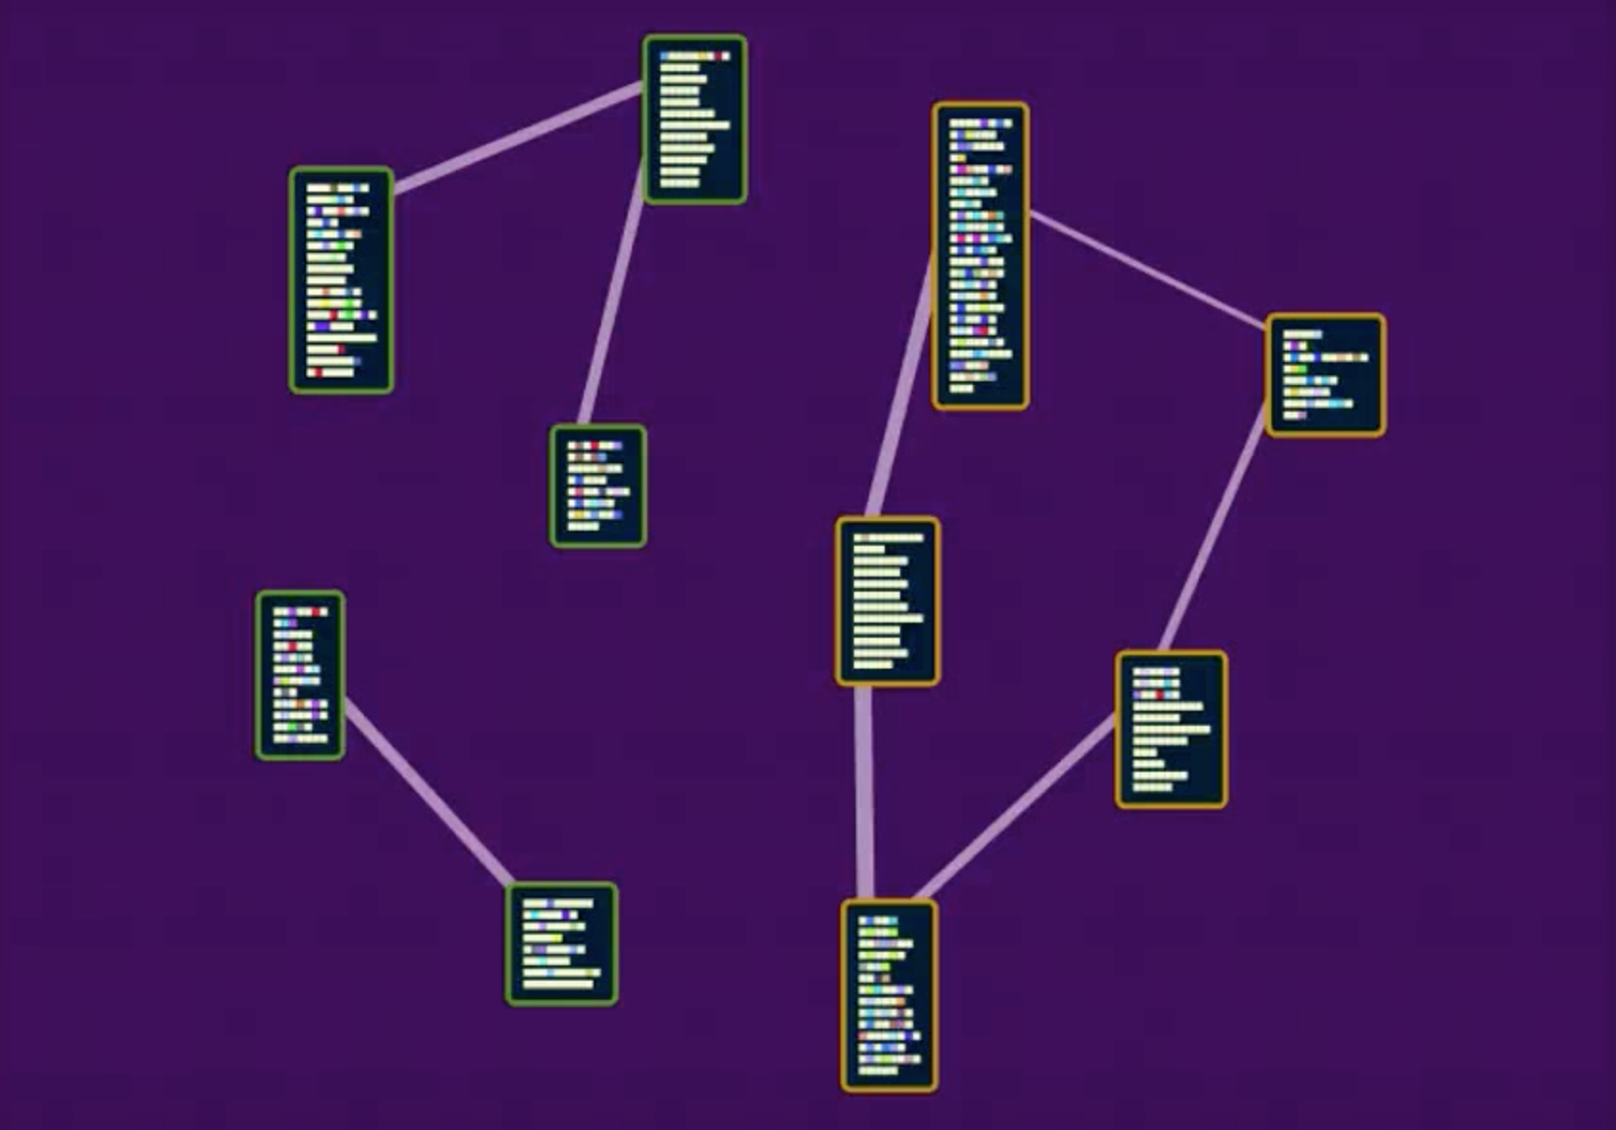

Figure 10. A live, prototype view of networks of TWiC topic rectangles implemented in D3.

It should also be noted that underlying these graphical objects is actual topic model data. In a lead up to this prototype I had made another that showed the associated text underlying the lines representing text in each topic rectangle, as seen in Figure 11 below. As the mouse moves over each line, the full text consisting of topic and non-topic words pops into view. This is possible because the D3 code library intentionally allows programmers to link graphical objects with the data they represent.

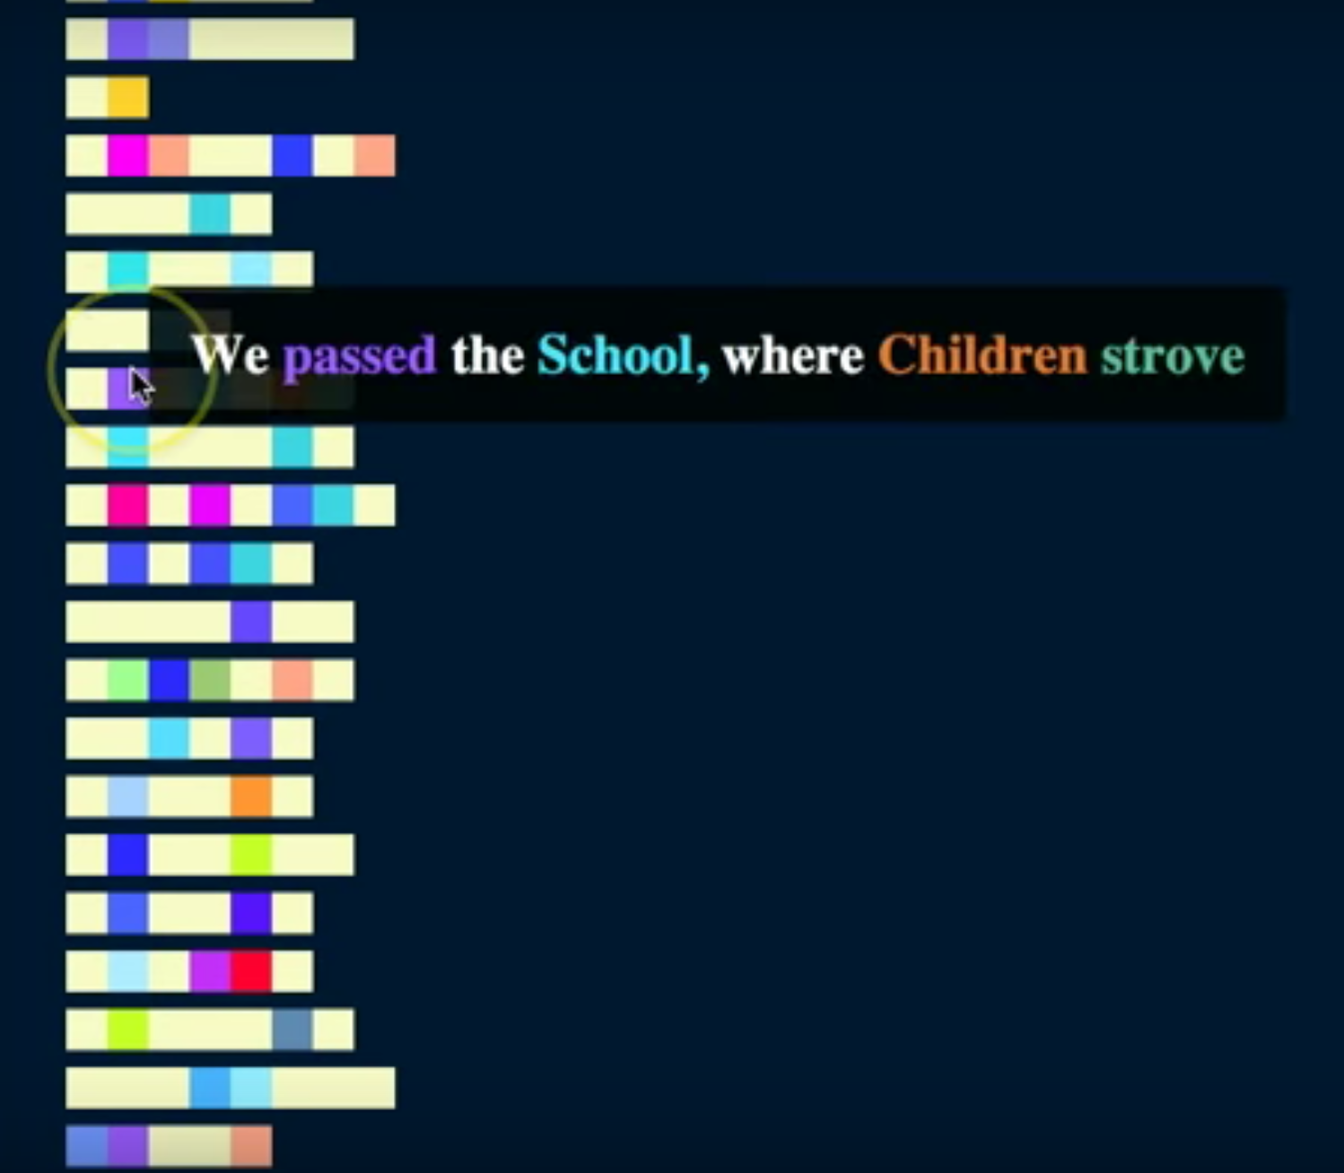

Figure 11. A D3 prototype of colored lines representing topic words/non-topic words of each line of the Dickinson poem, “Because I could not stop for Death” (F23.1, Fr479A). The video of this can be seen at <https://www.youtube.com/watch?v=h64JcZtelRU> (Armoza, “D3 and Topic Modeling – Topics from On High with Mouseover”).

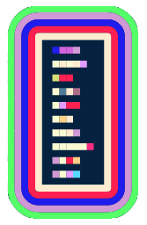

Figure 12. The final version of what a topic rectangle looks like in TWiC

The final version of a topic rectangle looks like Figure 12 above: a rectangle filled with colored and non-colored line segments representing the first ten lines of a poem. The rectangle is surrounded by five rectangular rings representing the top five topics of a text. The innermost ring represents the top (or most prevalent) topic for the text, and the outermost ring represents the fifth most prevalent topic for the text.

**Model Relationships**

So far we have already seen two early versions of TWiC’s final views, the “Text View” and the “Text Cluster View,” the final versions of which I’ll be discussing toward the end of this section. What is inescapable when showing the data-turned-graphical objects of TWiC though is that they should be able to relate to every level of a topic model’s data, from the big data that shows the average topic distribution of a corpus to the small data of topic word distributions inside the topics themselves. Once I had made that realization, coupled with the physical limits I encountered while trying to display all of this information in one single view, it became clear that *multiple* views would be needed, and specifically ones that could be made meaningful as standalone views and meaningful when viewed in juxtaposition to one another. This would mean that each view of a level of the data would have to display its own relationships and somehow connect them to the relationships displayed in other views of the topic model. I decided that the best way to allow for both of these needs was to use interactive highlighting. By choosing unique colors for each topic – something implicit in the views above – you can then choose a darker version of that color, and the result is an eye-catching relationship between two shades of alternating color. Attaching code in D3 to the mouse events of one of these graphical objects, you can trigger any desired behavior. In the case of a TWiC data shape, if the “resting” state of a shape (or part of that shape) is a darker shade of the color that represents a topic, mousing over it should “highlight” or restore the full color assigned to that topic.

Below is the first of TWiC’s data shapes that was treated to such a highlighting effect.

One of the most used outputs of a topic model is one that would also seem the least understood. The “topic keys” file displays each topic alongside its numeric topic distribution weight. With this simple list, it is thought that users of topic models can better understand the “topics” of their corpus. However, after some investigations of the “topics” file which contains the topic distributions for each of the texts in the modeled corpus, it turned out that the distribution weights in the “topic keys” file are merely averages of the distributions for each text. In other words, each figure given for topic X for each text is summed, divided by the number of texts and placed in the “topic keys” file. Since researchers are so interested in these values, as amalgamated as they are, I considered creating a data shape that reflected them. After some consideration of ideas like icons of containers holding proportional amounts of topics, I decided to use bullseyes. At first, I wanted the rings of such a bullseye to have a width proportional to their weight out of the N topics of the model, but I soon realized that if small enough these rings would be near invisible to the user. Below in Figure 13 is what such a topic bullseye looks like. The bullseye depicts ten topics, each of its colored rings representing a topic of the model, with the top most topic at its center. In its two use cases, topic bullseyes represent average topic distributions. In the first, it represents the average top ten topics of the entire corpus, and in the second, it represents the average top ten topics of a cluster of texts “underneath” of it.



Figure 13. Above is one of TWiC’s data shapes called a “topic bullseye.” Each uniquely colored ring represents a unique topic from the model. Moving inward from the outer ring of the bullseye, topics increase in their prevalence in the model and at the center is a colored circle that represents the top topic.

One of the most basic expectations of a topic modeling visualization is the ability to inspect its topics, not just colored shapes representing them. If the bullseye above presents a perspective on the topic distribution weights in the “topic keys” file, what is needed is a separate view to marry them with the topic word lists in that same file. Separating these two views into individual panels is where TWiC began to become a highly interactive, workbench-like visualization – users lay out their tools of inspection and put them to work. The question that follows this juxtaposition is, “How are they connected?”

The first view forms what is called the “Topic Bar” in TWiC. This panel features a scrollable list of every topic word list of the topic model, ordered by the unique ID assigned to each list by MALLET, from topic 0 to topic N. Each topic is assigned a unique color. This is accomplished via a random color generator algorithm that also looks to keep the colors as distinct as possible.[27] The result is a panel that looks like this:

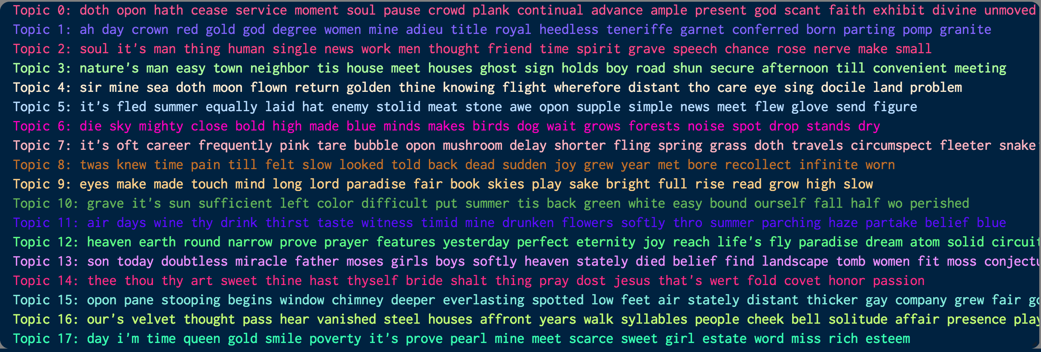

Figure 14. TWiC’s “Topic Bar” panel

Each word list contains the number of top words that the user asks MALLET to display as the top topic words. In this case, the default of twenty words is used. Highlighting via mouseover could have been used in this view, but in this case it is interruptive of browsing through the topic list by mouse scrolling. Users can instead click on each topic to “highlight” it, which really just inverts the text foreground and background colors, creating a solid bar of color across the panel. The “Topic Bar’s” creation provided impetus to include many types of mouse interactions in TWiC. Instead of just thinking of highlighting as occurring via mouseover, in some instances of interaction with these objects it may make more sense to click or double-click.

The topic bullseye would end up using all three types of mouse interactions. In TWiC it is initially seen in one of the first panels on screen, the “Corpus View.” This view shows one large topic bullseye that represents this average of all the topic distributions assigned to each text of the modeled corpus. If the bullseye is in an “active” state (or ready for interaction), users can mouseover each ring invoking the highlight animation that fades the other rings into the background while the ring underneath the mouse pointer is brought forward.[28] This mouse action is what enables the linking of levels of topic model data relationships in TWiC. Once a TWiC data shape is highlighted in one panel, any other data shapes in the current panel and other panels that share that topic are also highlighted. Clicking a ring brings the bullseye into a “paused” state, and the user is free to move the mouse around while the ring remains highlighted, as are the other linked data shapes throughout the visualization. Clicking outside of any shape in the blank spaces of panels will un-pause the panels and cease the highlighting. Below are views of the “Corpus View” atop the “Topic Bar” in its various states of highlighting.

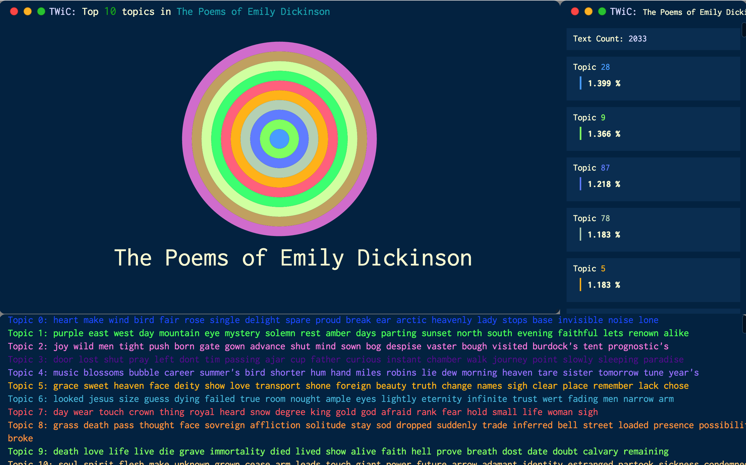

Figure 15. TWiC’s “Corpus View” features a topic bullseye representing the top ten topics of the modeled corpus. Also below it is TWIC’s “Topic Bar” which features all of the topic model’s topics, each given a unique color.

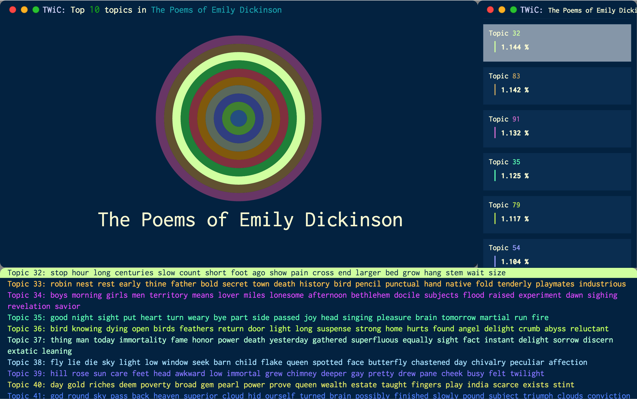

Figure 16. A version of the views seen in Figure 15, but in this instance a ring has been highlighted via mouseover of the topic bullseye in the “Corpus View” panel, and the “Topic Bar” reacts by highlighting the topic word list linked to that ring.

There are two new elements in the above screens that bear explanation. The first is the introduction of well-defined panel elements. After some development of the ideas behind TWiC’s data views, it became necessary to differentiate the panels and further develop their general functionality. Each TWiC panel, with the exception of the “Topic Bar”, features a title bar at its top that describes what is being displayed within it. Panels are also resizable in the way that most panels (or windows) are in the graphical operating systems of modern computers. Arrows appear at every edge and corner of a TWiC panel that allow the user to resize them. The contents of panels containing non-textual data shapes are scaled accordingly when panels are resized. At the top left of TWiC’s panels are Apple operating system-like “stoplight” controls that hide (and un-hide) the panel by shrinking it down to a small bar (clicking the red circle), “minimize” the panel to the smallest size allowable while still displaying its graphical objects/data shapes (clicking the yellow circle), or “maximize” it to fit the whole screen (clicking the green circle).



Figure 17. A hidden TWIC panel – note the ‘^’ in the red stoplight circle, indicating a click will restore the panel to its most recent size. Its default state before being put into this hidden form would display a ‘v’.

**The Meta-metadata of TWiC**

The other major new element in Figures 15-16 is the other metadata-like panel of TWiC: the “Data Bar.” This panel is unlike any other in TWiC. It shows metadata of the topic model (which is itself metadata), but it also uses the interface thematic of context. With the exception of clicking on a topic in the “Topic Bar”, any time a user clicks/double-clicks a data shape in TWiC (topic bullseye, topic rectangle, or, as we will see, topic word) the “Data Bar” displays information about the data behind that object. In the case of clicking on the topic bullseye of the “Corpus View”, TWiC’s “Data Bar” displays the number of texts in the entire collection, and the entire topic distribution listed in descending order. Items listed in the “Data Bar” such as topics and topic words will also respond to mouseover (highlighting and clicks pause/unpause highlighting like in the other panels). In Figure 16 for instance, the “Data Bar” shows that Topic 32, the 8th ring in the topic bullseye represents an average 1.144% of the Dickinson corpus.

Seeing such average distributions from this perspective brings further weight to an argument in favor of critical examinations of text-level topic data. The corpus-level, average topic distribution in particular seems to spread out the topic distribution to an almost even state for many topics. In the model shown above and used for this writing for instance, the top topic 28 represents on average 1.399% of the topic words of the corpus. The least prevalent topic 34 represents on average 0.857% of the topics words of the corpus. Therefore the usefulness for these average topic distributions seems more to point the user of the topic model in the direction of topics to look at, rather than being able to give off significant conclusions about the topic composition of a corpus.

Double-clicking on the topic bullseye in the “Corpus View” reveals the next TWiC view. TWiC’s JavaScript code provides a series of entry navigation animations triggered by these double clicks that visually extend a metaphor of “diving down” into the data of the topic model. On the first double-click of this bullseye, TWiC’s “Corpus View,” “Topic Bar,” and “Data Bar” are resized and repositioned automatically to make space for a new panel in the top right: the “Corpus Cluster View.” These resizing/repositioning animations continue until the user reaches the level of the texts, at which point all of TWiC’s panels are open. From that point forward, double clicks of a data shape in a panel merely reveal the data shapes “underneath” it, which are then displayed in the corresponding TWiC panel “underneath” that one. The “Corpus Cluster View” was also one of the first views conceived for TWiC, particularly as it mimics the network-like visuals of so many text analysis data visualizations. The relationship for this network however was also a point of critical inquiry. To reiterate, TWiC’s exploratory thematic intends to allow users to connect the “big data” of a data model like a topic model with the objects being modeled. Thus, if that corpus were to be split apart, it would have to be split in ways that were either meaningful to the topic model or somehow meaningful to the corpus.

Since the decision was made to favor the topic model (at least initially), TWiC’s “Corpus Cluster View” splits apart the texts of its corpus by their top topic and calculates how “far” the average topic distribution of those texts are from the corpus’s average topic distribution (as featured in the “Corpus View”). Such a Euclidean distance is a relatively simple calculation that can be made via something called the “Jensen-Shannon divergence” equation. Taking the square root of the divergence yields a one-dimensional “distance” – a single number. This is problematic for a two dimensional visualization, yet never the less provides a potentially useful visual figure for assessing where topics sit in the “topic space” of the corpus. The remaining dimension (labeled ‘y’ in the typical [x,y] Cartesian pairing) is left for graphical object collision detection code in D3 to determine. Each cluster in this view also uses a topic bullseye since it is representing similar information (an averaged set of topic distributions). A number below each bullseye, colored with the topic’s chosen color, indicates which topic the bullseye represents.[29] This results in the view below:

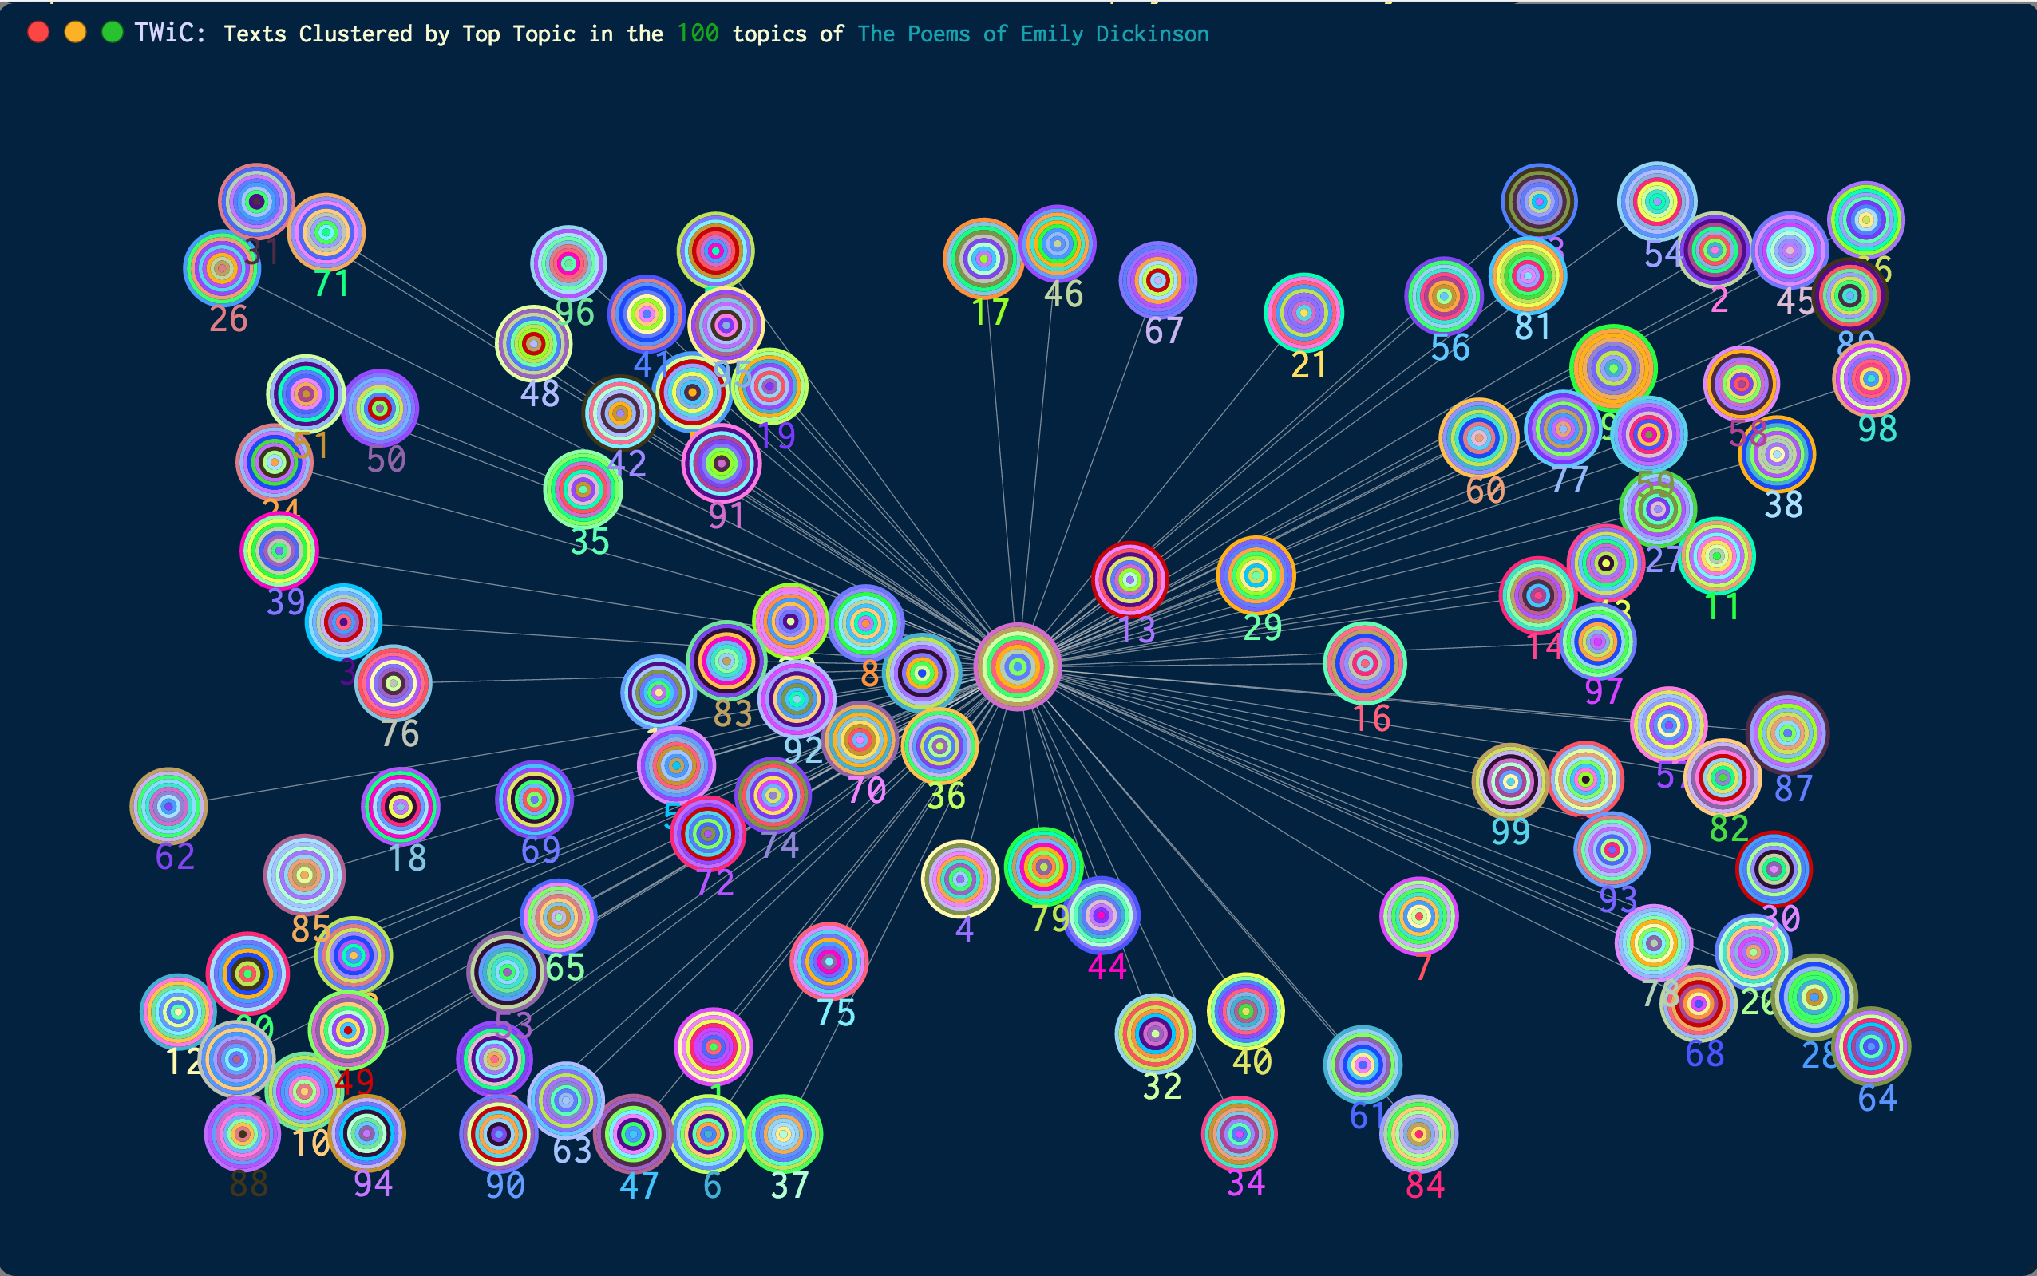

Figure 18. TWiC’s “Corpus Cluster View” displays topic bullseyes representing the texts of the topic model, clustered by their top topic, and set at a Jensen-Shannon distance from the corpus average topic bullseye (the same from the “Corpus View”) at its center.

As you can see, the coloring of the bullseyes all vary quite noticeably from the corpus average topic bullseye at the center of this view. And this visual distinction is in part the point of TWiC as an exploratory tool. The whole topic composition of a corpus is not easily described from the initial MALLET outputs, let alone the semantic (or otherwise stylistic) semblance of each derived topic word list. When highlighting via mouseover/click occurs in this view however, the lines connecting each cluster bullseye to the central bullseye are also highlighted, as are the lines and bullseyes of other clusters who share that top topic (ring) being highlighted. If the central bullseye shares that topic, it too is highlighted. This is the first instance of how mouseover interactions help TWiC to highlight topic-text relationships in the corpus. But that is not the end of the visual narrative of relationships. Since multiple TWiC panels can be sized to fit on the same screen and mouseover interactions trigger highlighting in the other panels, we can begin to see the relationships between multiple scales of the topic model data – in this case the relationships between the corpus-level average topic distribution and the cluster-level average topic distributions. Further, as with the “Corpus View,” once a text cluster bullseye is clicked, the “Data Bar” displays the calculated “distance” to the central bullseye, the number of texts in the cluster, and the average topic distribution of its texts in descending order. This is seen in the image below, where topic 9 is being highlighted across all four visible panels.

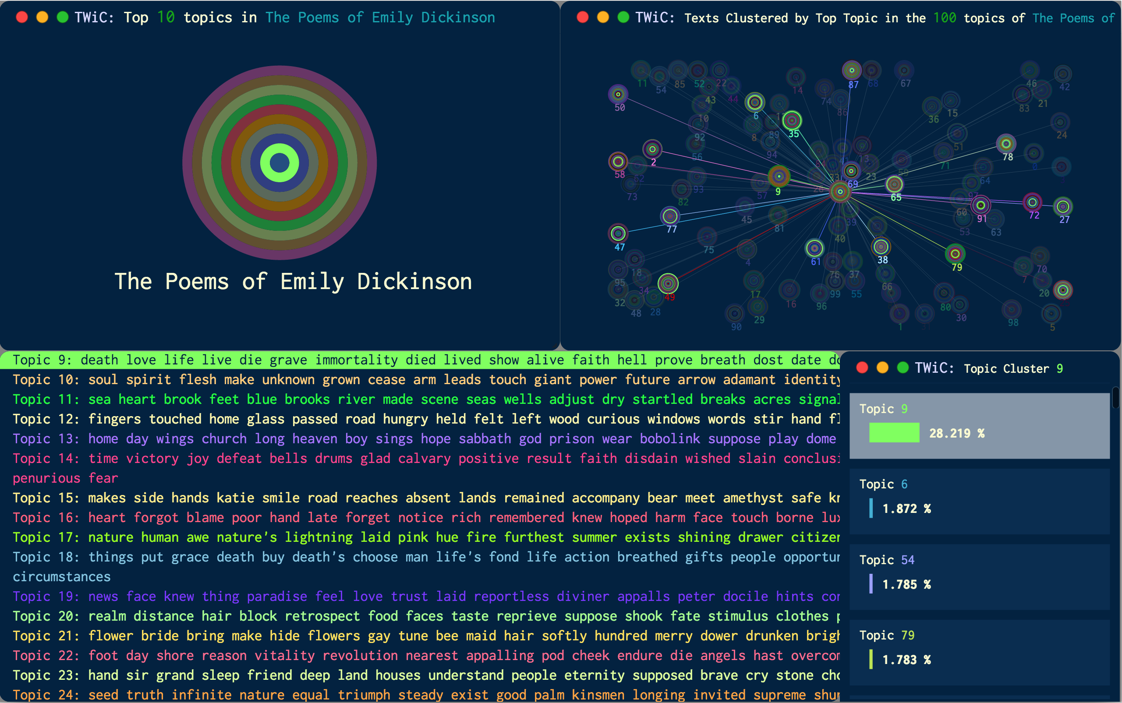

Figure 19. With four of TWiC’s initial panels visible, relationships between multiple scales of data in the topic model emerge.

Also of note, beyond the relationships between multiple scales of data that these views in juxtaposition provide, is the higher percentage of topic 9 of the cluster metadata shown in the “Data Bar.” This points toward a more meaningful area of investigation for the researcher interested in that topic: texts where that topic is highly prevalent. When the central bullseye is clicked on, it again displays the metadata of the corpus-level bullseye.

**The Contexts of Topic Words**

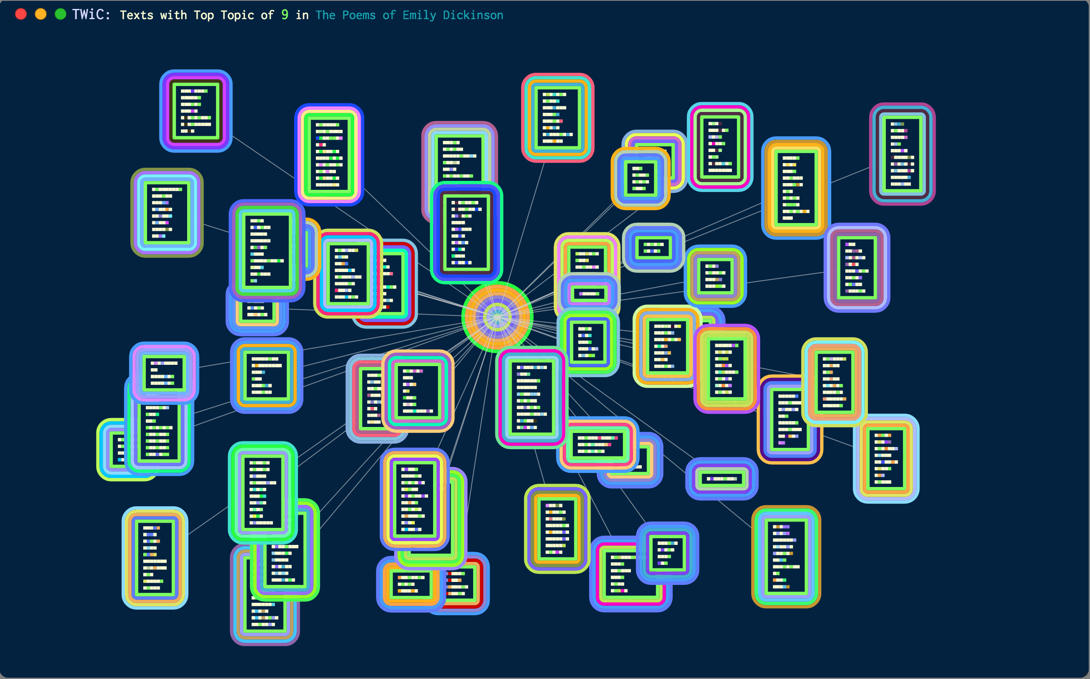

Figure 20. TWiC’s “Text Cluster View” displays topic rectangles representing texts that each shares a top topic. In this case, these are Emily Dickinson poems that share the top topic 9.

The title “TWiC” alludes to the idea that the topic words of a topic model have a natural context, a context perhaps more natural than the quintessential topic word lists. Before the topic model is introduced though, the quintessential contexts of the words being modeled are, of course, the actual texts we are interested in examining. These are the contexts the topic rectangle inhabits and to which they give us access. They act as a visual entryway in the epistemological/semantic barrier separating probabilistic numeric data and our texts – in this case, Emily Dickinson’s poems. Below the “Corpus Cluster View,” topic rectangles in TWiC are put into network form at a distance from the text-cluster bullseye in another panel called the “Text Cluster View.” In order to get to this view, the user double-clicks the text-cluster bullseye of interest in the “Corpus View” and TWiC’s navigational dive-animation proceeds one level down.

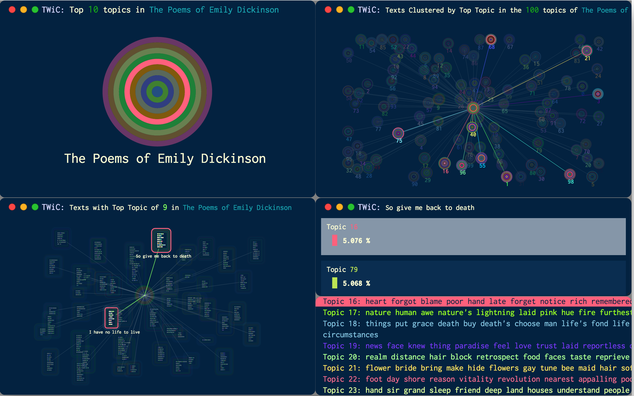

Figure 21. With five of TWiC’s panels visible, relationships between topics, corpus topic distributions, and the text topic distributions are first made. Here topic 16 is seen throughout.

This view functions similarly to the “Corpus Cluster View” in its mouse interactions, but instead of data relationships between clusters of texts and the overall corpus, we are given relationships between the text-level topic distributions and the overall text cluster. Remember, each text in such a cluster shares a top topic, however texts could certainly be organized by other shared topic model attributes or calculations should one want to re-implement this part of the visualization. For instance, instead of “top” topics, we could choose to be interested in similar topic distributions, another potentially useful metric for determining the similarity of texts. Mousing over each of the rings of the topic rectangle reveals topic connections between texts just like the “Corpus Cluster View” does for text-cluster bullseyes. And just as it is the case for topic bullseyes, any topic rectangle that is moused over is brought to the foreground, just in case there are any occluding data shapes. When a topic rectangle is clicked on, the “Data Bar” displays the Jensen-Shannon distance to the central, text-cluster bullseye as well as the topic distribution of the text in descending order. Like the previous view, clicking on the central bullseye reveals the metadata of the data shape “above” this view: the text-cluster bullseye as seen in the “Corpus Cluster View.”

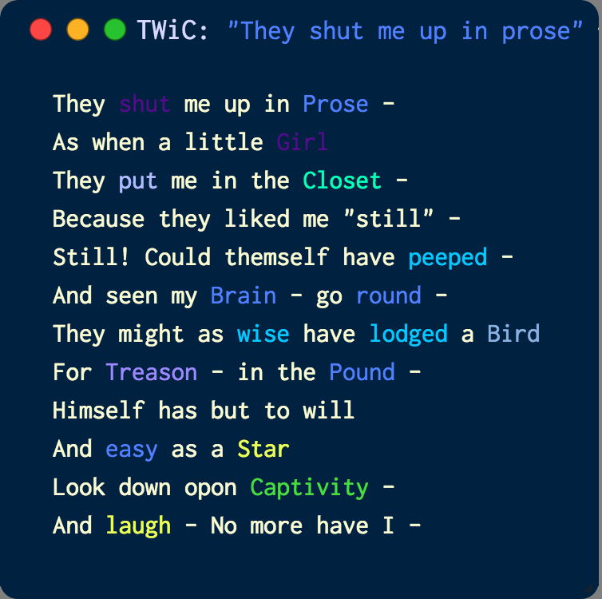

Figure 22. Dickinson’s poem “They shut me up in Prose” (F21.6, Fr445A) in TWiC’s “Text View” panel. (The dark purple words that are difficult to see against the dark blue background are “shut” and “girl”, respectively, both from topic 3.)

Once we are at this point, where topics and multi-scale topic distributions have been visually introduced, all that is missing is the data from that very first TWiC prototype: the re-situating of topic words into the digital versions of their authorial contexts. This is TWiC’s final, topic model view: the “Text View.” Double-clicking a topic rectangle navigates TWiC down to its lowest level, where highlightable topic words can now be seen and read amongst each other. This is an old-fashioned reading context for the texts of the corpus, but in another sense it is an entirely new one. The colored topic words can be thought of as relatively little-seen view of a topic model – if but because it is counter to prevailing ideas about measuring and interpreting big data. Mousing over topic words highlights all words from that topic in the current text as well as all visible data shapes of the other panels that feature that topic. The other topic words from other topics in the text then become un-highlighted. Stop words[30] not featured in the model are all the same color. In this version of TWiC, they are CSS (Cascading Style Sheet) color “lightgoldenrodyellow”. You may notice that the screen has slowly been running out of space. Recall though that all of these panels can be resized, maximized, minimized, and hidden.

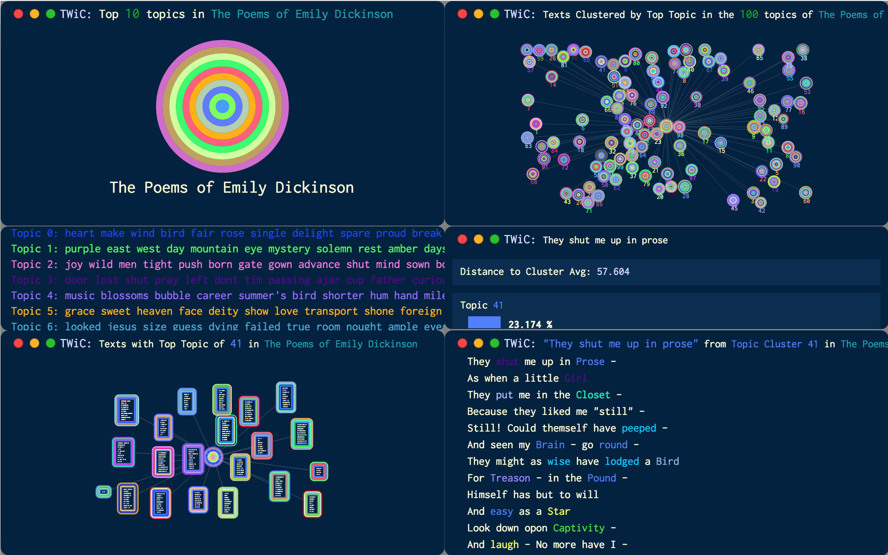

Figure 22. All of TWiC’s topic model-focused panels are open in this view, visually connecting the topic distributions of texts with that of text clusters, corpus clusters, and the topic distribution of the entire corpus.

Topic words are the last data shape in TWiC. Clicking on them in the “Text View” freezes the highlighting as it does in other panels, but it also takes the user one step further into topic model data. Once a topic word is clicked, all of the top-weighted words of the topic[31] are listed in the “Data Bar” in descending order of their in-topic weight found in MALLET’s “topic word weights” file. Topic word weights are in fact one of the key access points for understanding the topic words of a topic model. They register not only that these words are of some importance to a topic, but also *exactly how important* they are to that topic. To use a more familiar spatial metaphor in place of the “topic space” being conveyed in this visualization, without topic word weights to convey a word’s importance to a topic it would be like trying to understand the size of the United States, finding out that Rhode Island and Texas are two of its fifty states, and then walking away with that data without any further qualification of it. Above is a view of Dickinson’s sixth poem from Fascicle 21, “They shut me up in Prose” (F21.6, Fr445A), visible alongside the rest of TWiC’s panels. Below are the topic word weights of its top topic 41.

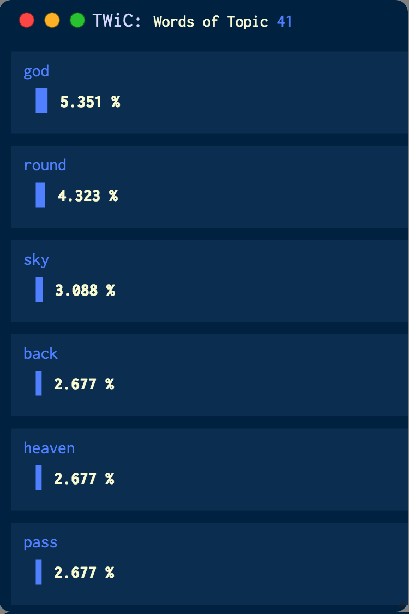

Figure 23. The most weighted words of top topic 41 of Dickinson’s “They shut me up in Prose” (F21.6, Fr445A) from Fascicle 21. “god”, “round”, “sky”, “back”, “heaven”, and “pass” are highly featured in this topic. Scrolling downward in the panel reveals the less weighted topic words of topic 41.

**The Big and Small Data Relationships in a Topic Model**

With that spatial metaphor of Rhode Island and Texas in mind, it would do to review the data shapes and levels of a topic model’s hierarchy. Thus far, I have showed the connections and patterns amongst the levels of a topic model’s data, but have also omitted the texture of the data relationships exposed by TWiC. Understanding these relationships provides a basis from which we can return to the original literary-historical question at hand: determining the hidden semantic patterns that wind their way through Emily Dickinson’s fascicle books. To begin, let’s return to TWiC’s top level and take a closer look at the corpus-level topic distribution of Emily Dickinson’s poetry as represented by the topic bullseye in the “Corpus View” panel. These topic weights are displayed in the “Data Bar,” but taking a cross section-like perspective, that bullseye looks like this:

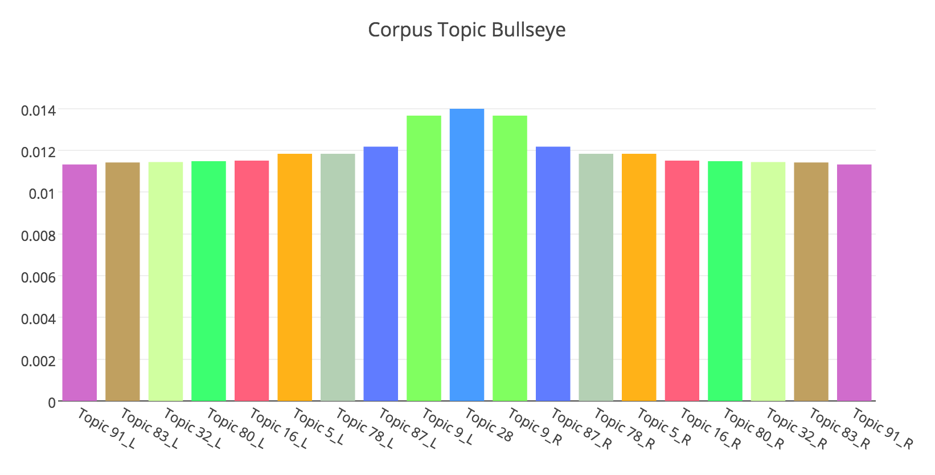

Figure 24. Cross section view of the corpus-level topic bullseye of Emily Dickinson’s poetry in TWiC. “_L” and “_R” indicate the “left” and “right” portions of the same crosscut topic ring.

Just as in the previous view of this data shape in TWiC, the top topic of the corpus is topic 28, and the rest of the top ten topics extend outward in a gradual downward slope, hovering at around 1.0 - 1.2% topic weight. Viewed in a more traditional histogram visual for comparison and more comprehensive assessment, the full topic distribution of this corpus looks like the following:

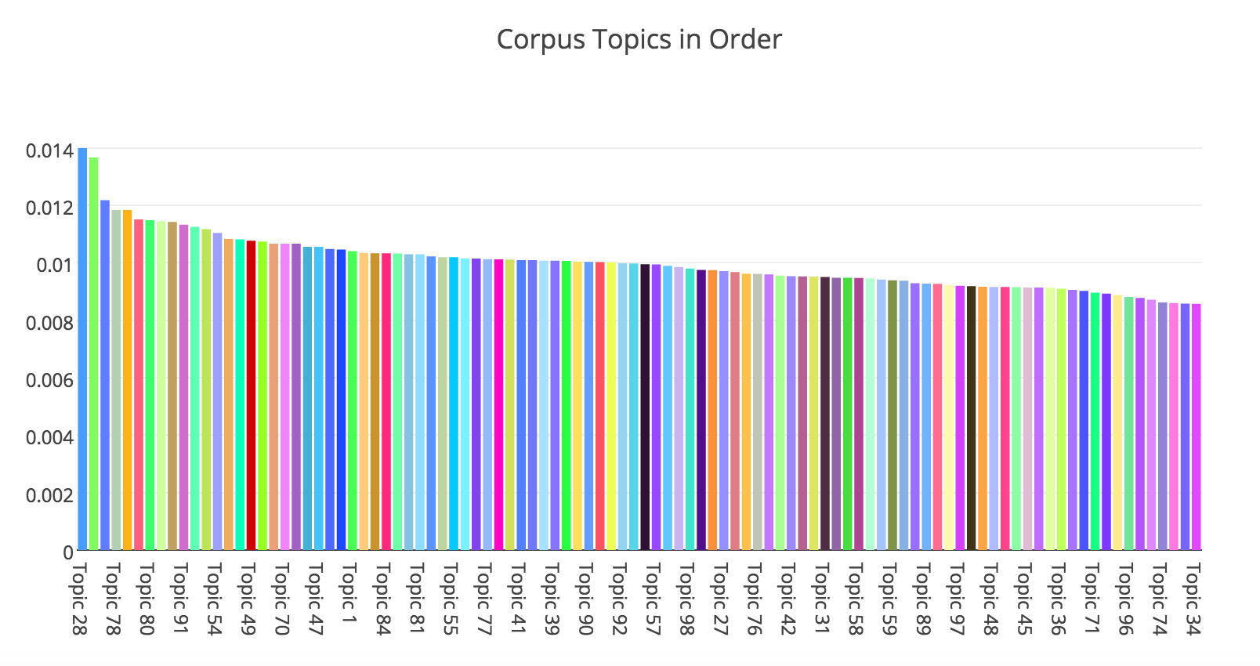

Figure 25. The full 100-topic distribution for this corpus of Emily Dickinson’s poems. Note the group of five prominent topics, as well as the steady and gradual diminishment of topic weight as the histogram moves through the bottom 95 topics. The range of topic weights is [0,1], though the highest average topic weight 0.014 or 1.4%. Every third topic label is shown for space. The shape of the topic distribution is the more relevant visual cue here.

Looking at the text cluster bullseyes reveal how the topic model’s data is being filtered, and how those clusters are related to the overall corpus-topic weights. Let’s look at the cluster for the top topic of “They shut me up in Prose” (F21.6, Fr445A), topic 41. Taking the cross section-like view, we see that the topic distribution (the average of the topic distributions of all texts with their top topic as topic 41) is notably different than the corpus-level topic distribution, as is its ordered histogram.

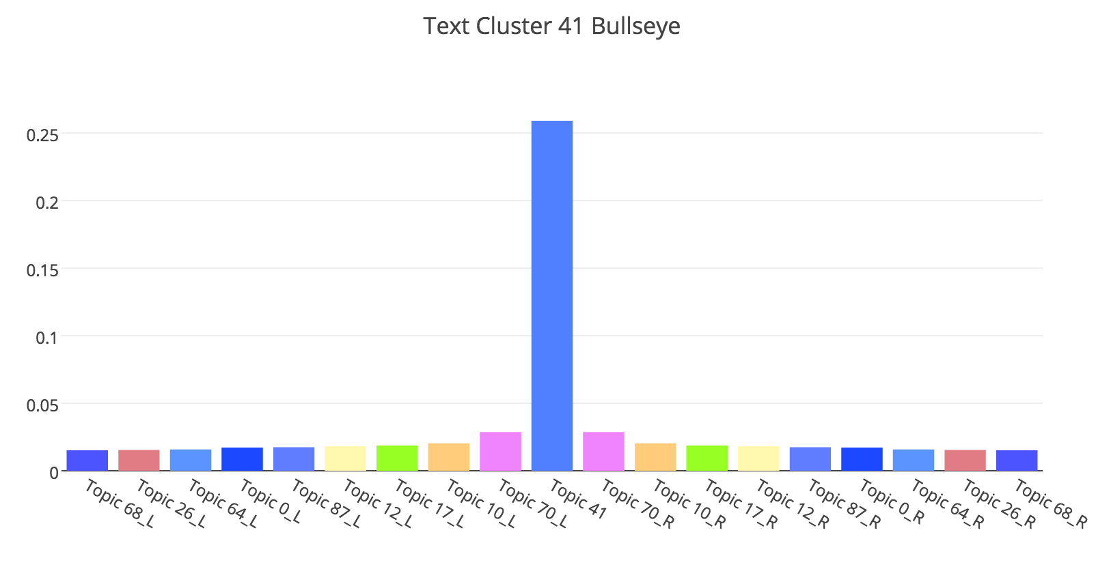

Figure 26. Cross section view of the text cluster 41 topic bullseye of Emily Dickinson’s poetry in TWiC. “_L” and “_R” indicate the “left” and “right” portions of the same crosscut topic ring.

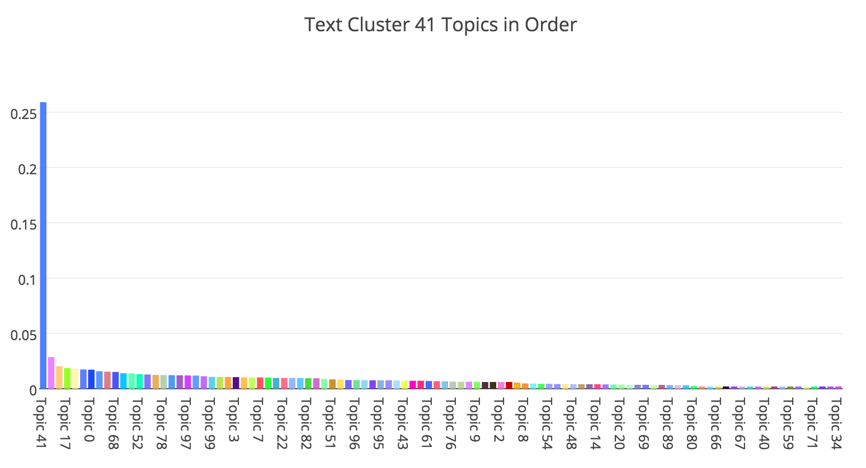

Figure 27. The full 100-topic distribution for the cluster of Emily Dickinson’s poems highly featuring topic 41. Note the expected falloff from topic 41 to its averaged topic siblings. The range of topic weights is [0,1], though the highest average topic weight 0.25 or 25%.

These views are also no surprise, as I have intentionally grouped texts by their top topic. The differing percentage of that top topic in each text of the cluster would be of interest for inquiries looking at just how much topic 41 is featured in that text and why. However, what this shows in contrast is just what other topics co-occur in topic 41-dominant texts. Despite the dramatic-seeming falloff, these topics make up on average, around 75% of these texts’ topic distributions. To think of the connection between this cluster-level view and the corpus-level one, consider that what I have done is taken every text that highly features topic 41 and pulled it out of that corpus distribution. This filtering action is the drilling down and splitting apart of the corpus visualized in bar plot form. The other co-occurring topics in this text cluster distribution appear to merely reveal how their low weights diminishes their corpus-level averages, but it is actually in this low-weighted or “tail” data where the topic model inscribes its meanings most precisely – in the texts themselves. Diving down one more level, we find how dividing up the topic model’s cluster-level data reveals its richly descriptive roots. Taking the previous example of a crosscut bullseye (or topic rectangle rings), let’s take a look at the topics of text 627, “They shut me up in Prose” (F21.6, Fr445A).

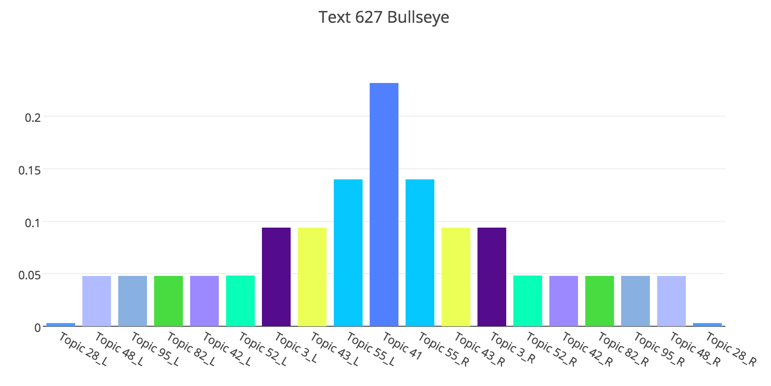

Figure 28. The crosscut topic bullseye for “They shut me up in Prose” or “Text 627” (F21.6, Fr445A). Topics 41, 55, 43, and 3 dominate, while topics 52, 42, 82, 95, and 48 round out a lower, but still prevalent tier of topics. “_L” and “_R” indicate the “left” and “right” portions of the same crosscut topic ring.

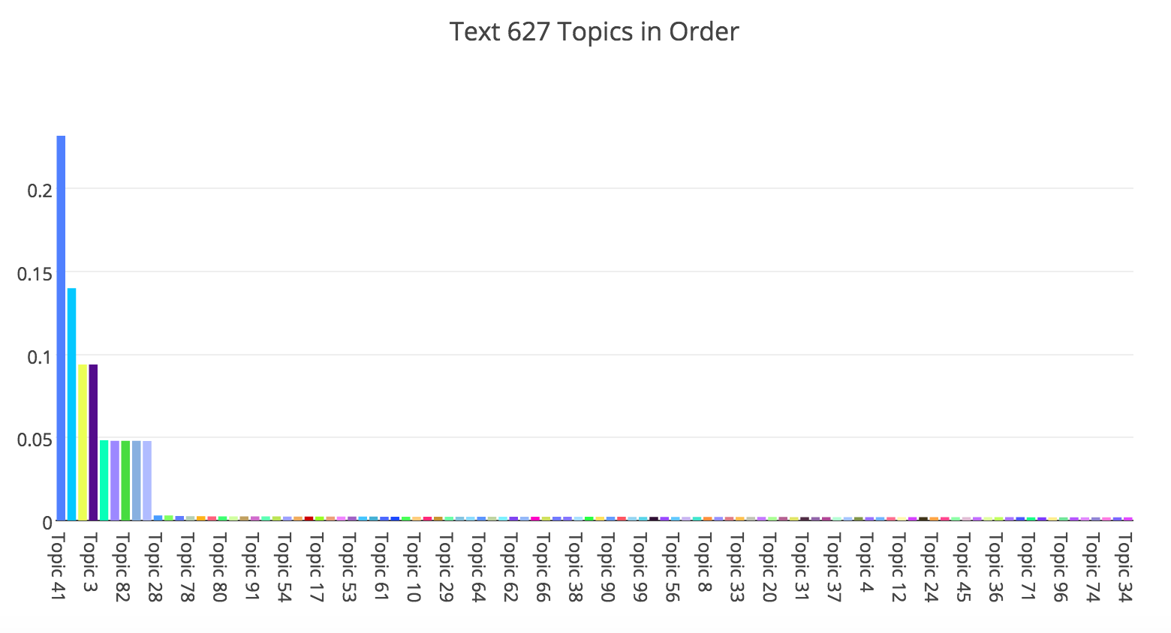

Figure 29. A full 100-topic distribution of Emily Dickinson’s “They shut me up in Prose” (F21.6, Fr445A). The range of topic weights is [0,1], though the highest average topic weight 0.25 or 25%.

The top ten topics of this poem compose a fairly, discretely defined hierarchy of topics – with first tier topic 41 at 23%, second tier topic 55 at 14%, third tier topics 43 and 3 at 9.4%, and fourth tier topics topic 52, 42, 82, 95, and 48 at just under 5%. I will be discussing just what those topic words are and how we can think of them in the next section, but I want to stay just above the topic word level for the moment. Now that we are at the level of an individual text, what we find when we weed away the corpus and cluster average topic information is – no matter how small its topic weights may be – a distinguishable, fingerprint-like topic distribution, or as Heginbotham writes of fascicle characteristics, a “thumbprint” (Heginbotham xii). If we would like to consider how that text and its topic distribution relates to a collection of texts, particularly an intentionally arranged collection like Dickinson’s fascicle books, we only need to place those distinguishable distributions in context with each other.

**Original Contexts and (Digital) Humanities Criticism**

You may have noticed that of the prominent words in topic 41 listed in the “Data Bar” image of Figure 23, only “round” is found in “They shut me up in Prose” (F21.6, Fr445A). Now that TWiC’s views have allowed us to juxtapose all of the big data of a topic model with the human contexts of the texts being modeled, there is still more work to be done in order to understand the information presented. From the beginning of this section I have been alluding to TWiC’s topic model-related views, and that is because there is one more view I have yet to mention, and that is its “Publication View.” Since the Dickinson fascicle issue presents yet another level of scholarly contextualization, I have built a view that I hope will not only help researchers to examine the topic model of Emily Dickinson’s poetic arrangements, but perhaps will extend to other collections as well where original publication arrangement can inform potential discourses between their text components.

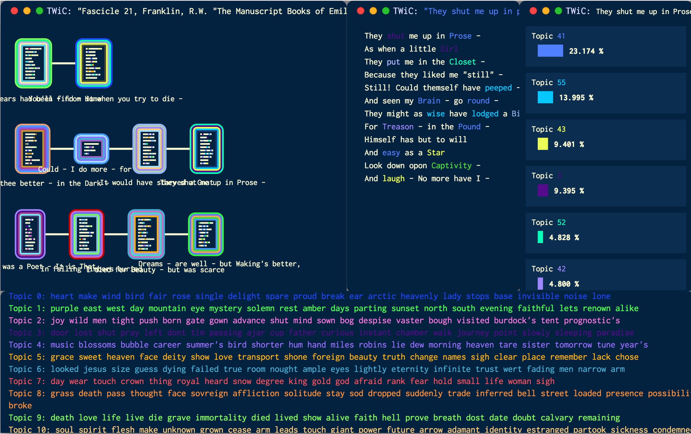

Figure 30. TWiC’s “Publication View” featuring all of the poems in Fascicle 21 in their original manuscript order.

TWiC’s “Publication View” reads another custom JSON data format I have created that describes the order of the poems in the fascicles as described by Franklin,[32] and visualizes that original manuscript arrangement within TWiC’s visuals. In the image above you can see that this view features a new panel, containing the topic rectangles representing all of the texts of fascicle 21.[33] Topic rectangles are connected via lines, each row of rectangles representing a physical paper page and the poems’ locations on that folded paper: from left to right, its left back page, left front page, right front page, and right back page. Since Dickinson’s paper sheets were not stacked and then folded, it follows that the right back page would face the next sheet’s left back page, and so forth. Mousing over the topic rectangles invokes the same behavior from TWiC’s “Text Cluster View,” but this time topic model relationships between the texts of the original publication can be seen. Mouse interactions works just like the “Text Cluster View” and its accompanying panels. Double-clicking a topic rectangle reveals the text in the “Text View.” Clicking a topic rectangle reveals its topic distribution in the “Data Bar.” And clicks of topic words also reveal the corresponding topic’s word weight distribution.

The “Publication View” affords many possible explorations of the topics that weave their way through Dickinson’s fascicles. Its introduction is also a good place for me to begin to describe how one can explore a topic model with TWiC, and use its metadata to provide a new analysis of the fascicle poems. If I did want to determine the shared topic associations among texts from this publication perspective instead of initially exploring from the perspective of the topic model, I could find out much about Fascicle 21 from the above view. Since Heginbotham has provided the pointed example of the poems of fascicle 21 and the poetic discourse arising from their arrangement, I will compare her criticism with how the topic model views these poems.

**Analysis**

**TWiC and Fascicle 21: The Threads of a Tapestry Revisited**

When Martha Dickinson Bianchi spoke of her aunt weaving the threads of a tapestry, she offered an elegant metaphor for the creative process, and certainly one applicable to the complex creations offered by a proto-modernist poet like Emily Dickinson. Uncovering those threads, their character and placement, is precisely the task of a topic modeler. The wonder of its algorithmic processes is that they work only with the evidence (the written words) of the conceptual model of the author(s), and they determine large-scale patterning in that evidence. For us, these patterns appear to denote potential narratives within the texts. TWiC was built as an exploratory tool. It allows users to navigate a topic model and determine points of inquiry. Play may be *critical* inquiry, but the follow-through is just as important as well. With those corpus, cluster, and text relationships introduced, there is still the question of how to proceed with macro- and micro- analyses with the topic model’s data. Though analytical outputs of the metadata presented in the “Data Bar” may be formally implemented in the future, below I will offer analysis based on the endpoints and relationships that arise from such inquiries via TWiC.

The panels of TWiC that I have introduced so far all attempt to take a close look at how the data of the model exists within a mathematical topic space and how that data relates to individual texts. The “Publication View” takes us one step closer to the author’s handiwork, with respect to that model of her “topics.” We know how the texts are related by topics. We know where those topics exist and how prevalent they are in those places. We even know how important those topic words are to the topics they inhabit. Still, it is difficult to view the whole tapestry, so to speak. What if we wanted to more precisely characterize how the topics of Emily’s fascicle books played among one another? Below is a list of the seventeen poems of Fascicle 21, for instance. Each title is colored by and lists its top topic. That information is followed by how prevalent that topic is to the poems of the rest of the fascicle.

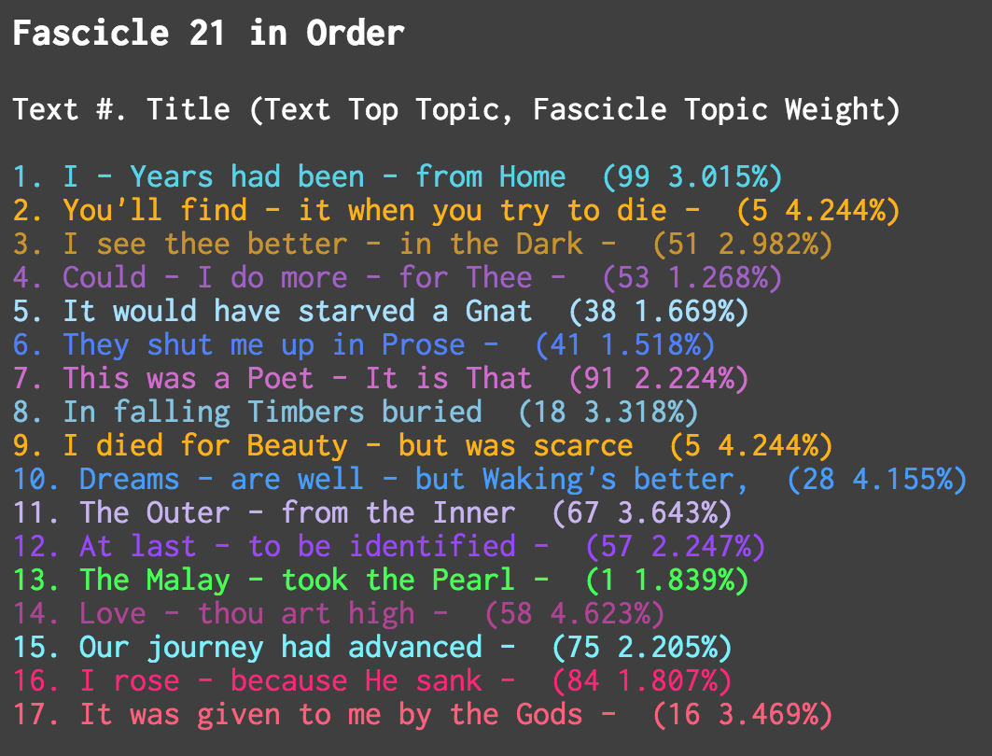

Figure 1. The poems of Emily Dickinson’s 21st fascicle listed in the order suggest by Franklin. Alongside each title are the top topic of that poem and the average topic weight of that poem among the other poems of the fascicle. Each title is given the color assigned to the topic by TWiC.

There are several implicit pieces of information of note in this view of the fascicle. There is a notable individuality among these poems. Remember that the topic model being visualized determines the topics of Emily Dickinson’s writings from her entire set of poems, and not just the fascicles. With the exception of the second and ninth poems, “You’ll find – it when you try to die –” (F21.2, Fr441A) and “I died for Beauty – but was scarce” (F21.9, Fr448A), which share topic 5 as their top topic, no poems in this fascicle share a top topic. This finding follows an oft-repeated assertion that likely resulted in the initial separation of her fascicles and perhaps also reinforced a hesitance to embrace fascicle-based readings: that Dickinson’s poems function quite well as standalone works. The second figure listed next to the titles is the average topic weight of that particular topic among the topic distributions of each poem in the fascicle. So there is a dynamic interplay of topics in the fascicle as well. Let’s re-visualize that average topic dynamic for a moment, looking at the relative topic weights of each of the top five topics of the fascicle: topic 58 (4.62%), topic 5 (4.24%), topic 28 (4.16%), topic 67 (3.64%), and topic 16 (3.47%).

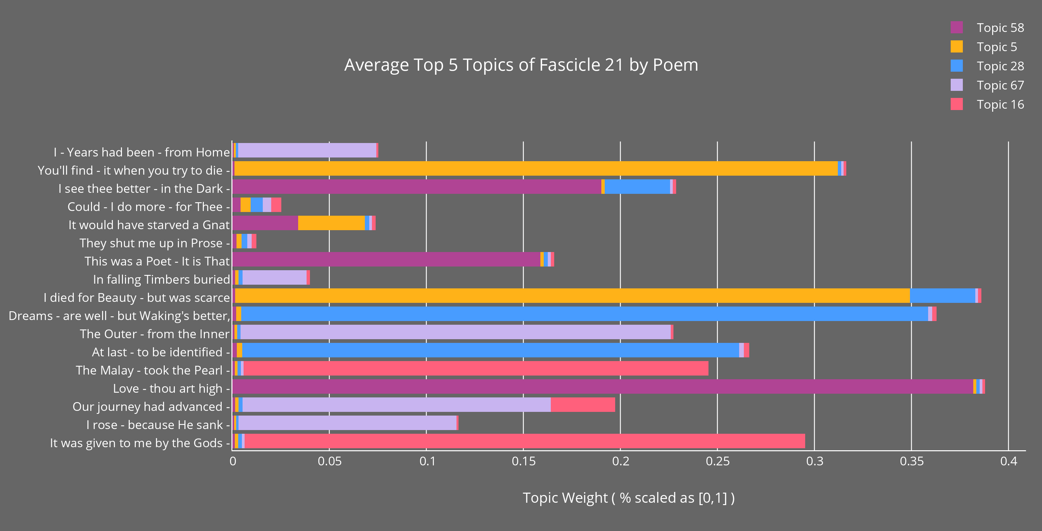

Figure 2. The top five topics on average of all poems of Fascicle 21. This view shows the relative topic weights of those topics in each poem of the fascicle. Poems are also listed in order by which they appear.

Gone for the moment are the topics important to each individual text and in their place are the topics important on average to the fascicle itself. Topic 5 shows itself as prevalent in the two poems mentioned previously, but now it also appears that it is somewhat prevalent in the intermediate fifth poem, “It would have starved a Gnat” (F21.5, Fr444A). Similarly, “I – Years had been – from Home” (F21.1, Fr440A), “In falling Timbers buried” (F21.8, Fr447A), “The Outer – from the Inner” (F21.11, Fr450A), “Our journey had advanced –” (F21.15, Fr453A), and “I rose – because He sank –” (F21.16, Fr454A) share increasing and then decreasing amounts of topic 67. Other visual topic dynamics can be traced similarly amongst the poems. These dynamics could themselves be regarded as discursive. From this view alone, one could picture a topic conversation – independent of what those topics may linguistically represent. The relative, strong finish offered by topic 16 in “It was given to me by the Gods –” (F21.17, Fr455A) stands out as some sort of salient exclamation. Below is TWiC’s “Text View” of that poem, with topic 16’s words in pink. I will leave the poem below for consideration and a bit of foreshadowing of the analysis to follow. It certainly keeps with one thematic semblance embodied by both the topic model’s fascicle dynamic pictured above, as well as Heginbotham’s characterization of Dickinson “owning the gold” (Heginbotham 22) of her poetry – a differing understanding of wealth that granted her a poetic boldness. For Heginbotham, while this fascicle consistently reflects the “‘business’ of the working poet” (24), it begins with the poet looking back upon a prior grief-stricken state and ends with her reaching toward the “miracle of power” (39) offered by the freedom of poetry. Of course, it is not just topic 16’s words in the poem that bring its full meaning(s) to the fore, but how the words of each topic in the poem interact.

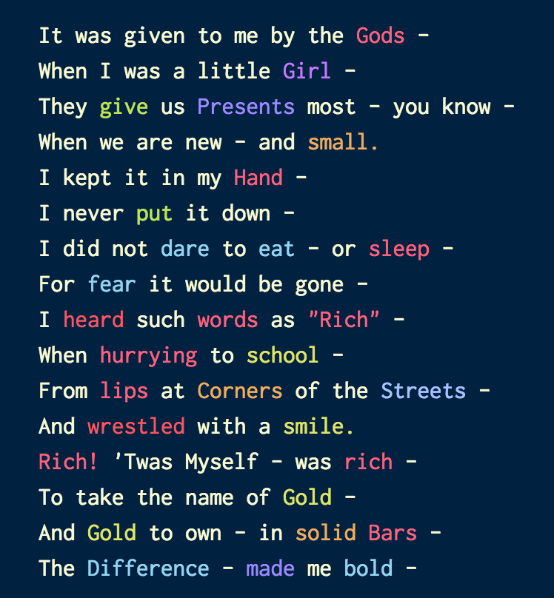

Figure 3. The last poem of Dickinson’s twenty-first fascicle: “It was given to me by the Gods –” (F21.17, Fr455A) features topic 16 words (word weights in parentheses): “hand” (2.72%), “rich” (1.814%), “sleep” (1.089%), “words” (0.908%), “gods” (0.364%), “lips” (0.364%), “bars” (0.183%), “hurrying” (0.183%).

Rosenthal and Gall’s attention to sequence returns here in an important way for such interactions, as well as for humanities consideration of topic models. Rosenthal and Gall flatly disagree with Franklin’s view that the fascicle poems were likely just ordered out of convenience: “That Emily Dickinson had sequences in mind is the most natural of conjectures” (Rosenthal and Gall 47). For them the groupings themselves stand as evidence of some organization. Rosenthal and Gall speculate that had Dickinson prepared them for publication she would have worked at this organization further. They describe her as a writer who played an instructional role in forming ideas for the modern poetic sequence. To exemplify Dickinson’s intentional organization, they offer a treatise on Fascicles 15 and 16, the interplay of the poems within those fascicles and how they relate to poems in other fascicles as well. They posit that certain poems and fascicles themselves “stage” one another, acting as “testing grounds” for concepts and thematics as well as further fascicle making (52-53). All of these activities and formalized relationships are a function of considering sequentiality.

However, employing the idea of sequence also yields implicit, chronological assumptions of meaning-making that move from the front to back of publications. Rosenthal and Gall attempt to erode such fixed chronologies, ones that exist as thematic structures or discourses that move from the front to the back of a publication, and ones that take hold due to the lack of certainty concerning the actual fascicle-arrangement timeline. They call the fascicles, “physically-linked structures that allowed [Dickinson] to give a tentative order to the chaos of emotions by which the writing was seized” (48). This tentative order makes use of reciprocity instead of pure, chronological sequentiality: “the reciprocities among [Dickinson’s] poems show her grasp...of the way separate poems within the same surge and float of feeling reinforce one another and grow into an encompassing, unified body” (47). This “surge and float of feeling” or linear (and potentially non-linear) sequentiality is in the very least analogous to the topic dynamics displayed in Figure 2 and Figures 4-8 below. In fact, as it will become clear, the interplay between the topics of the modeler and those topics from humanities criticism can service a complementary understanding of topic models and their texts.

Heginbotham’s arguments, much like Rosenthal and Gall’s, involve the poetic sequence, but Heginbotham’s position steers a bit closer to the material construction of the fascicles. To pull us closer to the pages of Dickinson’s fascicles, let’s consider for the moment how topics function at the level of the page. If there is an overall narrative or narratives per fascicle as suggested by Miller, Oberhaus, and others, we can hypothesize a hierarchical parallel (in the very least metaphorically) between the critically-perceived, conceptual model Dickinson brought to the construction of these books, and how the topic model perceives their construction. Taken at the page level, the topic distribution of Fascicle 21 looks like this:

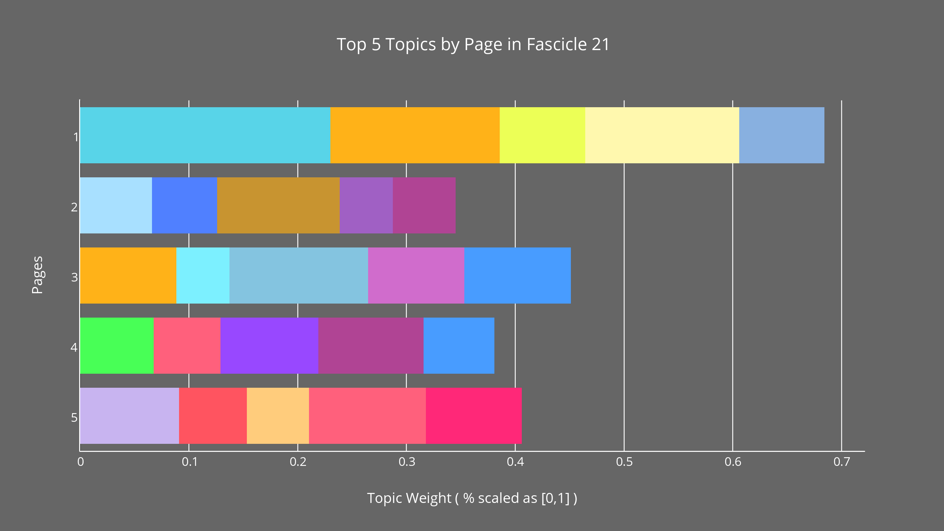

Figure 4. The top five average topics of each page of poems in Fascicle 21. Here the context for topic distribution is the physical page, and not the entire publication. Precise topics and percentages are available for view in Figure 5.

Something to keep in mind when viewing the topic dynamics of this level of publication granularity is that the topics in Figure 4 are situated in a different context than those of the previous graph. Before, the material context was that of all poems in the fascicle constructing a topic narrative. At this level, the context is each separate sheet of paper and the poems on it that construct that narrative. As I was mentioning, the further we dive into the data the more unique and noisy it becomes. Even with superlative views like the “Top 5” topics, it has become more difficult to visually comprehend. To ease that difficulty I will be providing some more detailed, alternative views below. Similar to the previous fascicle-level view, topics like 5 and 67 remain present at the page level, but since those topics represent averages of all poems in the fascicle, other prominent topics of the poems get washed away. Page 1’s topic 99, for instance, representing about 23% of the words in that page does not even appear in the top five topics of the fascicle as seen in Figure 2. In this way, much like TWiC’s views of a topic model, the deeper we go into the publication, the more expressive an image of Dickinson’s topics emerges.

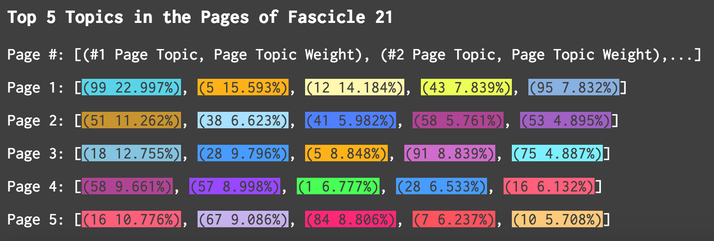

Figure 5. The top five average topics of each page of poems in Fascicle 21. In this supplemental view for Figure 4, topic IDs and average topic weights are shown.

With the labeled view of Figure 5 in view, we can note a few things about the topics and their weights as they are distributed across a physical page. One immediate observation is that these physical pages, regardless of the shape of topic distribution, behave remarkably like their poem constituents in that their topic assignments are quite unique. However, like higher view of all of the poems of the fascicle, highly featured topics form apparent connections or potential discourses across the boundaries of the page. It’s not as if this observation is so surprising. It undergirds the entire enterprise of both topic modeling and close reading. Semantic gestures of an author are carefully threaded throughout a work. Topic 5 first appears on the first page and reappears in a comparatively diminished state on the third. Topic 58 is featured in opposing dynamic from the second to the fourth page. Topics 28 and 16 work in a similar opposing dynamic, but in their case they do so over sequential pages.

I have not yet mentioned the words involved in these patterns, what would otherwise be considered key evidence to verify those observations. Yet these patterns, once resituated into their authorial contexts could be said structure the composition or fabric of the model. It can feel frustrating or even reductive to speak broadly of language that we know is employed in such a polysemic fashion. But to utilize a spatial metaphor, if a view of an entire fascicle is like observing the composition of our solar system from outside of it, this page-level view is like staring down at one of its planets – the blue marble of Earth, for instance. We can see the smatterings of green, brown, blue, and white. These images don’t give us much detail about the forests, deserts, oceans, or atmosphere, but in juxtaposition they do characterize those features and set them into potential relation with one another. We know though that there are significant differences between a tropical rain forest in Brazil and the moss-covered one in Washington State, between a summer hurricane on Earth and a hundreds of years-old storm on Jupiter. Let’s take one last look at the entirety of fascicle 21, a sort of satellite image of its topic fabric.

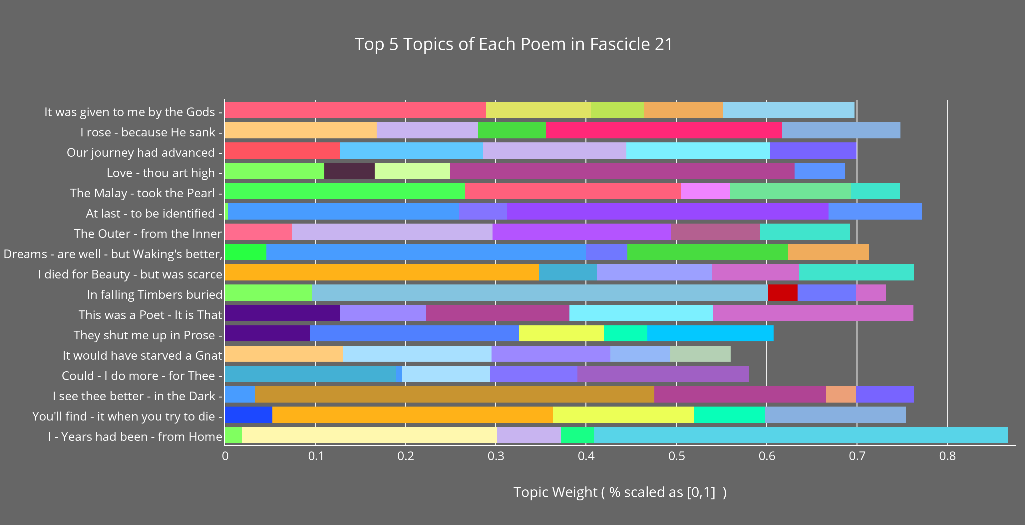

Figure 6. A proportional view of the top five topics of each poem of Fascicle 21, listed in order. See Figure 7 for topic IDs and weights.

Here are those fingerprints we were observing in TWiC’s “Text Cluster View” and “Text View” panels, but now juxtaposed in (potentially) intended sequence and with the proportions set out by the topic model. From the perspective of the topic model, Dickinson’s arrangement and needlework, and Franklin’s bibliographic forensics, here is the view of the topic fabric of Fascicle 21. Each poem stands alone in its topic composition, and yet we can see prominent topics weave their way throughout. They appear and reappear, travel from one poem to the next, and as we will see, converse with each other across the material pages of the fascicle. If your eye or critical sense is like mine, it is drawn to sequential poems with shared topics. I have already mentioned Eleanor Heginbotham’s two poems that speak to each other in many senses across the fascicle’s pages. Below is a detailed view of that fabric. Note Heginbotham’s poems, “They shut me up in Prose” (F21.6, Fr445A) and “This was a Poet” (F21.7, Fr446A) in Figures 6-7 and their shared topic 3.

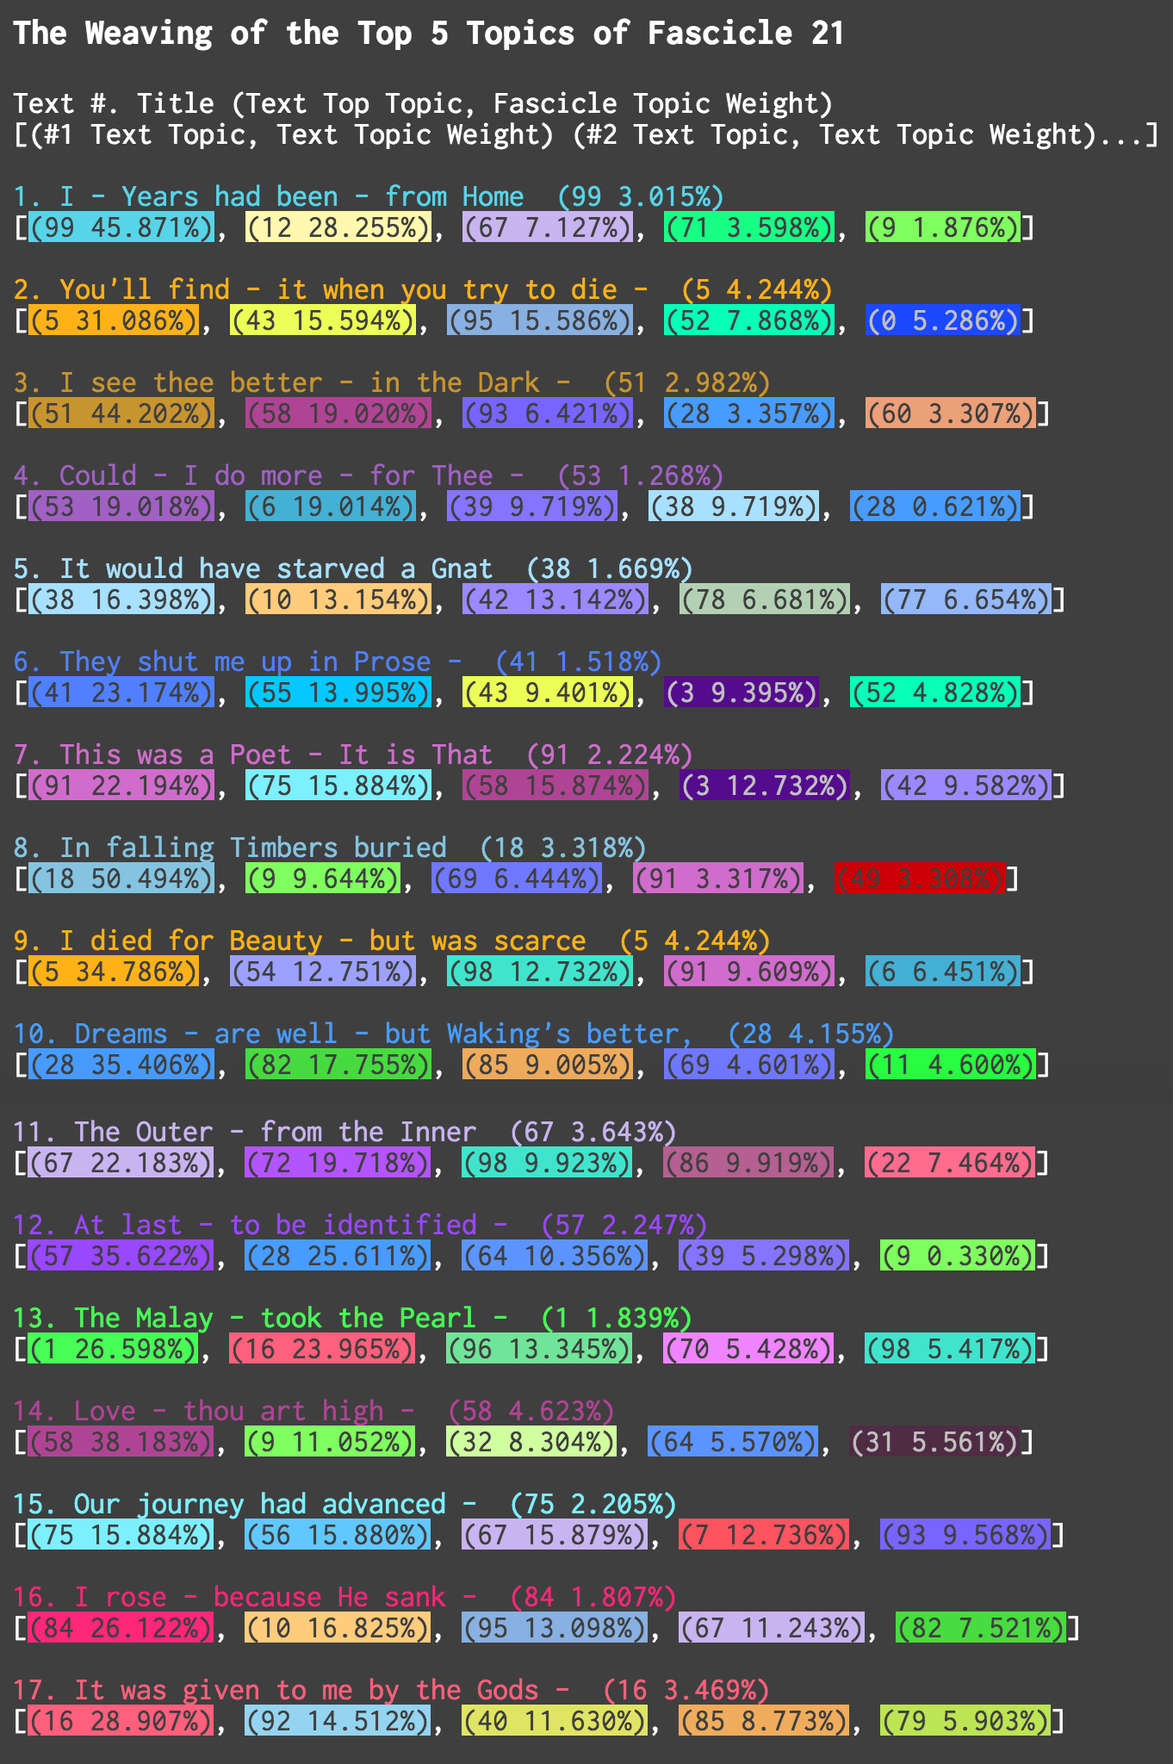

Figure 7. Pictured above is the topic “fabric” of Fascicle 21, featuring its poems in order as well as the IDs and weights of the top five topics of each poem.

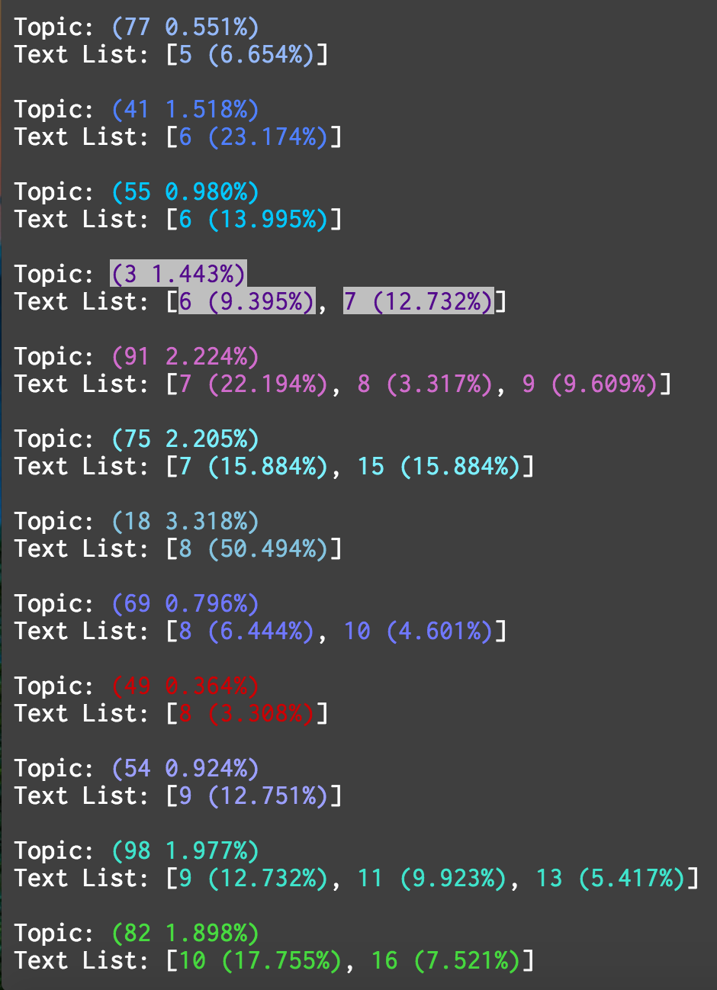

Figure 8. Some of the “threads” of the topic “fabric” of fascicle one, pulled apart and viewed in order of topic introduction of the fascicle. Key to reading these figures - *Topic: (Topic ID, Fascicle Topic Weight)* followed by *Text List: [Poem# (Poem Topic Weight),...]*

Like the mouseover highlighting effect of the “Text Cluster” and “Publication” views in TWiC, we can tease the threads of this fabric apart to see where else and how much they are featured.[34] In the image above are a few of the topics of the fascicle in the order they are introduced. We can see that in “They shut me up in Prose” (F21.6, Fr445A) and “This was a Poet” (F21.7, Fr446A) – the sixth and seventh poems in the fascicle respectively – topics 41, 55, 91, 75, and 3 are in the top five topics introduced in those poems. To be specific, topics 41 and 55 are introduced and never mentioned again. Topics 3, 91, and 75 are introduced and spread. Topic 3 stands alone though. It looks as if the two poems have shared something across the two fascicle pages. And it seems when close reading the model data, that it is the words of this topic found in the differing contexts of both poems that act as a fulcrum for this collection of poems. Rosenthal and Gall use a similar planetary metaphor. They call such fascicle poems, “revelatory, magnetic centers,” which act within “a process of tensions and counter-tensions in motion, self-contained yet not rigid” or a more succinctly, “a system of relationships” (48-49). The prose-related thematic of these two poems is a rare one in Dickinson’s entire oeuvre. Many of the fascicle’s topics work in contrast to them. Thus, they act as a sort of poetic genesis: the “shut...Girl” (“They shut me up in Prose” 1-2) behind the “ordinary...Door” (“This was a Poet” 4-7) of prose, and the freedom that poetry granted her.

**Words to Pay Attention To and Words to Ignore**

****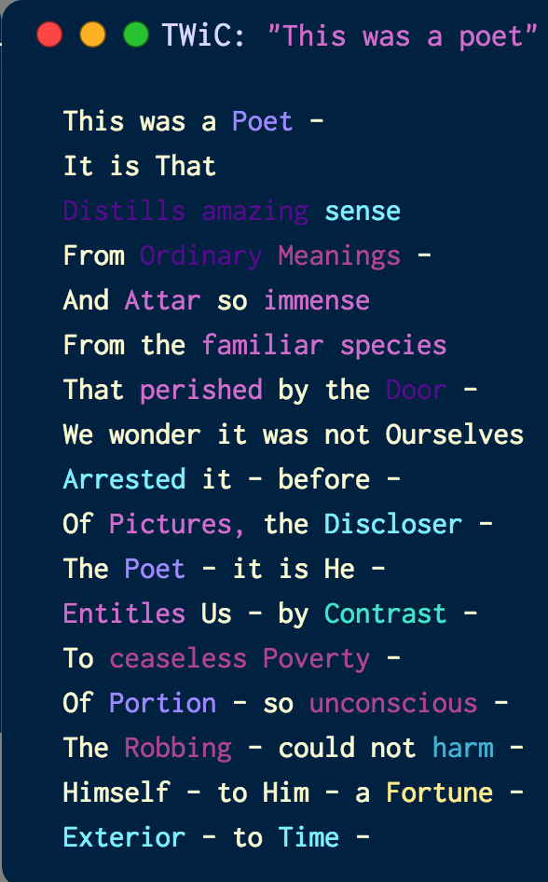

Figure 9. “They shut me up in Prose” (F21.6, Fr445A) and “This was a Poet” (F21.7, Fr446A) as seen in TWiC’s “Text View.” Topic 3 is the darker, purple colored topic – “shut”, “Girl” in the former, “Distills”, “amazing”, “Ordinary” and “Door” in the latter. Note: TWiC currently does not preserve stanza spacing.

The analysis of the words of Emily Dickinson’s fascicles using TWiC begins at an unexpected place: which words to completely ignore. An option for MALLET that I have not yet discussed in detail is the ability to use “stopword” lists to filter the words of a corpus before it is modeled. In addition to the removal of word order, this feels like yet another blow to the structural integrity of the texts we are trying to read at a distance. Looking back to the solar system metaphor for a moment, when one does step further and further back from an image, its less prominent details become obscured. In somewhat similar fashion, it becomes important to strip away frequent function words, what would more typically be thought of as the glue of prose. In poetry, of course, it’s more typical for every word to count. As it turns out for a topic model though, the inclusion of these very important, and, at times meaning-full, function words just makes for noisy, less understandable topics. Even from a mathematical accounting of topics and their words, high frequency function words like “the” can provide a probabilistic, warping effect on what would otherwise be the underlying linguistic (e.g. semantic or stylistic) field.

I came to this conclusion through testing of my own on the Dickinson corpus and with much credit to Lisa Rhody, who has also gone through the trials of topic modeling a large corpus of poetry. Modeling a corpus while looking for poems that utilize ekphrasis, Rhody was alarmed to find among MALLET’s default 538-word stopword list many words thought of as notable identifiers of potential ekphrasis in a poem. These include, “after, before, look, looking, looked, looks, said, saw, say, saying, says, see, sees, seeing” (Rhody). After experimenting with four separate stopword lists, each including none to all of the MALLET’s stopword list, Rhody observes that inclusion of even small amounts of function words and/or regularly-used verbs (e.g. “see” or “say”), “impeded topic cohesion” and in fact removing them allows for the model to be inclusive of texts would have otherwise not been categorized as sharing similar thematics (Rhody). This seemingly small point returns us to Blei’s suggested motivations for humanities scholars using topic models. Though they will likely (and pleasantly) confirm our carefully considered observations of the shared affinities of texts, it is important to remember that topic models attempt to ascertain a hidden structure amongst the texts of a corpus. By narrowing the choice of words being modeled in each text to those that are more unique, and not frequently chosen by the necessities of syntax, the high level view of the corpus comes into more meaningful relief. And conversely, zooming back in to those topic words of that hidden structure, now in context via the visualization, topic models can provide new avenues for close reading – ones that might not have been imagined when we were also concerned about the prepositions and pronouns that facilitated our previous close reading hypotheses. Though Rhody recommends limiting the stopword list to MALLET’s, a programmatic and manual examination of Dickinson’s lexicon provided many less common, idiosyncratic and nineteenth century pronouns, spellings, and contractions. These were all added to the extra stopwords list that MALLET allows the user to give MALLET to filter in addition to its default stopwords.[35]

**Analyzing a Topic Model with TWiC**

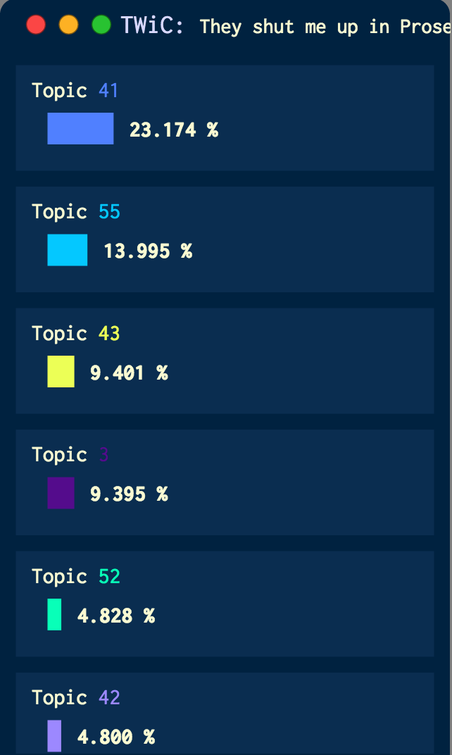

Figure 10. The first few topics of the topic distribution of “They shut me up in Prose” (F21.6, Fr445A) as seen in TWiC’s “Data Bar.”

There are several ways topic models have been used for a humanities-critical assessment of texts, and I have introduced a few in the previous sections. Just as a reminder, one typical task is to examine if a topic can be interpreted as having the semblance of a semantic field, linguistic register, sociolect, etc. Another possible task would be to assess a collection of texts based on the proportional hyperparameter estimates/topic weights of the topics in a text. But what are we to make of identified topic words once they have been placed back into their original human-generated contexts? I have learned by examining this type of visual that much like the initial interpretation of a topic – before further examination of its quality – glancing at topic words this way can be somewhat misleading. Firstly, it’s important to remember that words not assigned a topic are not considered by the model at all. If I see that the model has labeled certain words as belonging to a topic there are a few automatic presumptions one can make: (1) Those topic words are important words for the model, and therefore for the text. (2) The conjunction of multiple words in the same topic in one text are necessarily linked by the characteristic (e.g. semantic) that links all words in that topic. (3) Topic words from one topic found in the text are necessarily discursive with words from other topics in the text. All three of these presumptions are reasonable. All three could also be entirely incorrect.

Some of what follows depends on the hermeneutical beliefs of the critic, but before diving into a specific set of analyses of fascicle poems, I want to lay clear how I will be judging these topic words in context. When I began my comparative analysis of Dickinson’s poems I considered which data to look at first. The model or the critics’ writings? The topic words or Dickinson’s ordered deployment of them? There are no clear answers to either of these questionsfig, but I will start with the modeler and how it considers its input. The topic modeler considers words without order and, figuratively, it “imagines” how Dickinson created these poems. With that in mind I will make the following statements. Underwood proposed in 2012 that since topics are not always semantically unified (for many of the reasons I have already mentioned), they are more like discourses (“What Kinds of “Topics” Does Topic Modeling Actually Produce?”). I will take that proposal one step further and make the assumption that topic words within the same text are also inherently discursive. But just like topics, not all words are created equal, and we know this since each word is given a weighting within its topic. Therefore (1), (2), and (3) become possible when they are modified by adding that the prominence of that word is altered by its weighting.

Let’s take a look at a few visual configurations of “They shut me up in Prose” (F21.6, Fr445A) that can act as critical templates for us. In order of their introduction, “They shut me up in Prose” uses nine topics. Each of these will be colored in the same way from the previous visuals of the Dickinson topic model as viewed by TWiC. The first view I want to address before we look at how the model views its topic words within the poem, is a look at the topics themselves, or, well, the top topic words we are usually given in the MALLET keys file.

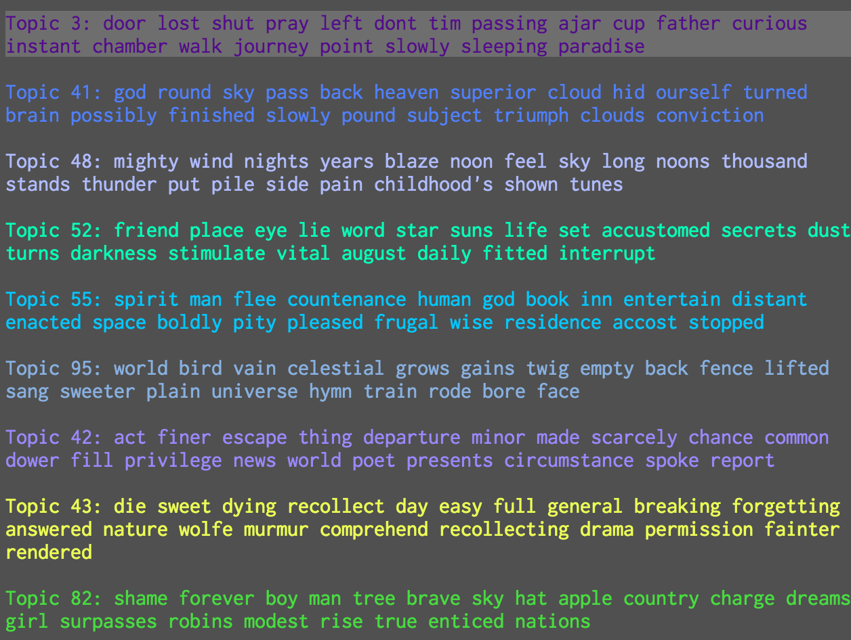

Figure 11. The topics of “They shut me up in Prose” (F21.6, Fr445A)

If while looking at these topics you are somewhat strained to find semantic groupings, you could hardly be blamed. Glancing at them and having some experience with Dickinson’s poems helps, but as Lisa Rhody has also experienced, the figurative language of poetry is not as accessible, to us *or* to the topic modeler. The words evoke some of the brief vantages Dickinson offers in each writing, and of course they also evoke the elusiveness she often interjects between us and the reality she is describing. Topic 43, for instance, appears as one of the most assembled reflections at the end of a life and Topic 42, the vantage and actions of a poet. But in the case of these topic words, I have just offered you descriptive glue that is in essence, extra-textual, and which belies the inherent structuralism of something like a topic model. After all, we are no longer looking at the carefully ordered words of the poems, but words collected in the general, cognitive sense that piece them together. I have done something a little tricky with the above topic list however. I have put them in the order in which words from those topics are first introduced in the model’s view of the poem.[36]

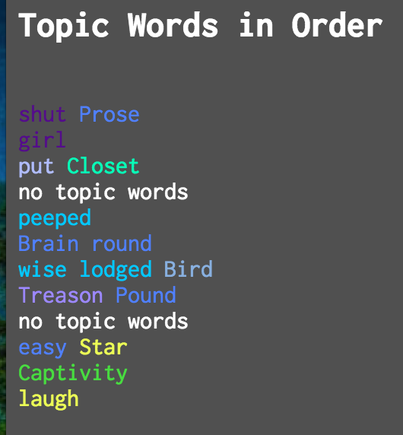

Figure 12. The topic words of “They shut me up in Prose” (F21.6, Fr445A) in their original order[37]

Above in Figure 12 is a listing of the words of the poem that come from those topics, also in the original order and scansion with which Dickinson put them. Remember that these topic words represent a few assertions: they are not in the stopword list given to MALLET and they come from lists of words (each the entire lexicon of the corpus) differently weighted according to their algorithmically sampled propensity to be used together. This is the beginning of a movement back towards more human-cognitive contexts, but what is different here is that this is a filtered view of what the model deems important about this poem…and *how* they are important. To go over the words above briefly, paired up are “shut” and “girl” (topic 3); “Prose”, “Brain”, “round”, “Pound”, and “easy” (topic 41); “put” (topic 48); “Closet” (topic 52); “peeped”, “wise”, and “lodged” (topic 55); “Bird” (topic 95); “Treason” (topic 42); “Star” and “laugh” (topic 43); and, finally, “Captivity” (topic 82). I will return to these topic words, looking back to the critique of Eleanor Heginbotham, but one is struck by just how evocative they are of being “shut up in Prose” and perhaps what it might mean to be free of that “Captivity”, especially in the pairings above. But that is not the end of the story for the topic model at this level. Its hidden structure remains so when its data are placed back into human contexts.

Topic words in this view take the form of a sort of genetic sequencing, the beginning of something rather than its end. The topic model decodes and renders Dickinson’s meaning into its parts: “shut Prose / girl / put Closet / – / peeped / Brain round / wise lodged Bird / Treason Pound / – / easy Star / Captivity / laugh”. When I spoke of the phenomenology of words, I said that each digital word is a distinct set of numbers under a character-encoding scheme. When we look at topic models, this is a good way of thinking of the derived patterns that are topics. Here’s another look at “They shut me up in Prose” from the perspective of topic patterning.

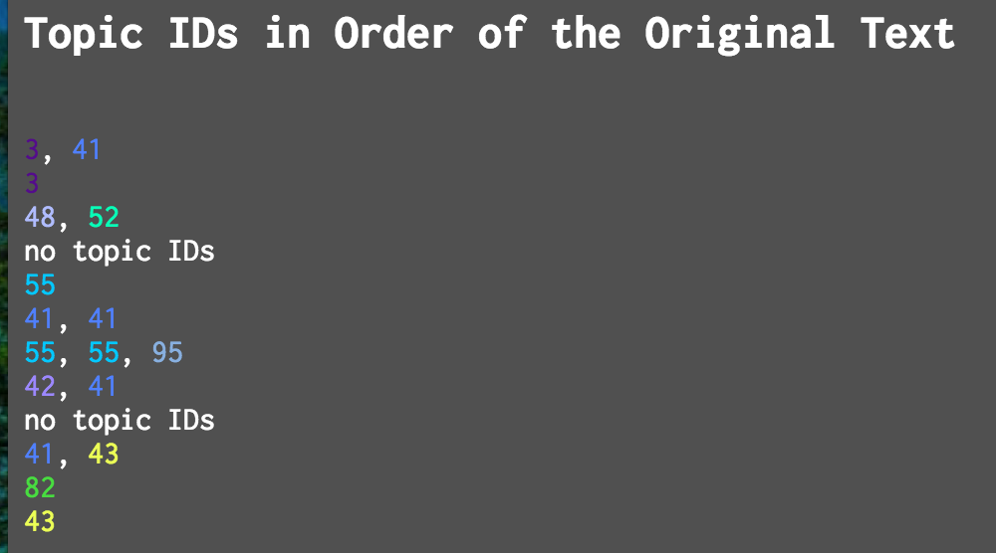

Figure 13. The topic words of “They shut me up in Prose” (F21.6, Fr445A) substituted by their topic IDs

So really – to use the generative characteristics of the model – the poem “They shut me up in Prose”, now renamed as “shut Prose” reads as “3, 41 / 3 / 48, 52 / – / 55 / 41, 41 / 55, 55, 95 / 42, 41 / – / 41, 43 / 82 / 43”. How strange to read a sequence of numbers and render aesthetic and meaning! Yet there it is before us. Lines 1 and 2, 5 and 7, 6 and 10 all share the in repetitions at their beginning – “shut…Girl”, “peeped…wise”, “Brain…easy”. Lines 1, 6, 8 and 10 and 12 repeat at their ends – “Prose…round…Pound”, “Star…laugh”. Only line 7 bears the quality of 3 topics: “55, 55, 95” or “wise lodged Bird”. And lines with singular meaning reverberate the poem’s essence of “shut” isolation and the ascendant perspective of its “Bird” (the poet): “3…55…82…43” or “girl…peeped…Captivity…laugh”.

Also recall that underlying each topic ID number and thus sequence of numbers in each line is a calculated prominence, a probabilistic weight/hyperparameter estimate. Going back to the topics themselves we find the following view, the data of which is made available via TWiC’s “Data Bar” when clicking on a text’s topic rectangle.

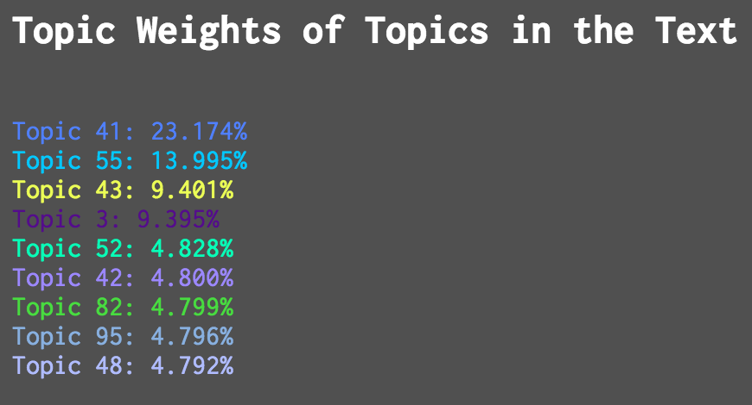

Figure 14. The weights of the topics of the topic words of “They shut me up in Prose” (F21.6, Fr445A)

This reveals that the prior images of the topics/topic words of the poem were partial. Like the accentuation and prominence of meaning brought about by the contrasting words of a poem and the interstitial forces of those other words disregarded for the model (e.g. pronouns, articles, prepositions, etc.), the weighting of topics at the level of the individual text provides an aesthetic weight that itself can be discursive. Below is a view of those topic words in Dickinson’s order, the text-level topic weights of which are shown via the size of their font.

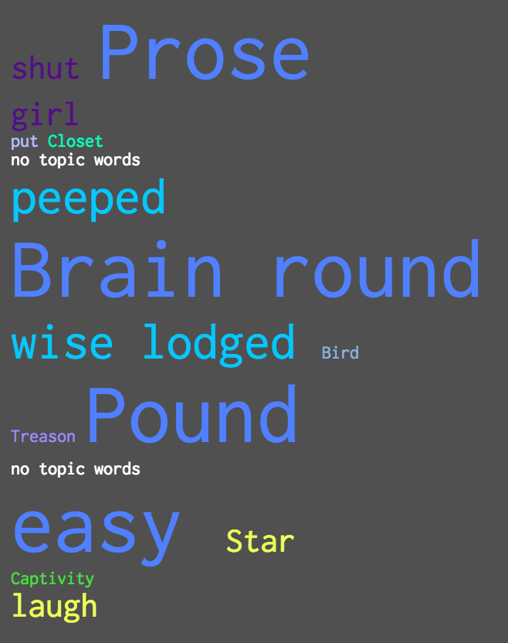

Figure 15. The topic words of “They shut me up in Prose” (F21.6, Fr445A) sized by its text-level topic weights

This is the first view that gets closer to how the model envisions this text. “Prose”, “Brain”, “round”, and “Pound” compose 23% of the poem’s topics; “peeped”, “wise” and “lodged” about 14%; “Star” and “laugh”, 9.5%; and “shut” and “girl”, 9.5% as well.[38] The rest of the topics words compose another 25% of its thematics. And if you’re following along with a calculator, the remaining 20% is assigned to generative, statistical noise: topics without any of their prominent words in the actual text, but never the less given the topic composition of this particular poem, having the dummy, non-zero probability of having its words present. Also notice though that by weighting each word with its text-level topic weight, a sort of visual homogeneity between those topic words arises. This is because we have not yet considered the weights of the words within their own topics.

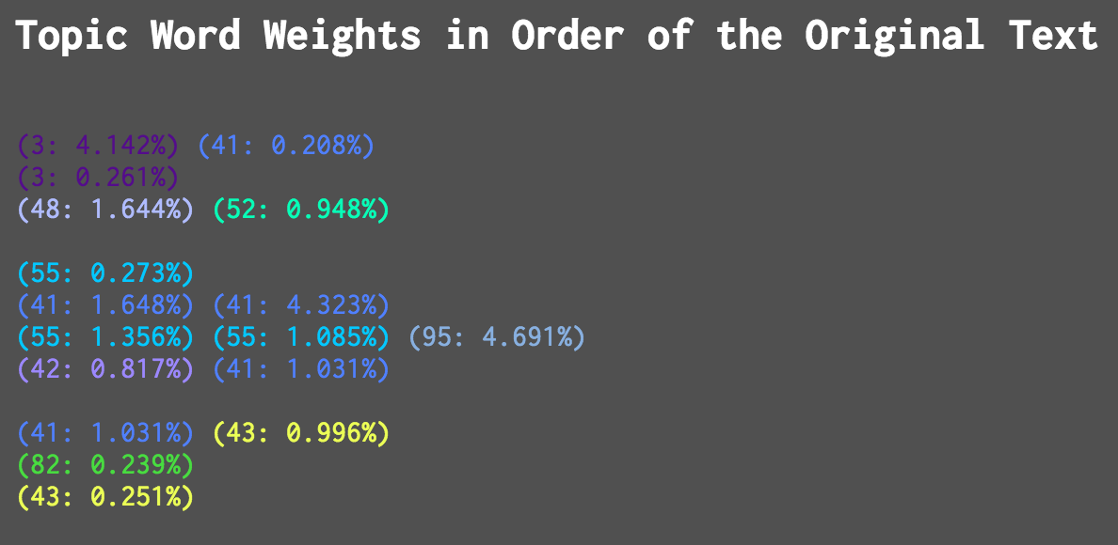

Figure 16. Topic word weights of “They shut me up in Prose” (F21.6, Fr445A) in their original word order

Above, like the listing of the text’s topic weights, you can see the topic-level weighting of the words featured in “They shut me up in Prose” (F21.6, Fr445A). It becomes easy to see that merely having a topic word as present in a text is not enough to determine the semantic contours we often would like to draw out from data at much larger scales *or* by close readings of texts. Like the distribution of topics across the entire corpus, once the weights are drawn out across the corpus, the accentuation of topic words occur at smaller scale of prominence than the topic composition of a text itself. Still, we can make a relative visual accounting of these weighting like the one that looks at text-level topic weighting above.[39]

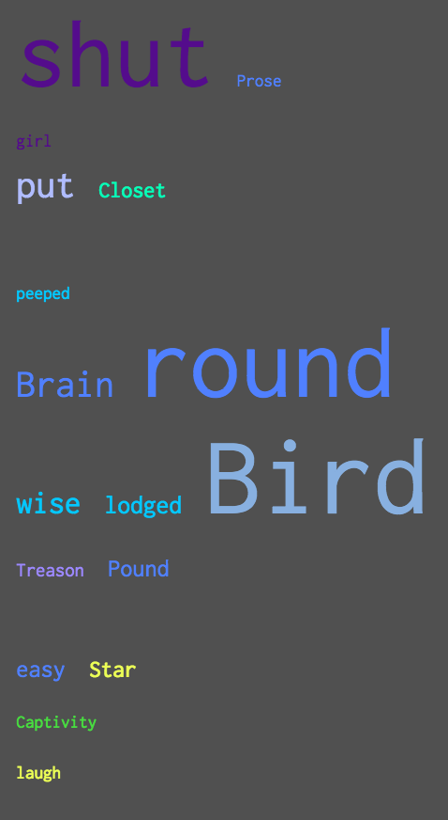

Figure 17. Topics words of “They shut me up in Prose” with font size relative to their topic-level word weights.

The fragility of the topic model is borne out by a view such as this one. I would describe this view as the sort of frayed ends, or tiny roots, upon which a larger structure stands. Though words that were once seen as cohabitants of fields of semantic noise now begin to fall away we get closer to a view of the primary elements of a topic model and the essences (semantic, register, or otherwise) of the text. Looking at those words that hold 1% or more of their topic-level weighting we find, “shut…put…Brain round / wise lodged Bird…Pound / easy”. The bird may be put shut in a pound, her brain going round. And yet something is missing. Where are the poet’s captors? Who is wise? Who easy? It feels as if by diving down to this level, we have reached the point at which there is a significant amount of information loss to the overall poem’s core, linguistically-structured message (whatever that may be), and this is because the word weights judged alone are out of the sight of their relationships to the other topic words in the surrounding context. That which connects the larger, hidden structure also holds together these wispy topic strands – these seemingly, inconsequentially weighted words. To combine the two previous views of an individual text in a topic model we get a visual that accounts for both the importance of a word to its topic, a text’s words to each other, and a text’s topics to its corpus.

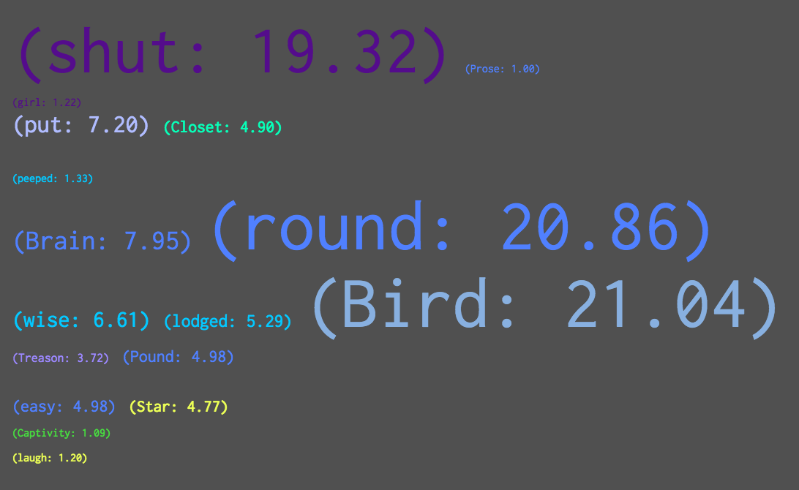

Figure 18. Topic words in “They shut me up in Prose” (F21.6, Fr445A) sized according to topic and word weights

By incorporating the text-level topic weights and topic-level word weights into the font sizing, we can then bring both into view at the same time, but back to a view more familiar to users of topic models. Like my first ordered topic list, we now see the words of the modeled text in a new light, listing in order of the re-contextualized prominence of this composite weighting scheme.

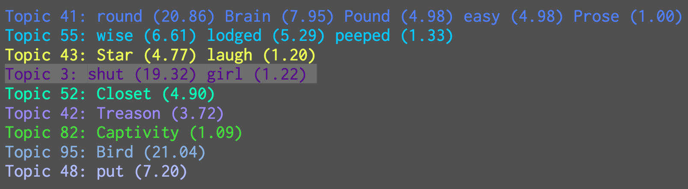

Figure 19. Topic words in “They shut me up in Prose” (F21.6, Fr445A) each given a weight that is the composite of its text-level topic weight and its topic-level word weight. Instead of being listed by order of topic introduction or topic prominence, the topic lists are reorganized by the total sum of the composite weights descending from most to least.

Taken out of those human – or in this case, Dickinsonian – contexts momentarily, this view offers a better and more complete summation of the modeled text where the rank of both the topics – a more model-generative perspective – and words – a more human-generative perspective – can be seen concurrently. The weight values deserve some explanation, as they cannot be considered a percentage. Instead, they should be regarded as a valuation of the topic words employed in the poem, relative to each other but also relative to the overall poem. Armed with this re-contextualized view of the model, I can now proceed with a comparative analysis of a topic model and traditional humanities criticism of the fascicle poems. To add the rich, literary-historical context of fascicle ordering to the mix, I will examine “They shut me up in Prose” (F21.6, Fr445A) and “This was a Poet” (F21.7, Fr446A) – poems not only in the same fascicle, but made to face each other by Dickinson, a very suggestive arrangement as Heginbotham argues.

**Juxtaposing a Transposition: A New Hermeneutics for Topic Modeled Texts**

“Tracing the threads” of Dickinson’s tapestry-like poems has been no easy task for critics, and should they even desire to, engaging with the intentional fallacy is a luxury to which Dickinsonian scholars have limited access. The reticence to engage with a reasserted fascicle ordering understandably offers a perturbing complication beyond the arduous nature of assessing thematic commonalities amongst the 7-21 poems of each fascicle-grouping and then amongst the fascicles (and perhaps unbound sets) themselves. What the above assessment of a topic model’s data offers is a brief glimpse of a hidden structure, another place where, like Heginbotham posits, the imaginative possibilities of Dickinson’s poems dwell. But as I indicated when introducing the comparison, the diachronic juxtaposition of topic models and prior critical assessment is a place I feel where initial humanities criticism based on topic models must begin.

Heginbotham’s first example of intra-fascicle, poetic discourse is between these two poems within the 21st fascicle; a grouping that Heginbotham proposes represents Dickinson’s narrative of her interaction with the ideas of “Poetry” and “Prose.” Set directly opposite each other, the words, references, and lineation engage in a play that poses Prose as a form of unethical imprisonment versus a Poetry presented as an ethical freedom. Traditionally read apart, these two poems brought into the fascicle context bring potential autobiographical truths to light in characteristic Dickinsonian slant. As Dickinson writes in the next fascicle – the only other mention of “prose” in her oeuvre – “I dwell in possibility– / A fairer house than Prose” (F22.11, Fr466A).

When brought together and read in discursive relation as their fascicle suggests they might be, the poems showcase not only what they do in isolation – a biographical take on Dickinson’s family life and struggles as a writer – but also a newfound understanding of why Dickinson chose to be a poet. The first stanzas align “They shut me up in Prose – / As when a little Girl / They put me in the Closet – / Because they liked me ‘still’ –” (“They shut me up in Prose” 1-4) with “This was a Poet – / It is That – / Distills amazing sense / From Ordinary Meanings / And Attar so immense” (“This was a Poet” 1-5). “Still” for Dickinson is “to be dead or dead-in-life” while “distill” represents not only poetry’s concentrated perfume of polysemy (the “Attar” of the rose), but also a “homophonic antithesis,” the undoing of the stultifying existence of “Prose” on the opposing page (Heginbotham 5-7).

If I did want to bring this understanding of these poems closer to a quantified overview of its words, one of the simplest moves I could make would be to count frequencies. I could account for what is there in the pages in the most visual of senses: the frequency of words and the amount of word-crossover between works. Of course this belies the often figurative nature of poetry. A poem’s words are not its purest of constituents, but the potential polysemy of each is instead. Stop words aside, this may be hypothetical reason enough to consider topic modeling as ideal for poetry – if its methods could be adapted for what are typically smaller collections of texts. The presumption that it is better suited for prose because of that genre of writing’s sheer volume is flimsy argumentation in the world of language, if not in the world of statistics. What is a topic model measuring of prose if not its words’ polysemy and the polysemic contexts that arise from using them in conjunction? What makes methods like topic modeling that take a Bayesian stance a success is that there are context-related, unknown variables in writing: these topics that thread their way through corpora.

The combined weighting scheme of the previous view (Figure 19) is enough fodder for future analyses given its new perspective on how an individual text is characterized within a topic model. However, I want to dive deeper down this black hole – where a collection of texts has been pulled apart into its components – in order to get to some sort of singularity where humanistic and statistical accounting merge. Given Heginbotham’s description of how these poems function alone and then how they function when posed across from each other, I’ll select five “human” topics: “The Imprisoners”, “The Poet”, “Prison/Prose”, “Freedom/Poetry”, and “Poetry’s Source” and I will also assign them each a color.



Figure 20. Colored labels for Eleanor Heginbotham’s critical thematics (or topics) in Fascicle 21’s sixth and seventh poems, “They shut me up in Prose” (F21;6) and “This was a Poet” (F21;7).

I will select the words and phrases that I feel and Heginbotham indicates are tied to these critic-borne topics. And in the spirit of a topic model, I will also consider that each word/phrase can be in multiple topics. Below are TWiC-like views of these two poems utilizing Heginbotham’s topics. Note that for polysemy, I’ve put brackets next to those words/phrases with numbers colored to correspond to their human-critical topic.

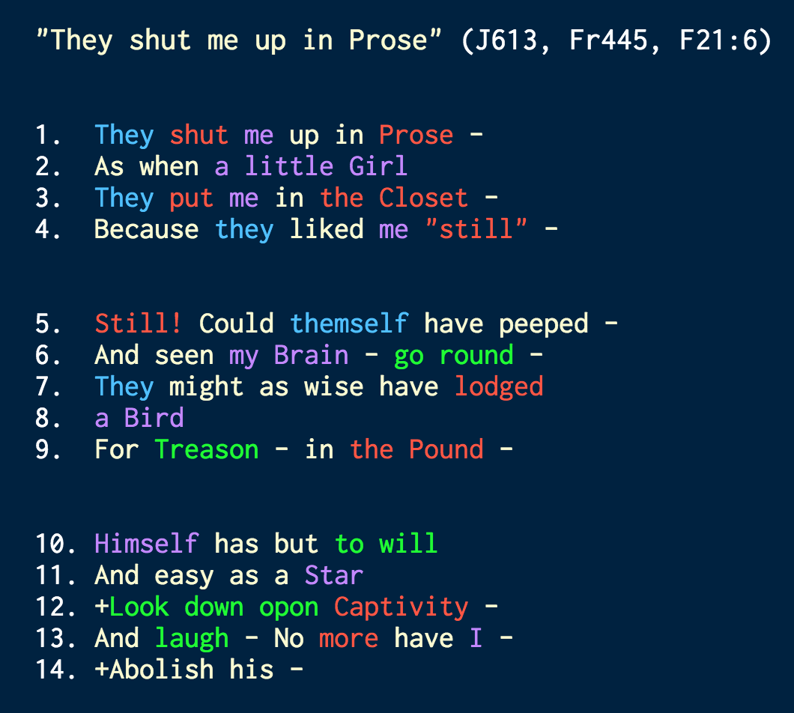

Figure 21. Heginbotham’s criticism of “They shut me up in Prose” (F21.6, Fr445A) with critical topics highlighted by unique color. The “+” of lines 12 and 14 refer to a variant line, “Abolish his”, presented here for completeness, but not modeled.

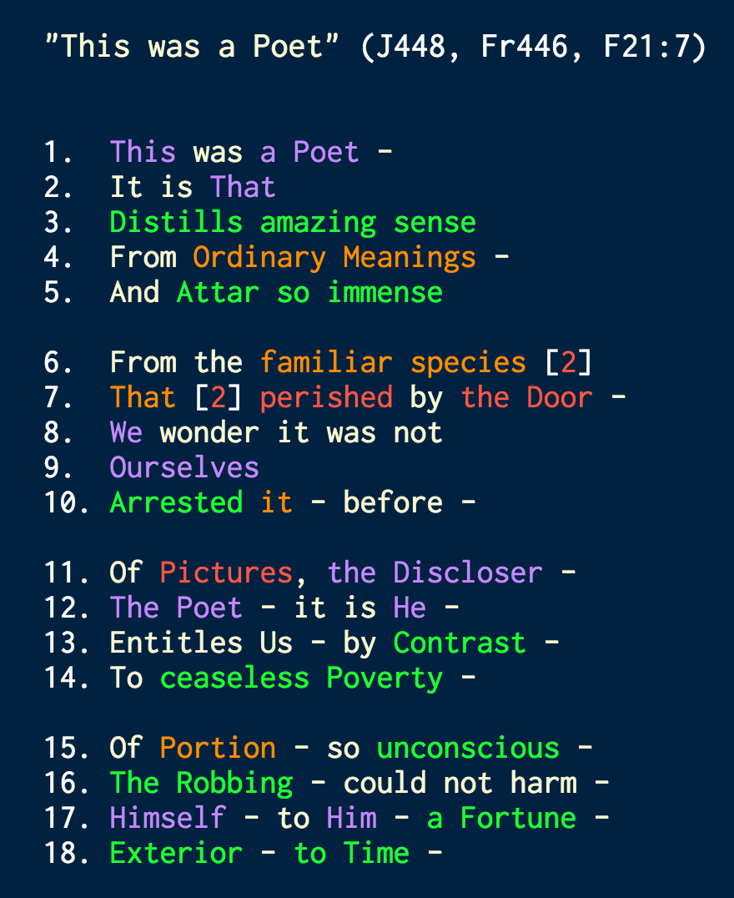

Figure 22. Heginbotham’s criticism of “This was a Poet” (F21.7, Fr446A) with its critical topics highlighted by unique color

To quantify these topics based on an established close reading, we can simply count them to account for dynamics between poems. In one sense, this is part of the function of close reading a discourse between works, akin to a Northrop Frye-like centripetal, inter-textual meaning/motion. Here it plays out between two fascicle pages. Transferred into bar plot form we see the following:

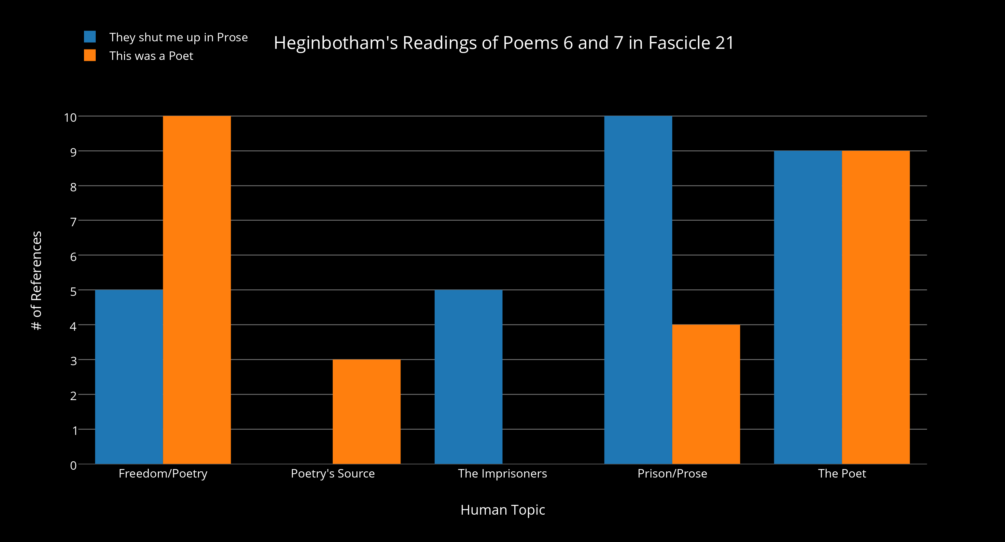

Figure 23. Human topic frequencies across “They shut me up in Prose” (F21.6, Fr445A) and “This was a Poet” (F21.7, Fr446A)

As we would suspect, “They shut me up in Prose” features a higher accounting for both “The Imprisoners” and “Prison/Prose” and a relative dearth of “Freedom/Poetry” and “Poetry’s Source.” Perhaps the most interesting point from this flattened accounting of the poem’s human topics is the consistent presence of “The Poet,” herself. To think about these topics as operating more like the topic model’s view however, we could re-contextualize the human topics like I have with the topic numbers above. By temporarily removing Dickinson’s words that undergird each of Heginbotham’s topics, we can see a textured view that resembles the scansion of the poem’s topic dynamics.

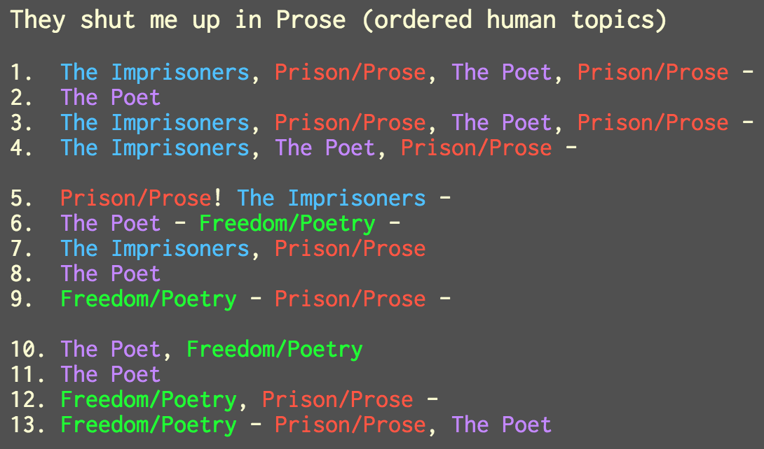

Figure 24. Eleanor Heginbotham’s critical “topics” for “They shut me up in Prose” (F21.6, Fr445A), inserted in the order and structure of the original poem. Commas have been added to separate topics. Vertical bars (|) signify polysemic, overlapping topics.

Having yet to marry Heginbotham’s reading with my topic model of Dickinson’s poems, we have some remarkable conclusions from “reading” this view which would seem and is inherently diminished in its interpretable possibilities. In “They shut me up in Prose”, the poet begins the first stanza surrounded by her imprisoners and prison/prose, either within each line, or between imprisoning lines. In the second stanza, the threat of prison and the imprisoners is met by the poet’s freedom/poetry across its lines. And much like in the actual poem, in the third and final stanza it is the poet and freedom/poetry that overcomes this threat via her/its dominance. Not only are her imprisoners absent from the stanza, but in the final line it is freedom/poetry and the poet that surround prison/prose.

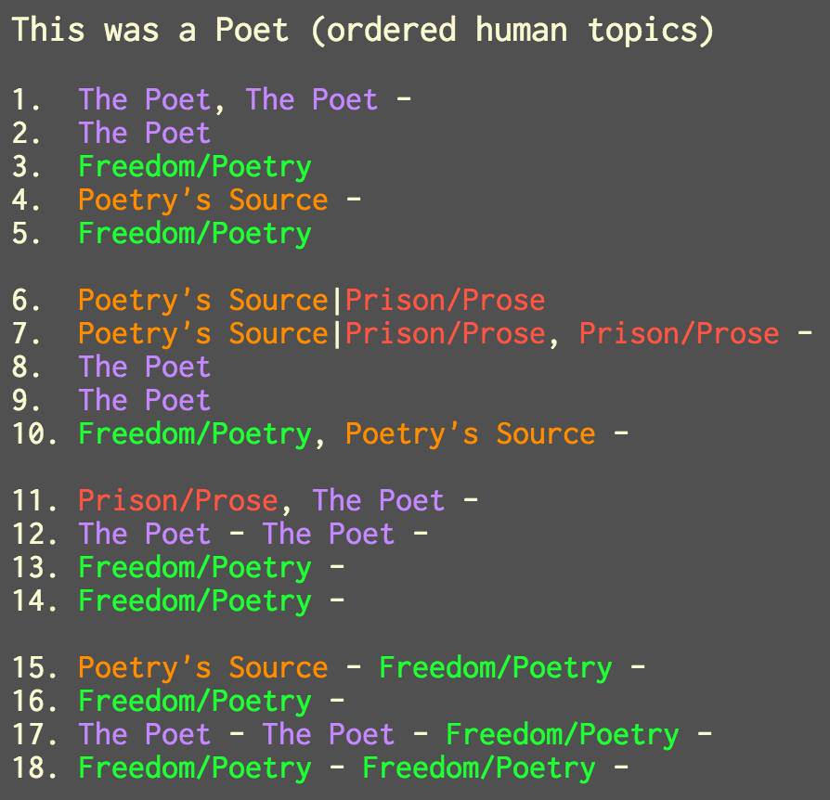

Figure 25. Eleanor Heginbotham’s critical “topics” for “This was a Poet”, inserted in the order and structure of the original poem. (Commas have been added to separate topics. Vertical bars (|) signify polysemic, overlapping topics.)

In “This was a Poet”, the poet establishes her presence firmly in the first stanza. Poetry is then introduced, as is a somewhat innocent description of its source – in the original form. “Ordinary meanings” ironically provide an “Attar so immense” (4-5). Heginbotham explains this ordinariness or “still”-ness as a fate worse than death for Dickinson. It is not until the second and third stanzas that we are reminded more explicitly of prison/prose as being poetry’s source, but also that the poet derives (in the original, “Discloses” (11)) freedom/poetry from that confinement. With the final stanza, the poet has eliminated that confinement and her imprisoners, and is able to fully realize that freedom – “a Fortune - / Exterior - to Time -” (18).

Discursively, we can see that a visual patterning for confinement has been flipped between the poems. In “They shut me up in Prose”, the poet is surrounded by prose until she can break free. In “This was a Poet”, any mention of prose is surrounded by stanzas of freedom/poetry offered by the poet. The weighting of these human topics by text would mimic that dynamic. Of course, as with any sort of close reading, let alone this neo-structuralist one, the interpretive narrative is based upon my own conceptual model of the text. In this case my conceptual model consists of topics established solely or at least mostly by an external source: Heginbotham’s fascicle reading. But remember that even when we look at a topic model, we are approaching the texts its topics represent with some form of conceptual model – i.e. putting labels on each topic – even if we are not intimately familiar with the texts of the collection.

One reason I wanted to go through the exercise above is to illustrate a point regarding computational modeling and the outputs of a close reading. It bears out that the task of human conceptualization of a text, however polysemic, is not unlike computational modeling. The difference is that the work of the Bayesian topic model is not only to confirm what we suspect, but to also determine the relationship and presence of hidden thematics that we did not. The disparity between the two methods seems less stark once put into similar visual form. So though the topic model may not be as capable as human perception, and the human not as capable as the topic model’s ability to detect lexical patterning, there are easily determined points where they disagree, agree, and/or overlap.

The other reason is that such a view brings us one step closer to being able to visualize those points. Specifically, it is the points where they overlap by highlighting the same words that show us different perspectives on those words. The words upon which they disagree, where a topic model disregards words (e.g. stop words) or where a human conceptual model thinks a word derives mainly from a different topic are plain to see. Where the two agree, we already understand as topic word lists that are comparatively easy to interpret and align with our preconceptions. The overlapping words however can display where the models converge but from sometimes entirely different perspectives.

There are many ways to slice and organize this overlap in the data sets, and many views that would result from posing the weight of Heginbotham’s model against MALLET’s topic model. But here’s one way to do it. For human topics, I’ll count the number of occurrences of a human topic (as seen in Figure 23), and use those frequencies as weight values.[40] The multiplied products of these model weights yields a discursive dynamic that is reflective of both the topic model as well as the human critical model. Below I’ll provide two views of this discourse using the data in this way: one intra-textual and one inter-textual, one favoring the perspective of the topic model’s topics and the other favoring the perspective of Heginbotham’s topics, respectively.

First up is a view of both poems by themselves. By eliminating instances where only one model regards a word as derived from/representing a topic, we get the desired overlap in models. The combined weight for this view and for the one to follow will utilize a relative weight that comes from multiplying the combined topic model weights (like those shown in Figure 19) with the number of instances where words represent a topic in the human model. Since I want to show the topic model’s perspective of what this new weighting would look like, words will be labeled with their MALLET-generated topic ID and TWiC-generated color. The image below shows those topic words re-inserted into their original stanzas, with font sizing scaled by that new relative weight.[41] Uncolored words are words that do not appear as related to topics in *both* models. Next to each colored topic word is a parenthetical listing of its MALLET topic ID, topic prevalence ranking for the text from the MALLET model, and the relative weight that combines MALLET and Heginbotham’s model.

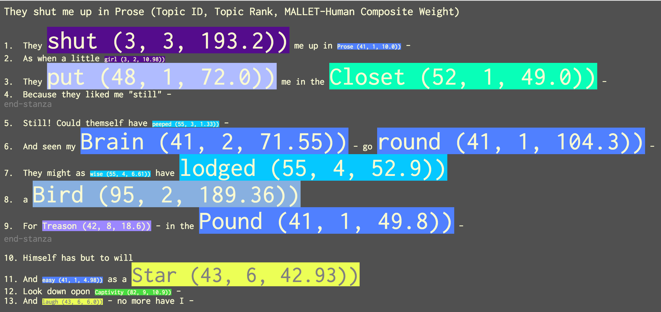

Figure 26. “They shut me up in Prose” (F21.6, Fr445A) in a view that displays the overlap in topic words from the MALLET topic model and Heginbotham’s “topic” model. Topic words are scaled by a weighting scheme that features both models’ topic weights.

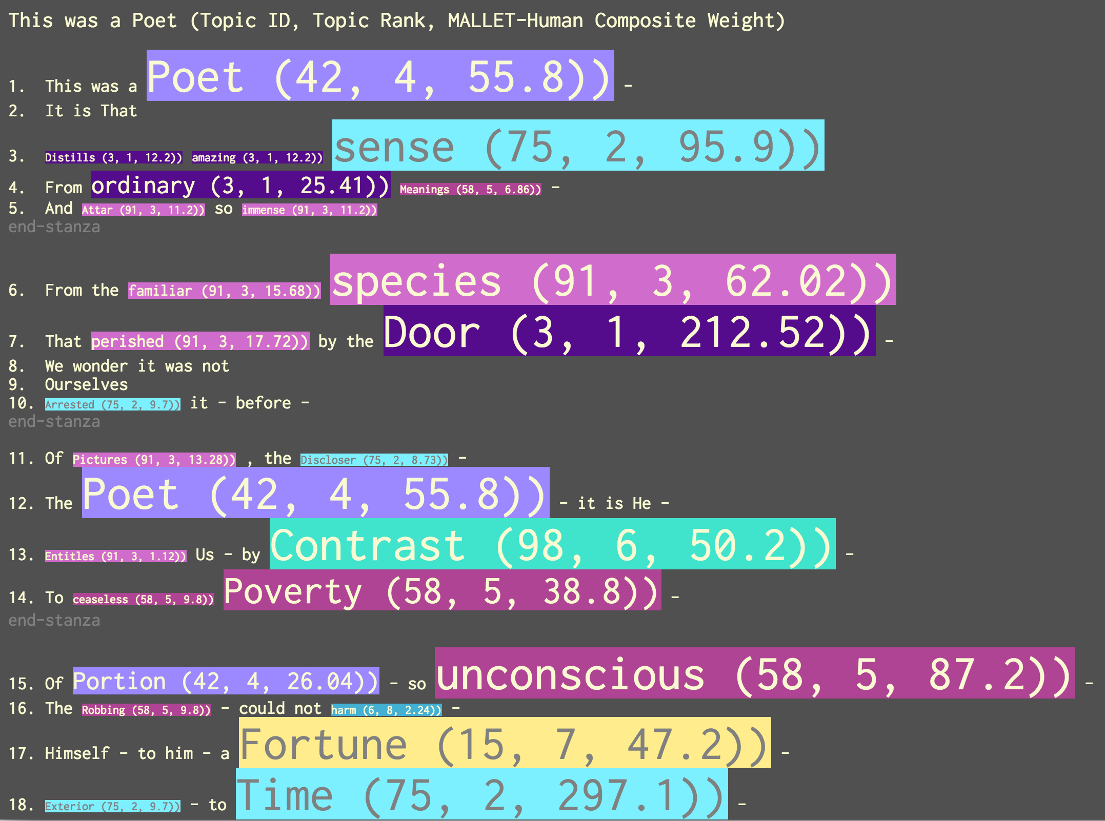

Figure 27. “This was a Poet” (F21.7, Fr446A) in a view that displays the overlap in topic words from the MALLET topic model and Heginbotham’s “topic” model. Topic words are scaled by a weighting scheme that features both models’ topic weights.

Much could be said about the two figures above. I think they offer particularly rich ground for new intra-fascicle readings of these poems and others. It does take a bit of work to get to a point like this where we can compare a topic model with our own conceptual model, but with views like the overlapping one above we can get a fuller sense of how our perceptions are brought into play when looking at texts that have been topic modeled. I won’t linger too long on the reading here for either poem – as the journey to this point has been lengthy – but I will note a few things. One aspect of the view of “They shut me up in Prose” might be familiar. Again we see that “shut” and “Bird” seem to loom over the other words given their weights, and I think it would be safe to say that this is a good example of how a topic model can bolster our well-thought-out conclusions on what is essentially a small grouping of figurative language. The “shut” of topic 3, a word that figures highly in the topic, agrees well with Heginbotham’s theme of a fear of imprisonment, as does topic 52’s “Closet”. Topic 91’s “Bird”, a.k.a. Dickinson, has her “Brain” going “round”, two words linked to the activity of poetry in both models, and if you look closely, these words are also seen as having some sort of lesser relationship to “Prose.”

Similarly, in “This was a Poet”, in descending order “Time”, “Door”, and “sense” stand out, each with a weight of 100 less from each successive term. Topic 75’s “Time” linked to the “soul”, “eternity”, and even another use of the “brain” – harkening back to topic 91 – we know figure prominently in Dickinson’s other poems. This is the boundless, metaphysical playground, where topic 58’s “unconscious” art renders “amazing sense” or the “Fortune” that is poetry can be developed by the “Poet” of topic 3 – a prominent topic and thus a presence in both poems. Perhaps what is most surprising about this view is the prominence of “Door”, a word that represents the prison of prose, a theme that if you recall from earlier analysis seemed to disappear in prominence moving from “They shut me up in Prose” to “This was a Poet”. But since it still figures so prominently here in what would otherwise figure as a formalist reading, we could conclude its high weighting relates to its corpus-level dominance in topic 3.

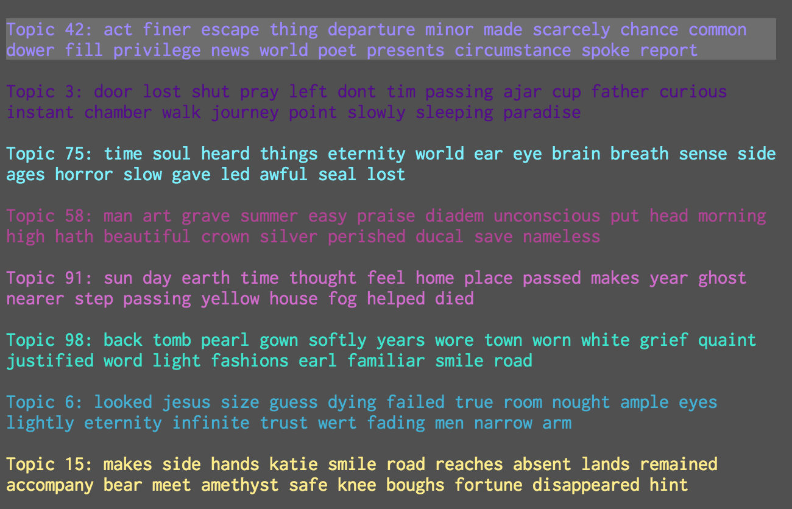

Figure 28. Topics of “This was a Poet” (F21.7, Fr446A) in the order in which they are introduced in the poem

And that brings us to one last view, what is perhaps an intra-fascicle view even closer than the previous one (Figure 23) where I was counting instances of human topics. By taking the same weighting scheme that combine’s MALLET’s topics with Heginbotham’s, we can simply switch our topic lens and take a look at how the overlap in topics looks more from the perspective of Heginbotham’s model.

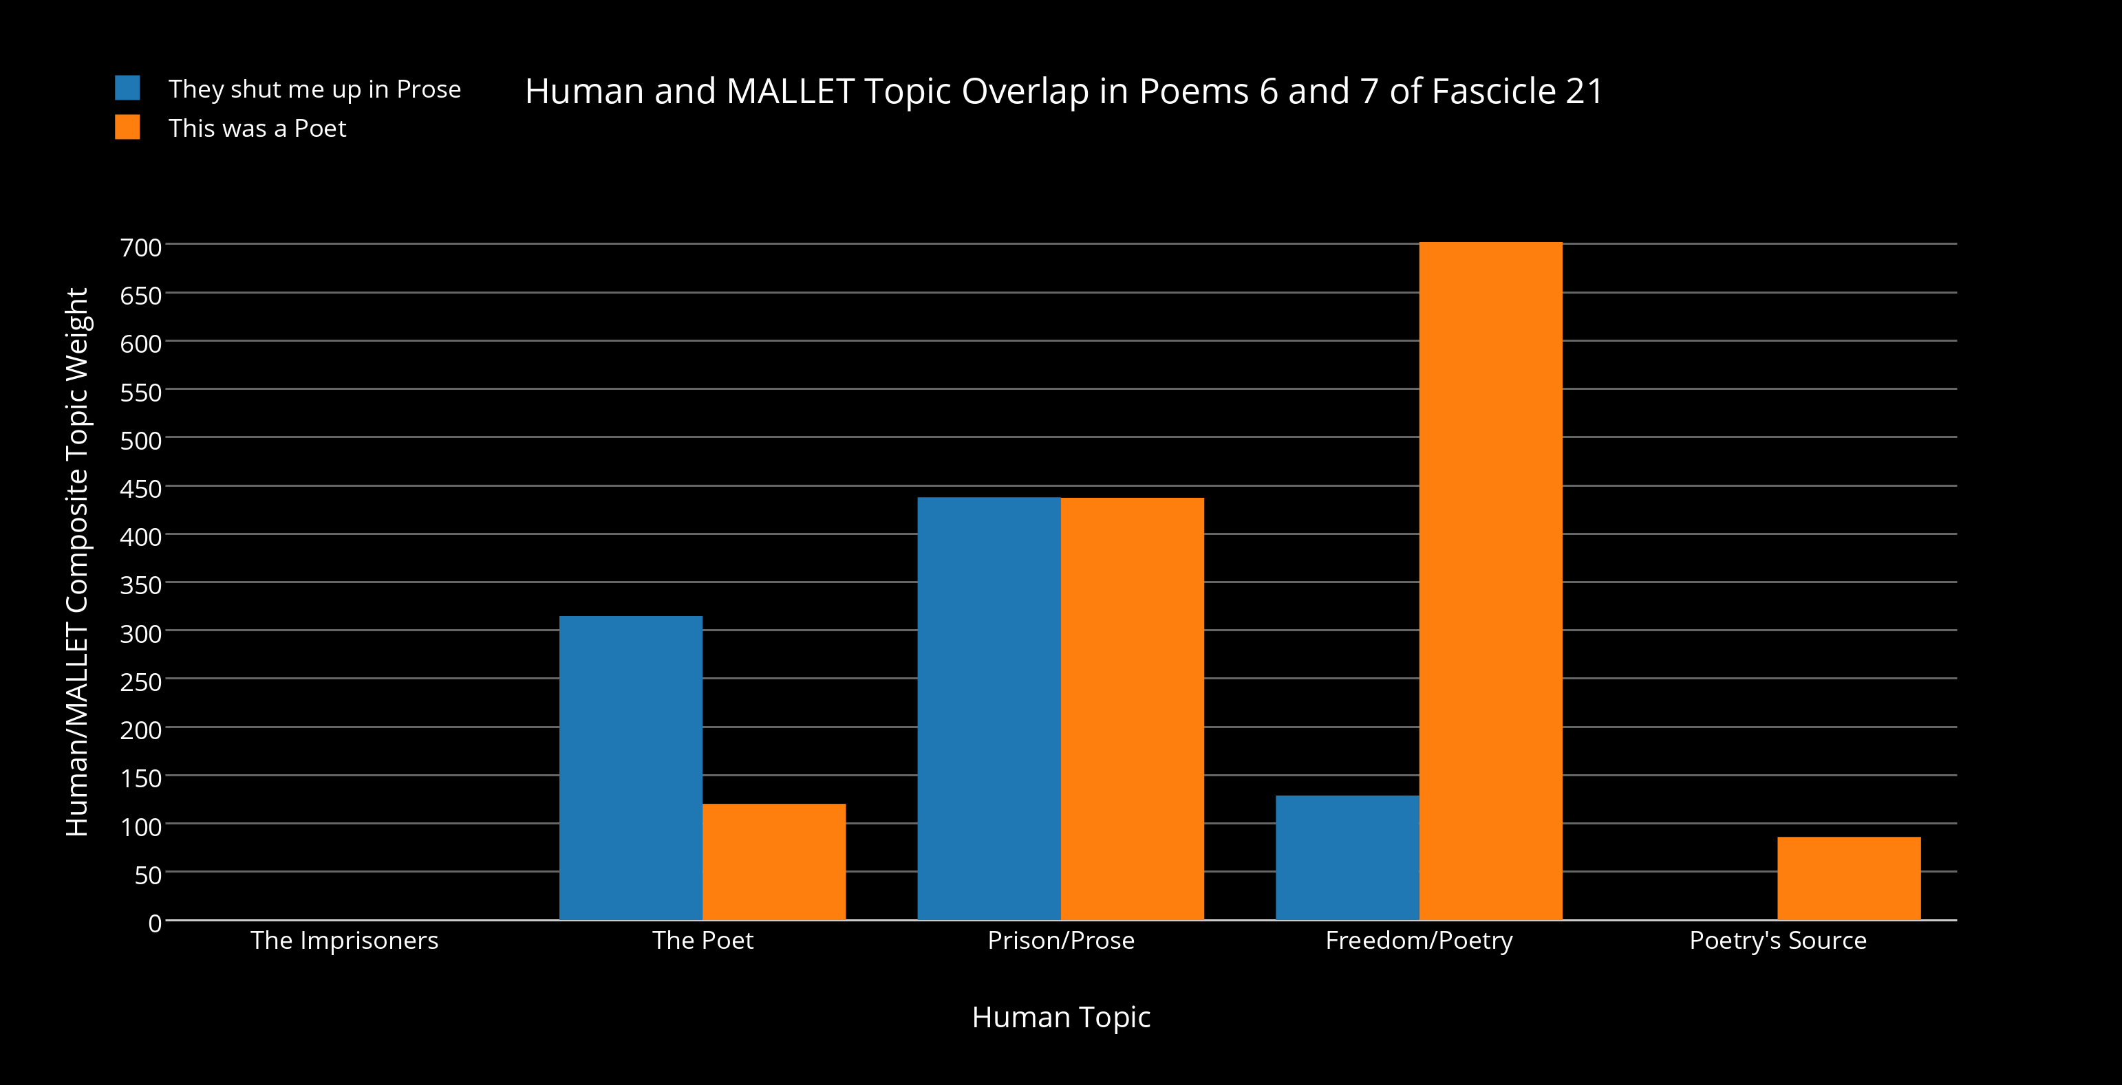

Figure 29. “They shut me up in Prose” (F21.6, Fr445A) and “This was a Poet” (F21.7, Fr446A) in a view that displays the combined weight values of topic words from the MALLET topic model and Heginbotham’s “topic” model. This view features Heginbotham’s categories in a comparative bar plot.

From the perspective that Heginbotham provides, this appears to be a very confusing chart. This comparative bar plot is not simply graphing a count of the frequency of her categories as they appear in either poem though. Not only is this a combined weighting between the topic and human models, but it is also a relative weighting of her categories across the two poems. Both of these understandings help explain some of the counterintuitive values in Figure 29. “The Imprisoners” has vanished in prevalence from both poems in the graph. Taking another look at views of the topic model’s words re-inserted into poem contexts (e.g. Figure 9) and the previous highlighted views of Heginbotham’s criticism in this section (Figures 21-22) shows that the reason is because they are only mentioned as the third-person pronouns, “they” and “themself”, and are in the topic model’s common stopwords list. Since “They shut me up in Prose” features the use of “Bird”, it exceeds the presence of “The Poet” in the latter poem, and this makes sense when you consider that the topic model has determined that references to birds (184 occurrences in the corpus) – which are indirect references to herself, the poet – feature quite prominently in Dickinson’s oeuvre, certainly more so than her direct references to “poets” (18 occurrences). In this light, these combined weight values are less about occurrences (like Figure 23) than they are about the overall certainty of a thematic presence in a text. To do the math for her topic “The Poet” upon which these figures are based – multiplying the topic weight of each overlapping word by the number of instances of the human topic in both poems and then adding all of those products together – “They shut me up in Prose” scores a 314.82 while “This was a Poet” scores to 120.33.

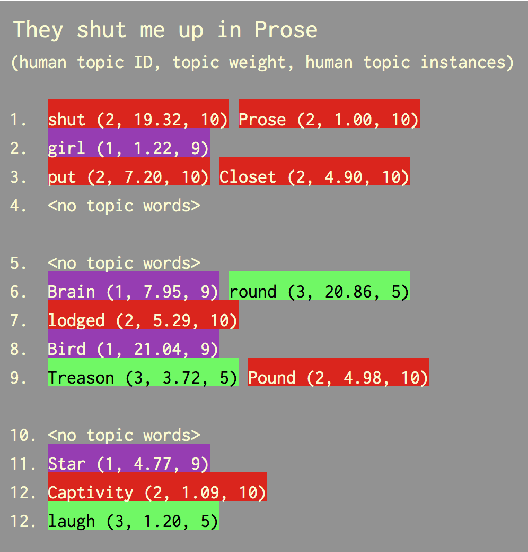

Figure 30. Colored block view of the overlapping topic words in “They shut me up in Prose” (F21.6, Fr445A) alongside the weighting figures used to produce the values in Figure 29.

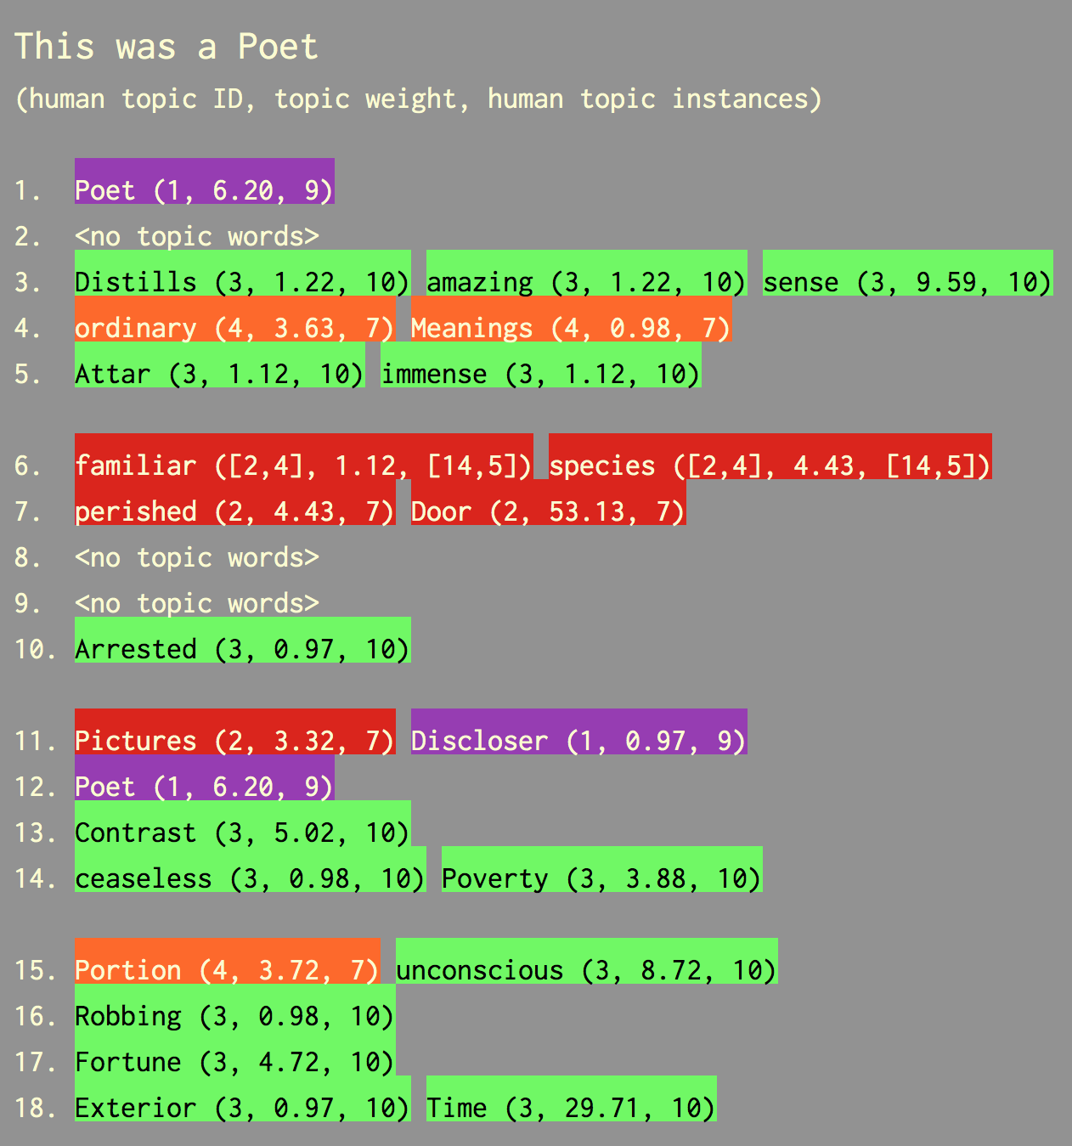

Figure 31. Colored block view of the overlapping topic words in “This was a Poet” (F21.7, Fr446A) alongside the weighting figures used to produce the values in Figure 29.

The dynamic across poems for “Freedom/Poetry” and “Poetry’s Source” is far less mysterious, but never the less bolsters the narrative that poetry is certainly resilient, an extant and prominent thematic moving from “They shut me up in Prose” into “This was a Poet”. The latter also begins a discussion of how the poet operates, and of “Poetry’s Source,” the “ordinary Meanings” from which poetry is derived (4). “Prison/Prose” weighs out across poems similarly. It maintains an even presence throughout both in the graph even though references to this metaphorical confinement are more explicit in “They shut me up in Prose” – notable by its telling first line alone. The reason for this is that “doors” from the “familiar species / That perished by the Door” (“This was a Poet 6-7) figure quite prominently in Dickinson’s poems (88 occurrences in the corpus) in comparison to something like a “Closet” (4 occurrences). For instance, in another poem she writes with much of the same meaning, but from a future in which she had crossed the door’s threshold:

“And now before the Door

I dared not enter, lest a Face

I never saw before

Stare stolid into mine

And ask my Business there –

“My Business but a Life I left

Was such remaining there?”

…

I laughed a crumbling Laugh

That I could fear a Door

Who Consternation compassed

And never winced before.” (“I – Years – had been – from Home”) (F21.1, Fr440A)

What I think can be said about comparing topic models and human conceptual models is that used together they can highlight the strengths and weaknesses of both perspectives. I see this particular usage in the above poem related to Dickinson’s use of “door” in “This was a Poet”. My own conceptual connection serves as a reminder of the important role that human conceptual models and their topics play in the initial weighing of a topic model’s words. To go back to the topic model’s comprehensive access to lexical patterning however, there’s another quite significant aspect of the poem above, “I Years had been from Home”. It is the first poem of the 21st fascicle. You can see this relationship via TWiC’s “Publication View” of this fascicle.[42] This version of “door” does not appear in the topic 3[43] shared by “They shut me up in Prose” and “This was a Poet”, but rather in topic 99[44] where “door” is also the most prevalent word but seems to be involved in a slightly different semantic field. Where topic 3 lists words of exclusion and uncertainty of a future path (e.g. “door”, “lost”, “shut” and “curious”, “journey”), topic 99’s words point to an exclusion that also carries joy and companionship (e.g. “door”, “leave”, “fear”, “despair”, but also “care”, “fellow”, “ecstasy”, and “glory”). They are also bridged semantically beyond exclusion. One of the least prevalent of topic 3’s words is also “paradise.” Of course, this topic relationship would require further careful analysis, but deeply mining the relationship between these topic words in the context of their original texts is something that TWiC was designed to do. To go back to the idea that overlapping human conceptual and topic modeling can play a role in our analysis of texts, TWiC’s “Publication View” provides a telling example. Since topic 99 and topic 3 are considered separately and TWiC currently clusters texts by their top topic, it would not have shown “I Years had been from Home” as being connected to the two poems we have been examining thus far. And yet, placed back into their original publication arrangement, this discursive text and topic relationship has emerged.

**Conclusion**

Topic models currently do not recognize that so-called “function” words have an integral role to play in human (a.k.a. “natural”) languages, but they also can lend explicit weight to words that would otherwise seem to stand by themselves when human critics do formalist and structuralist readings that extend outward to a handful of comparable texts. The fact that topic word lists weigh thcose words by their relative usage in the company of certain other words of a corpus only extends the utility of their usage well above and beyond what a concordance or a computed word frequency count can tell us. In one sense, counting or quantification of words already loaded with rich semantic, stylistic, and contextualizing value offers the same kind of results as topic modeling. They both appear to be a reduction of those dimensions. Critics would say that quantification *is* the crux of digital humanities, methodologically and as a salient reflection of contemporary cultural practice. This view misses the forest for the trees though. In one sense, the building of topics or the generative nature of topic modeling invokes and resembles the relative word frequencies of a text, but it is the *relative* part that we should keep in mind when using it – and just how relative. Many words in a text or a collection of texts can have high frequencies of occurrence, even when leaving aside these often disregarded “function” words. However, what a topic model can convey is which words are important and – due to the assigned probabilistic weights – *how* important they are given all of the words of the text(s).

Though I could certainly continue the analysis of Fascicle 21 and other fascicles, what I want then to conclude regarding TWiC is that in order to fully consider the results of a topic model, the relationships of its outputs – whether it be topic word lists, text-level topic distributions, multi-scale calculations based on those distributions, or topic-level word weights – all must be on hand for the user of a topic model. And in order for that data to be fully expressive, it must also be re-contextualized with the texts that they model. It is my hope that others will find the TWiC visualization useful in their own research and/or the ideas behind its design helpful to understanding humanities usage of topic modeling. As the example of Emily Dickinson’s fascicles demonstrates, there is still much to be uncovered about our texts, should we be willing to make use of this new, computational-critical sense. To return to Uexküll and Eagleman’s *umwelt* and *umbegung*, favoring this new sense allows us to explore it, its strengths and blind spots. It also can re-inform conclusions derived from our other more innate critical faculties. By tracing and re-describing the hidden patterns of language use, we are simply adjusting our focus. We can always re-adjust later and compare.

For the future study of Emily Dickinson’s fascicles, I think that TWiC and my writings about topic modeling here provide promising avenues for investigation. Not only can they provide new assessments of the fascicle poems, but they can also tell us how we can situate those assessments among prior criticism of these works. The latter may and should not be just something to disregard in favor of computational models. Rather, in similar fashion to what I have done with Heginbotham’s fascicle criticism in my analysis, we can also do with the conceptual/critical models of others – weighing out the value they have juxtaposed against those given by our new computational methods. This can also give us necessarily, quantifiable metrics of the efficacy of those new methods. On the other hand, the ability to visually explore topic models via TWiC (as well as some of the other advanced visualizations I described previously) facilitates something perhaps unexpected from such quantification. Recall Dickinson’s words: “Incredible the / Lodging / But limited the Guest” (Fr1452A). If, like I demonstrated at the end of my analysis, we take our new sensory inputs and new comprehensions of these “topics” and adjust their focus to include our prior knowledge of those topic words, we can extend our older sensibilities. To frame that concept in the world of literary theory: the humanities can establish new grounds for reader reception theories, and do so with the basis of computational modeling. In the case of Dickinson criticism, this concept extends beyond the important fascicle scholarship like those of Cameron, Heginbotham, Shurr, Rosenthal and Gall, and more. It includes the writings of those who read Dickinson’s poems without the restored manuscript contexts, or those interested in individual works and fragments. It also can be seen as a way of extending Dickinson’s own writing, for despite her poetic talents, she was after all, operating within a similar (if heightened) umwelt as the rest of us. Might scholars and Dickinson enthusiasts use such tools and the new senses they imbue to create new arrangements of her poems? These are our new fascicles.

**Special Note on How to Use TWiC and Online Documentation:**

**Documentation:** In addition to the information provided in Appendix A, detailed documentation on TWiC’s components and how to use it can be found at <https://github.com/jarmoza/twic/blob/master/README.md>. Future readers looking at this writing (e.g. post-2016), should defer to this documentation should instructions on running TWiC be changed in future versions.

**Usage:** A demo of TWiC has been hosted at New York University for easy test use. For the purposes of this writing, TWiC is hosted on a server at New York University at the URL: [i6.cims.nyu.edu/~jia237/twic/twic.html](http://i6.cims.nyu.edu/~jia237/twic/twic.html) (*Username:* digital *Password:* humanities). This may take a few moments to load. The recommend usage is to “zoom out” two levels on the Google Chrome web browser and refresh the page – this will allow for optimal TWiC use via the i6.cims server.

**Alternate Usage:** If not currently available at this site, TWiC can also be downloaded at [github.com/jarmoza/twic](http://github.com/jarmoza/twic). It can also be run via the method suggested on TWiC’s github documentation, README.md. These instructions are also listed in the section of Appendix A entitled “Running TWiC in the Browser.”

**Appendices**

**Appendix A: The Technology of TWiC**

TWiC was a sizable venture, and it bears at least a brief bit of writing to discuss the implementation and technologies involved, though they may be of less interest to those interested only in the broader strokes of this thesis. The research, design, and implementation of TWiC were quite extensive, consisting of months of development and resulting in thousands of lines of code. Not counting the dozens of test and alternate scripts, technology experiments, MALLET’s Java code, other external code libraries, and data analysis scripts that are not actively employed in a typical running of TWiC, my entire codebase consists of 13,231 lines of code. That means from corpus modeling to data interpretation to its display in the browser, TWiC runs on *at least* 10,140 lines of JavaScript, 2,881 lines of Python, 156 lines of CSS, and 54 lines of HTML – all written, debugged, and tested by me. It’s not that the large size of the codebase describes its contents all that well, but it does accurately depict the mountain of work involved in creating something like this visualization from scratch. I had many sources of help along the way. Some were books and articles documented in my bibliography. Others were countless posts on sites like [stackoverflow.com](http://stackoverflow.com) or [w3cschools.com](http://w3cschools.com), and of course, many discussions with peers and mentors, some of whom are mentioned in the “Acknowledgments” section of this writing.

To give an overview of how TWiC works in one pass from start to finish: (1) users begin by running a Python script local to their computers that takes their corpus and models it with MALLET. (2) The script then interprets MALLET’s output files and produces a set of its own output files built for the visualization code. (3) Depending on how users wish to serve those files, they point their web browser to a URL where TWiC’s main HTML file sits or where a server program is serving that HTML file. That HTML file calls a JavaScript file that utilizes my library of JavaScript to produce the TWiC visualization. This currently comes up as one of two initial pairings of panels, internally described by the code as “levels.” Users either see a level that initially includes the “Corpus View”, “Topic Bar” and “Data Bar” (via twic.html) or a level that includes the “Publication View”, “Text View”, “Topic Bar”, and “Data Bar” (via twic_publication.html). Since TWiC is still a prototype, albeit a highly developed one, these two levels are currently only accessible separately. In fact, it should be noted that since future implementations of TWiC are meant to be highly customizable, TWiC is designed so that the main JavaScript file that drives the visualization (twic.js) can set up a TWiC level with any of the panels it chooses to instantiate. Once a corpus is modeled via MALLET and interpreted by the Python script, users only have to execute step (3) through their web browser in order to use the visualization itself. The rest of the appendix below is divided up into three descriptive sections pertaining to the above process: the corpus, and server-side and client-side code.

**The Emily Dickinson Corpus**

The corpus used for the model discussed in this writing began as a series of 4,825 TEI files retrieved from the server endpoint, <http://www.edickinson.org/editions/1/works>, at the “Emily Dickinson Archive.” Assistance in locating this endpoint and understanding the naming scheme of the TEI files was provided by Emily Arkin, Senior Editor for Digital Publication Development at Harvard University Press. What was clear after parsing the XML fields of these TEI files is that the staff overseeing the encoding of the Dickinson poems had transcribed all poem versions and variants from several publications. Most of these come from the two well known Emily Dickinson manuscript companions, *The Poems of Emily Dickinson* (1955) by Thomas Johnson (1,776 poems) and *The Poems of Emily Dickinson: Variorum Edition* (1998) by R.W. Franklin (1,789 poems and more variants, an updated version of Franklin’s original *Manuscript Books of Emily Dickinson* (1981). The other source publications are Mabel Loomis Todd and Thomas Higginson’s *Poems by Emily Dickinson* (1890, 115 poems), *Poems by Emily Dickinson: Second Series* (1891, 166 poems), *Poems by Emily Dickinson: Third Series* (1896, 165 poems), and Martha Dickinson Bianchi’s *The Single Hound* (1914, 143 poems). This collection includes poems duplicated across all of these publications. Since topic models are weighted by the instances of words used together, one of the first Python scripts I wrote was to pull metadata fields and poems from the TEI files, and assess their similarity in order to de-de-duplicate the sample corpus as much as possible. This curation script proceeds as follows: (1) compare each poem of the corpus to each other, line by line and count the number of similar words, (2) produce a similarity score based on these results, (3) group poems by similarity score, and (4) compare the publication dates of poems with high similarity scores, and (5) take the poem in that group with the latest publication date. Variant phrases, one of the more studied aspects of Dickinson’s poetry, were discarded as well.

There were a few rationales behind this somewhat crude method of corpus building. One was that through initial modeling of all 4,825 files, topics that were notably similar were being produced, thus mucking up the potential source of analytical insight. Another was that this would be less a study that intended to provide accurate analysis of Dickinson’s oeuvre via a topic model and more one that would proof that this text mining method could be used to do so at all. In a future, more formal study of the fascicles using topic modeling and TWiC, scholars should take care to select poems by the goal of their inquiry. For instance, one could choose just to model the language used in the fascicle poems. I decided that poems outside the fascicles would likely have informed the writing of the poems within them, but one could decide the opposite. And in that case too, the scholar would have to choose whether or not to include duplicate poems and poem variants, especially as the fascicles contain multiple instances of both. As Heginbotham, Sharon Cameron, and others have pointed out, the duplicates and variants in the fascicle books may be more than mere oversight. They may allude to Dickinson’s editorial choices and intended internal thematic structure(s). The result of my own programmatic curation was a set of 2,033 TXT files, containing just the plain text version of each poem. All TEI-XML metadata was removed in preparation for topic modeling. Multiple spaces were output as single spaces since MALLET does not consider whitespace characters. Because of issues with character encoding in MALLET, and its disregard of punctuation, em dashes (–) became hyphen-minus (-) characters.

**Python: Server-Side Code**

**How to Run: Modeling a Corpus and Readying it for Visualization**

TWiC’s command line or “server-side” code runs in one interaction. At the computer’s command line interface, the Python script twic_corpus2vis.py runs from TWiC’s “code/general/py” folder, and the user waits for it to finish before starting up a web server (either locally in that directory or remotely for more technologically-advanced users) to serve its HTML file(s) for a web browser to read. The Python script is supplied a few run-specific arguments by the user, though most options/arguments can be changed in “twic_config.yaml.” I will list the run-specific arguments here before describing TWiC’s Python code. These arguments are series of letter arguments that indicate the steps of TWiC’s server-side that the user wishes twic_corpus2vis.py to run. These are ‘g’ - gather texts for modeling from a user-supplied folder and copy them into TWiC’s corpus directory, ‘c’ - make sure to clear old MALLET output files, ‘m’ - run MALLET, ‘i’ - interpret MALLET’s outputs into TWiC’s intermediate JSON data files, and ‘k’ - do not delete files from TWiC’s corpus director before gathering new texts. Arguments in the YAML file are (1) the user’s corpus source folder, (2) the internal name users want their corpus to be referred to as (this will be used to name the mallet output files and more), (3) the full corpus title users wish to be displayed in the TWiC visualization, (4) the number of topics, (5) the number of modeler intervals, and (6) the text chunk size for larger corpus texts. A typical run of the twic_corpus2vis.py script will look like this:

*python twic_corpus2vis.py gmi*

However, since this writing deals with the Dickinson corpus, there is no need to run this step, unless a user wants to generate a new model. The topic model described in this writing is included in the github repository, and one only need follow the steps described in the beginning of the JavaScript section of this appendix in order to run the TWiC visualization of the topic model of Emily Dickinson’s poems – start a server pointed at TWiC’s root folder and load up “twic.html” or “twic_publication.html” in a web browser.

**Internals**

TWiC’s Python code is written in Python 2.7. It uses what’s known as an object-oriented method of dealing with the data objects it must read in, handle, and re-interpret. When reading texts for modeling for example, it learns much about them before they are even sent to MALLET. It determines statistics of the text and if running the custom code for the Dickinson corpus, it will actually learn about the stanzas and lines of the poems, and use that data to compare them for similarity purposes. The scripts also build an internal object to handle the running of MALLET, which stores and supplies arguments (e.g. topics, intervals, stopword lists, source directory) for the MALLET’s various sub-steps that eventually produce the topic model. These arguments also include a XML-type regular expression that shows MALLET how to interpret and split the words of the corpus it encounters. So for instance, it knows how to handle words that contain punctuation when it encounters them. If I wanted to maintain hyphenated words as singular words and not split them, I would do that there.

Once MALLET’s run is finished, TWiC’s Python code generates a random color palette for each topic of the model (though a custom palette ability will be made available in future releases of TWiC). The code takes all of MALLET’s output files: topics, corpus-level topic weights, text-level topic weights, state file, and topic word weights and loads them into in-memory objects for easy handling. The code then makes other necessary calculations for determining the relationships between the levels of the topic model data. For instance, it makes Jensen-Shannon distance calculations based on the distance between the average topic distribution of each cluster of texts and the average topic distribution of the corpus, and so forth. The code takes all of that information and puts it into three JSON (JavaScript Object Notation) data files called twic_corpusmap.json, twic_corpusinfo.json, and twic_corpus_wordweights.json for the visualization to read. It also creates JSON files for each individual text, so that they too can be loaded by the visualization when its topic rectangles and topic-rectangle/text related views need to be loaded. All of this work is done on the user’s machine (by Python) because they would be relatively computationally- and memory intensive- processes to undertake as dynamically as the visualization on the web browser would require. Once the interpretation of MALLET’s outputs is finished, the visualization is ready to be run.

**JavaScript: Client-Side Code**

**Running TWiC in the Browser**

TWiC on the “client-side” or browser-side is currently driven by one of two HTML files: twic.html or twic_publication.html. Colors, fonts, and spacing of its HTML objects are styled by its twic.css file. The most visible part of TWiC, its interactive visualization, was written almost entirely in JavaScript. Overall, the reasoning behind the distinct object-oriented JavaScript hierarchy is to allow for consisted method-driven execution flow between its internal objects. All of the in-memory objects described in this section exist within that hierarchy. To run TWiC, a user runs a Python module called a “SimpleHTTPServer” at a particular port address (e.g. 8080) from TWiC’s top (a.k.a. “root”) folder. If on an Apple computer, the user runs the “Terminal” application. Then using the standard Python included on Apple computers (2.7), the command line instruction would look like:

*python -m SimpleHTTPServer 8080*

And for Python 3 users:

*python -m http.server 8080*

The user then starts up TWiC’s visualization by entering “localhost:8080/twic.html” or “localhost:8080/twic_publication.html” in the browser address bar. TWiC currently works best and was mostly tested on Google’s Chrome browser. If its visuals appear larger than or distorted in comparison to the screenshots in the “Topic Words in Context” section of this writing, the suggestion is to restart the browser, use the browser’s zoom out functionality, and to then load TWiC via the address bar. TWiC’s panels and shapes will resize according to the browser’s current zoom level. One JavaScript file must be edited to run the Dickinson corpus included in a download from TWiC’s github directory. At the bottom of twic_level.js make the following alteration:

namespace.Level.prototype.s_jsonDirectory = “data/dickinson/input/json/”; //namespace.Level.prototype.s_jsonDirectory = “data/input/json/”;

As default download of TWiC is readied for the corpora of users, this change will allow TWiC to read from the included Dickinson data directory.

**D3 (Data-Driven Documents)**

TWiC makes use a few third party code libraries, but most of it is custom, object-oriented code written by me utilizes a library called D3. D3, which stands for “Data Driven Documents” (see <https://d3js.org/> and <https://bost.ocks.org/>for examples), is a JavaScript library specifically designed to help link a subset of graphical, web browser HTML tags known as SVG (Scalar Vector Graphics) with data sets. It enables the dynamic adding of these SVG tags into the Document Object Model (DOM) that JavaScript uses to represent (in memory) the HTML tags and stylistic attributes that make up a web page rendered on a browser. Thus, using D3, one can write code that will display entirely different visuals depending on the data set that that code is given. This is how TWiC is able to load its intermediate data files (e.g. twic_corpusmap.json, twic_corpusinfo.json, twic_corpus_wordweights.json and all the individual text JSON files) and dynamically display what that data looks like using TWiC’s graphical data shapes and panels.

**Levels and Panels**

Internally, TWiC considers a collection of panels to exist within a “level.” TWiC’s panels are divided up into two subclasses: graph views and information views. This division is just to mainly keep a distinction between panels that display levels of the topic model and those that display its metadata. The graph views include the “Corpus View,” “Corpus Cluster View,” “Text Cluster View,” “Text View,” and “Publication View.” The information views include the “Topic Bar” and “Data Bar.” When the main script twic.js runs, the code determines which of these panels are loaded and with what mouse behaviors they are linked. So for example, when the “Topic Bar” is loaded, it says that any time any of the other panels encounter a mouseover event, trigger its “Update” method with information about the shape being moused over. This will result in the appropriate topic word list being highlighted inside of it. TWiC currently uses two versions of a level. One is loaded via twic.html, with the “Corpus View,” “Topic Bar,” and “Data Bar.” The other level is loaded via twic_publication.html, with the “Publication View,” “Text View,” “Topic Bar,” and “Data Bar.” Since I wanted TWiC users to encounter only a few panels at first, and then be able to “dive down” into the lower levels of data of the topic model, the level code also understands how to respond when a TWiC data shape is double clicked. It checks to see if the panel “underneath” it is loaded, and if not it triggers the appropriate resize and reposition animation. If that panel has already been loaded, it sends information on the data shape being clicked to that lower panel so that the view can be switched to show the lower-level data shapes underneath that clicked, higher-level data shape.

TWiC panels are made resizable via a combination of my own code and the jQuery JavaScript library (<https://jquery.com/>). They also reposition themselves automatically, trying to fit themselves into the smallest available amount of space. This is accomplished via a JavaScript library called Packery (<http://packery.metafizzy.co/>). TWiC panels are also divided into three portions: panel controls, title bar, and main body. The Apple OS X-like stoplight controls allow the user to hide (red circle), reduce to a minimal size (yellow circle), and maximize to fit the browser window (green circle). The title bar loads the appropriate title based on the type of panel and the data being loaded inside of it. The main body contains the relevant data shapes for the particular level of the topic model or the metadata it represents. This is discussed in more detail in the “Topic Words in Context” section of this writing as well as in the github documentation. Panels follow an internal code model of initialize, start, and then update. They keep track of how they should respond to mouse behaviors inside of themselves and how those mouse behaviors should be messaged out to other open TWiC panels.

**Data Shapes**

There are several types of data shapes, each are graphical D3 objects that represent elements of a topic model. Each data shape knows how to load and draw itself, and knows how to message its panel when it encounters a change or mouse event. The first is the topic bullseye, which represents the top N (currently fixed at ten) topics of an element in the topic model. The second is the topic rectangle, which displays a miniaturized version of the first ten lines of a text with its colored topic words in view (each line/topic word is itself a graphical line and not text). The topic rectangle is surrounded by rectangular “rings” representing the top N (currently fixed at five) topics of the text. The third data shape is actually the text itself. The insertion of text into a D3 object was no trivial matter. Since SVG-based text does not have all the well-established formatting of HTML, it ultimately was dropped from TWiC. However, since D3 is built to interact with SVG objects, and not a foreign body like HTML, special event based code was built to allow for the interaction between the text and TWiC’s other D3 objects. The last TWiC data shapes are the tiles inside of the “Data Bar” – divided into two subclasses of data tiles, topic tiles and metadata tiles.

**Github and Future Development**

The full topic model of the Dickinson corpus and source code for TWiC are too lengthy to be included here, and will remain for the foreseeable future at the popular code repository website Github, as will its other input and output data files, analytical scripts, and documentation. However, the following Appendix B will contain for readers inspection, the corpus-level topics and their weights and stopword lists. The URL for this project is <http://github.com/jarmoza/twic>, where you can view TWiC’s detailed description and usage documentation (housed in the file README.md) for further use with the Dickinson corpus and any other corpora. All future features being developed as well as bugs being fixed are listed in TWiC’s “Issues” section on Github. Those include the addition of a search bar to allow users to search for texts, words, topic words, and the addition of custom color palettes for topic colors. Some future bug fixes include better data shape collision spacing, better resize ability that responds to things like browser window size changes, and some other D3-related topic highlighting issues. TWiC may be added to Stéfan Sinclair’s “Voyant Tools” in future iterations. Also currently in development is a prototype website that will give users the ability to show an interactive and customizable “archive” of TWiC’s outputs, using its topic rectangles as icons for texts, and producing some of the analytical views as seen in the Analysis section of this writing.

**Appendix B: Topic Model**

**Topics and Raw Corpus-Level Topic Weights (Ordered by Topic ID)**

|  |  |  |
| --- | --- | --- |
| **Topic ID** | **Corpus Topic Weight** | **Topic Word List** |
| 0 | 0.05004 | heart make wind bird fair rose single delight spare proud break ear arctic heavenly lady stops base invisible noise lone |
| 1 | 0.04978 | purple east west day mountain eye mystery solemn rest amber days parting sunset north south evening faithful lets renown alike |
| 2 | 0.04112 | joy wild men tight push born gate gown advance shut mind sown bog despise vaster bough visited burdock’s tent prognostic’s |
| 3 | 0.04665 | door lost shut pray left dont tim passing ajar cup father curious instant chamber walk journey point slowly sleeping paradise |
| 4 | 0.04441 | music blossoms bubble career summer’s bird shorter hum hand miles robins lie dew morning heaven tare sister tomorrow tune year’s |
| 5 | 0.05661 | grace sweet heaven face deity show love transport shone foreign beauty truth change names sigh clear place remember lack chose |
| 6 | 0.05049 | looked jesus size guess dying failed true room nought ample eyes lightly eternity infinite trust wert fading men narrow arm |
| 7 | 0.04794 | day wear touch crown thing royal heard snow degree king gold god afraid rank fear hold small life woman sigh |
| 8 | 0.0466 | grass death pass thought face sovreign affliction solitude stay sod dropped suddenly trade inferred bell street loaded presence possibility broke |
| 9 | 0.06535 | death love life live die grave immortality died lived show alive faith hell prove breath dost date doubt calvary remaining |
| 10 | 0.04947 | soul spirit flesh make unknown grown cease arm leads touch giant power future arrow adamant identity estranged partook sickness condemned |
| 11 | 0.04815 | sea heart brook feet blue brooks river made scene seas wells adjust dry startled breaks acres signal wearing beloved grow |
| 12 | 0.04413 | fingers touched home glass passed road hungry held felt left wood curious windows words stir hand fled fluttered superior satin |
| 13 | 0.04331 | home day wings church long heaven boy sings hope sabbath god prison wear bobolink suppose play dome bell lot orchard |
| 14 | 0.0438 | time victory joy defeat bells drums glad calvary positive result faith disdain wished slain conclusion presuming obtained prospective penurious fear |
| 15 | 0.04247 | makes side hands katie smile road reaches absent lands remained accompany bear meet amethyst safe knee boughs fortune disappeared hint |
| 16 | 0.05506 | heart forgot blame poor hand late forget notice rich remembered knew hoped harm face touch borne luxury pace suffered sleep |
| 17 | 0.05135 | nature human awe nature’s lightning laid pink hue fire furthest summer exists shining drawer citizen sun volcano glove dropt conscious |
| 18 | 0.04925 | things put grace death buy death’s choose man life’s fond life action breathed gifts people opportunity violet latitudes unique circumstances |
| 19 | 0.0427 | news face knew thing paradise feel love trust laid reportless diviner appalls peter docile hints constancy caspian fight sweeter domingo |
| 20 | 0.0457 | realm distance hair block retrospect food faces taste reprieve suppose shook fate stimulus clothes penury realms vail years time’s beloved |
| 21 | 0.048 | flower bride bring make hide flowers gay tune bee maid hair softly hundred merry dower drunken bright thine liquor bestow |
| 22 | 0.04432 | foot day shore reason vitality revolution nearest appalling pod cheek endure die angels hast overcome league emperor april route mansion |
| 23 | 0.04366 | hand sir grand sleep friend deep land houses understand people eternity supposed brave cry stone chosen green vanished century skip |
| 24 | 0.04384 | seed truth infinite nature equal triumph steady exist good palm kinsmen longing invited supreme shun preferred significance plated bloom iniquity |
| 25 | 0.04758 | heart art vast company nay immortality accent visit dwell hill ascend ride fuzz rapture chamber instinct society bells hundred black |
| 26 | 0.04628 | hands abroad simple hand dust birds full leaves waters common sunshine hold cattle flung bow glee put showed drop tree |
| 27 | 0.04644 | sea son god father miracle firmament plank tonight built told tale hath storm mansions faith west shunned bridge crowd sails |
| 28 | 0.06692 | day night morning morn sunrise noon sun dawn place birds sunset east midnight men sleep summer’s home tired wake slow |
| 29 | 0.04937 | lost bore ring soul small loved home voice flower people grave satin held head born garden found sow guess riddle |
| 30 | 0.04169 | faith speech word laurel feet stately needle tree everlasting lay fell behold air bond vail fail unknown faces troth spurn |
| 31 | 0.04547 | lord stranger lift dare stand asked purple hide wait live test hat host deny curiosity witness round shy sweetest alms |
| 32 | 0.05471 | stop hour long centuries slow count short foot ago show pain cross end larger bed grow hang stem wait size |
| 33 | 0.046 | robin nest rest early thine father bold secret town death history bird pencil punctual hand native fold tenderly playmates industrious |
| 34 | 0.04099 | boys morning girls men territory means lover miles lonesome afternoon bethlehem docile subjects flood raised experiment dawn sighing revelation savior |
| 35 | 0.0538 | good night sight put heart turn weary bye part side passed joy head singing pleasure brain tomorrow martial run fire |
| 36 | 0.04352 | bird knowing dying open birds feathers return door light long suspense strong home hurts found angel delight crumb abyss reluctant |
| 37 | 0.04522 | thing man today immortality fame honor power death yesterday gathered superfluous equally sight fact instant delight sorrow discern extatic leaning |
| 38 | 0.04816 | fly lie die sky light low window seek barn child flake queen spotted face butterfly chastened day chivalry peculiar affection |
| 39 | 0.04816 | hill rose sun care feet head awkward low immortal grew chimney deeper gay pretty drew pane cheek busy felt twilight |
| 40 | 0.04553 | day gold riches deem poverty broad gem pearl power prove queen wealth estate taught fingers play india scarce exists stint |
| 41 | 0.04826 | god round sky pass back heaven superior cloud hid ourself turned brain possibly finished slowly pound subject triumph clouds conviction |
| 42 | 0.0456 | act finer escape thing departure minor made scarcely chance common dower fill privilege news world poet presents circumstance spoke report |
| 43 | 0.04792 | die sweet dying recollect day easy full general breaking forgetting answered nature wolfe murmur comprehend recollecting drama permission fainter rendered |
| 44 | 0.04839 | slow day read eyes letter left hear finished happy strove fingers knock learned final stars sentence guessed begun seam consciousness |
| 45 | 0.04371 | heaven hour stir thought borne belief parties demand blush cocoon heavenly start pit portentous nods rooms suspect centuries idleness sit |
| 46 | 0.04877 | sky sudden yellow hills winds plain evening room makes blue purple road worm guest rain decay begun diamonds gray sweep |
| 47 | 0.05049 | gain loss content amber price earn worth despair sacrament desert wilderness heaven grace perish delight holiday pay fraction feels smallest |
| 48 | 0.04381 | mighty wind nights years blaze noon feel sky long noons thousand stands thunder put pile side pain childhood’s shown tunes |
| 49 | 0.05148 | sea feet stand land night snow winter children neighbor fair peace sand bells storm sun heard play hill great story |
| 50 | 0.04533 | pain stone bone creature hight wait infinite ache conjecture moved recognition withdrawn lily sing step lead apparition utter decade glittering |
| 51 | 0.04941 | light dark house held force town holds return lamp dare arms glow made wick wait easy neighbor lay eye faint |
| 52 | 0.05171 | friend place eye lie word star suns life set accustomed secrets dust turns darkness stimulate vital august daily fitted interrupt |
| 53 | 0.05099 | bee flower butterfly afternoon nature’s single made clover bumble beneath bees grass eye honey june hills sign eden defrauded show |
| 54 | 0.0528 | men today dead children times thing dont precisely work met died smile year intimate fields wiser opposite women film paid |
| 55 | 0.04874 | spirit man flee countenance human god book inn entertain distant enacted space boldly pity pleased frugal wise residence accost stopped |
| 56 | 0.04732 | moment feet twill mortal nought period freight twould remembering cease remembrance weight put cedar weigh single drove soil universe reduce |
| 57 | 0.04754 | past half silver single circumference fear rest place privilege melody manner reversed choose experiment company leagues intimate lamps test term |
| 58 | 0.0453 | man art grave summer easy praise diadem unconscious put head morning high hath beautiful crown silver perished ducal save nameless |
| 59 | 0.0449 | dead meet find care living tree figure saved sigh squirrels divine meat perdition equally gently kernel precious awake send constancy |
| 60 | 0.05102 | love sweet miss fit time suit great parting build bright vain enamored dull ether judge flight wherefore grown close event |
| 61 | 0.05013 | find mind eye stars instant doubt wake fear thyself asleep forehead wreck prevail missing elate abode waiting absence difference forge |
| 62 | 0.04854 | rose bee bird dew breeze meadow fingers majesty plain play plush syllables velvet rare bobolink chase write sword step run |
| 63 | 0.04503 | air nature heavens silence universe window set time streets stood covert awe street feel ball eclipse strike search slay boldest |
| 64 | 0.04887 | life moon face star solemn subtle full climb night sake withdrew glow suffice light hast infinity memory glory morning’s guest |
| 65 | 0.04376 | bliss stood secret life gold told sudden gained decide breath science guard low buried pushed honest prize lip shrewd sail |
| 66 | 0.04837 | dear march birds close coming blue house bold makes april minds jay line faces die year dog forests sky purple |
| 67 | 0.04713 | spring white balm grave dead green color summer left fling outer sing closed secret bright dying diviner distant shuts rhine |
| 68 | 0.04315 | deem quiet forces ran clock consciousness patience syllable misery mutual ceased skill gave hearts broke dissolved costly climbing pendulum genesis |
| 69 | 0.04826 | knew anguish die told eden god unknown live fair dishonor learn full stooped mortality sake played option ashamed forfeit made |
| 70 | 0.05102 | time surprise eyes dream home prove power perfect paradise circuit narrow scant features venture believes esteemed wide garment swift walls |
| 71 | 0.04285 | nerve red anguish creatures breath cool steel blood hurt granite death extasy speech freight fall cunning adieu playing glad tears |
| 72 | 0.04198 | peace make skies golden thought tree fine robin hills earth frequently tradition woods breast picture thoughts axis behold orchards wonderful |
| 73 | 0.04371 | ear hear thought sound quick grief surmise common teach book springs smaller murmuring lower school thread everlasting shows skill forget |
| 74 | 0.04123 | beggar crumb table berry lady suffice men lips famine risk suspect nature’s holds figure gave plea tun dies dine charity |
| 75 | 0.04856 | time soul heard things eternity world ear eye brain breath sense side ages horror slow gave led awful seal lost |
| 76 | 0.04597 | soft sir fire village hill woods daisy everlasting strong purple mountains daffodil gathered stirs steal fit opal aster bonnet found |
| 77 | 0.04842 | house water called soul run body drink great thirst adequate moses rejoice soft mountains speak knew erect note presence man |
| 78 | 0.05662 | sun lives make sound world show bound mighty afraid stars sufficient instant’s trouble contented limit feeling fall hem clutch needless |
| 79 | 0.05343 | life face put give cold warm work paradise call frost soul eyes cool blow difficult vitality forget forgive crease stopped |
| 80 | 0.05491 | summer noon sun flowers bees butterflies bloom tune june lies setting dew bright tint south frost garden daisies roses spices |
| 81 | 0.04923 | days summer air child bee mistake wine back year uncertain partake show thine months sacred cheer altered haze permit sacrament |
| 82 | 0.04533 | shame forever boy man tree brave sky hat apple country charge dreams girl surpasses robins modest rise true enticed nations |
| 83 | 0.05462 | eyes long air liberty prayer drop sight bore bear patient round rise follow eye shape gaze content lips yesterday give |
| 84 | 0.04941 | knew years felt dropped met told glory dominion doubt spurn today pain ultimate big ways experience delight behold triumphant groped |
| 85 | 0.0518 | heaven earth small place judgment true solid reach quiet large world utmost doubtless goal saints life’s atom lie hopeless centre |
| 86 | 0.04557 | hope dust remain skies stay fair delight trust wheel blossom friends case extent lies adjusts homesick journey route saints compound |
| 87 | 0.05826 | god friend eternity paradise face existence time today visitor interview fear guest courtesy forbid creation seasons hand due remember treason |
| 88 | 0.04393 | day small witchcraft play memory acre mankind mention unknown design destiny eternally room part wrinkled early mountain hung thinking thanksgiving |
| 89 | 0.04434 | low wont met snow smiling sweet angels begins timid barefoot simple hands ermine service stooping early paused started lead kiss |
| 90 | 0.04798 | wind nature summer melody voice trees bird sea winter cricket squirrel march heard birds laid floods competing blew note elegy |
| 91 | 0.05418 | sun day earth time thought feel home place passed makes year ghost nearer step passing yellow house fog helped died |
| 92 | 0.04776 | perish grave fate doom time bold chance loneliness man lose leaves fail universe pause hath awful pillow numb fundamental begin |
| 93 | 0.04102 | sun drop flower death sea frost begun easy life woe hated held envy scarlet beauty larger fought pane helpless crawl |
| 94 | 0.04589 | soul divine present possession moments bear won danger shows stop society bliss fair majority convenient frightened dazzled spider perfidy evidence |
| 95 | 0.04485 | world bird vain celestial grows gains twig empty back fence lifted sang sweeter plain universe hymn train rode bore face |
| 96 | 0.04214 | mind alive balls conscious sting face life sea floor fan gown warm estate lean soul sun tie bread breathing mighty |
| 97 | 0.044 | ground fine found begin reverse feels sounds descend fetch abide root achieved befall prosperity effort leave dwelleth prudent gale repeal |
| 98 | 0.04685 | back tomb pearl gown softly years wore town worn white grief quaint justified word light fashions earl familiar smile road |
| 99 | 0.0477 | door leave dwell care fellow ecstasy business fear men despair house glory pursued odors hay floor thief ear spring talk |

**Topic “Threads” in Fascicle 21  
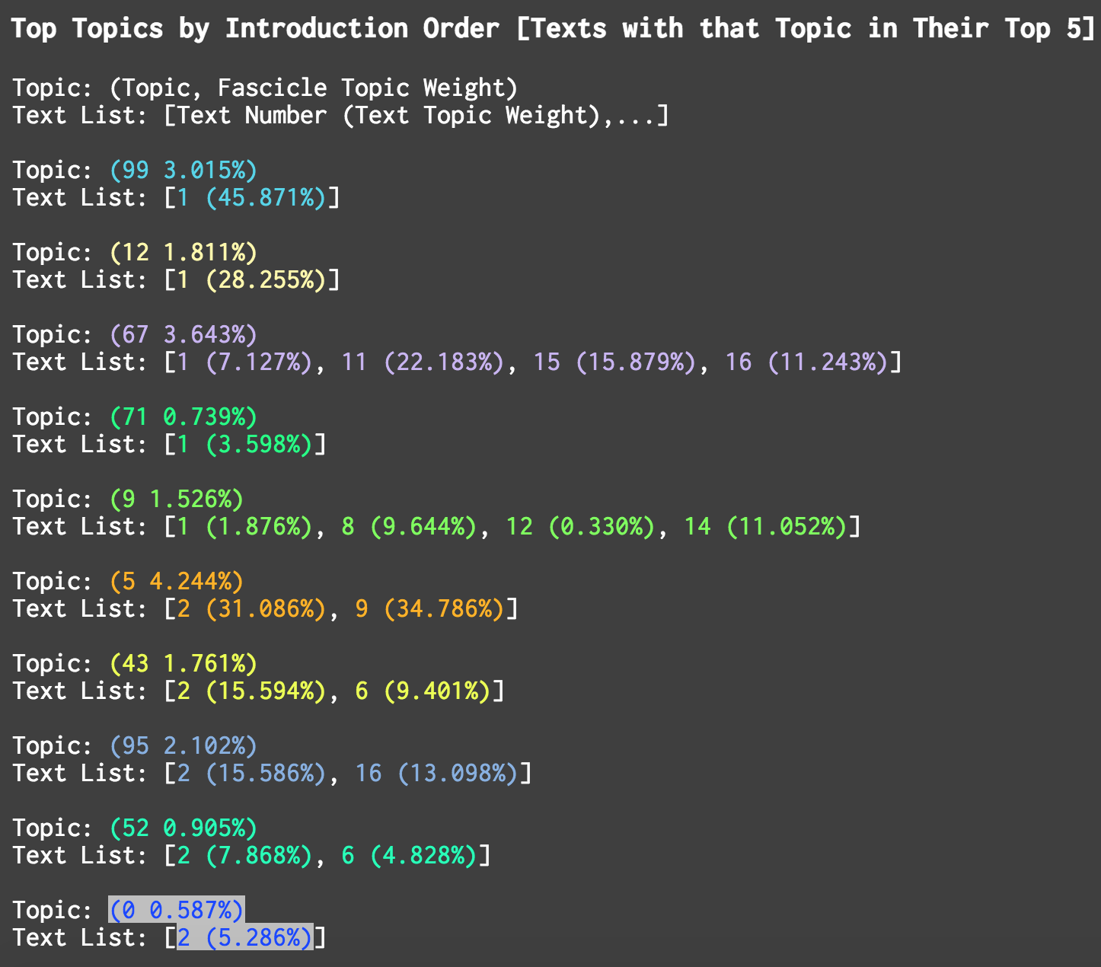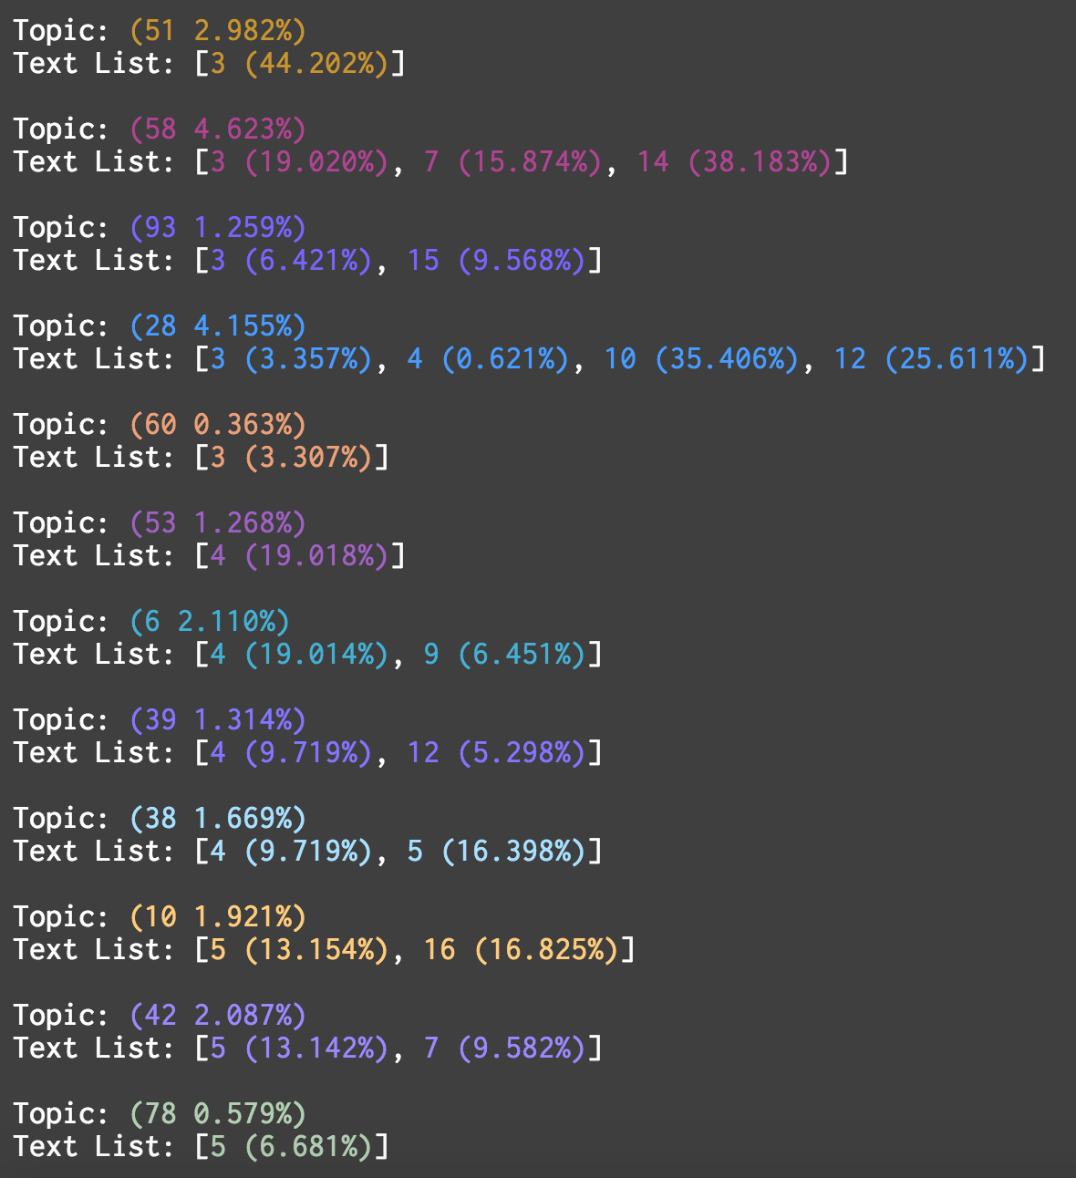**

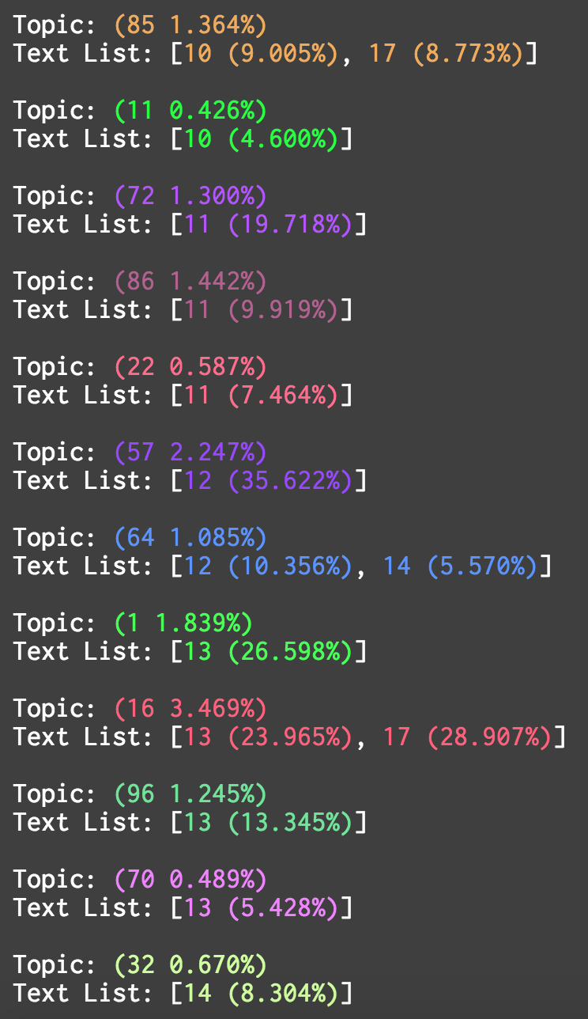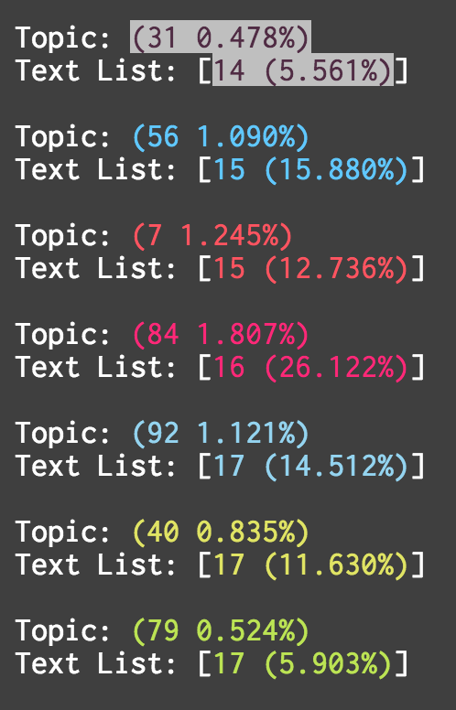

**Bibliography**

Alexander, Eric, and Joe Kohlmann. *Serendip*, 2014. <http://vep.cs.wisc.edu/serendip/>.

Amherst College Archives and Special Collections. “Emily Dickinson at Amherst College.” *Emily Dickinson at Amherst College*, <https://www.amherst.edu/library/archives/holdings/edickinson>.

Amherst College Digital Collections. “Emily Dickinson Collection.” *Amherst College Digital Collections*, <https://acdc.amherst.edu/browse/collection/collection:ed>.

Armoza, Jonathan. *D3 and Topic Modeling – Topics from On High with Mouseover*, 2014. <https://www.youtube.com/watch?v=h64JcZtelRU>.

———. *D3 and TWiC from on High – Force Directed Graph*, 2014. <https://www.youtube.com/watch?v=NAaig0eAvug>.

———. “Numbers, Not Words.” *Words...in Context*, January 21, 2015. <http://digihum.mcgill.ca/jonathanarmoza/2015/01/21/numbers-not-words/>.

———. *TWiC: Corpus Cluster View*, 2015. <https://www.youtube.com/watch?v=sHu_mPGGMn4>.

———. *TWiC: CorpusView*, 2015. <https://www.youtube.com/watch?v=wl9ubghSNxs>.

———. *TWiC: Freezing Panel Updates for Viewing*, 2015. <https://www.youtube.com/watch?v=N3XRdGKc8ZQ>.

Audanaert, Neal. “Understanding Topic Modeling.” presented at the Digital Humanities Summer Institute 2014, Victoria, BC, June 2014.

Bianchi, Martha Dickinson. *The Life and Letters of Emily Dickinson*. Boston: Houghton Mifflin Company, 1924.

Blei, David M. “Introduction to Probabilistic Topic Models.” *Communications of the ACM*, 2011. <http://www.cs.princeton.edu/~blei/papers/Blei2011.pdf>.

———. “Modeling ‘Science’: Dynamic Topic Models of Scholarly Research.” presented at the Google Tech Talks, Google, May 24, 2007. <https://www.youtube.com/watch?v=7BMsuyBPx90>.

Blei, David M., and Jonathan Chang. “Hierarchical Relational Models for Document Networks.” *The Annals of Applied Statistics* 4, no. 1 (March 2010): 124–50.

Blei, David M., Thomas L. Griffiths, Michael I. Jordan, and Joshua B. Tenenbaum. “Hierarchical Topic Models and the Nested Chinese Restaurant Process.” *Advances in Neural Information Processing Systems* 16 (2003). <http://papers.nips.cc/paper/2466-hierarchical-topic-models-and-the-nested-chinese-restaurant-process.pdf>.

Blei, David M., Andrew Y. Ng, and Michael I. Jordan. “Latent Dirichlet Allocation.” *Journal of Machine Learning Research* 3, no. 4/5 (2003): 993–1022.

Bostock, Mike, Jeffrey Heer, and Vadim Ogievetsky. *D3.js (Data-Driven Documents)*, 2011. http://d3js.org.

Bury, Liz. “Emily Dickinson Legacy Fuels War of the Archives,” October 25, 2013. <http://www.theguardian.com/books/2013/oct/25/emily-dickinson-legacy-archives-online>.

Cameron, Sharon. *Choosing Not Choosing: Dickinson’s Fascicles*. Chicago, IL: University of Chicago Press, 1992.

———. *Lyric Time: Dickinson and The Limits of Genre*. Baltimore, MD: Johns Hopkins University Press, 1979.

Chaney, Alison J.B., and David M. Blei. “Visualizing Topic Models.” *Proceedings of the Sixth International AAAI Conference on Weblogs and Social Media*, 2012.

Cody, John. *After Great Pain: The Inner Life of Emily Dickinson*. Cambridge, MA: Belknap Press, 1971.

DeSandro, Dave. *Packery.js* (version 1.4.2), 2013. <http://packery.metafizzy.co/>.

Dickinson, Emily. “Emily Dickinson Archive.” Interactive Archive. Accessed July 1, 2014. <http://www.edickinson.org>.

———. *Selected Letters*. Edited by Thomas Johnson. Cambridge, MA: Harvard University Press, 1986.

———. *The Manuscript Books of Emily Dickinson*. Edited by R.W. Franklin. Vol. 1–2. 2 vols. Cambridge, MA: Belknap Press, 1981.

———. *The Poems of Emily Dickinson: Variorum Edition*. Edited by R.W. Franklin. Harvard University Press, 1998.

Eberwein, Jane Donahue, and Cindy MacKenzie, eds. *Reading Emily Dickinson’s Letters: Critical Essays*. Amherst, MA: University of Massachusetts Press, 2009.

Farr, Judith, ed. *Emily Dickinson: A Collection of Critical Essays*. Upper Saddle River, NJ: Prentice Hall, 1996.

Ferlazzo, Paul. *Critical Essays on Emily Dickinson*. Boston, MA: G.K. Hall, 1984.

Franklin, R.W. *The Editing of Emily Dickinson: A Reconsideration*. Madison, WI: University of Wisconsin Press, 1967.

Gelpi, Albert. *Emily Dickinson: The Mind of the Poet*. Cambridge, MA: Harvard University Press, 1965.

Gershman, Samuel J., David M. Blei, and Yael Niv. “Context, Learning, and Extinction.” *Psychological Review* 117, no. 1 (2010): 197–209.

Harvard University Press. “Emily Dickinson, From Fascicle to Open Access.” *Harvard University Press*, 2013. <http://www.hup.harvard.edu/features/dickinson/>.

Heginbotham, Eleanor Elson. *Reading the Fascicles of Emily Dickinson: Dwelling in Possibilities*. Columbus, OH: Ohio State University Press, 2003.

Houghton Library Modern Books and Manuscript Collection. “The Emily Dickinson Collection.” *Houghton Library Modern Books and Manuscript Collection*, <http://hcl.harvard.edu/libraries/houghton/collections/modern/dickinson.cfm>.

Jockers, Matthew. *Macroanalysis: Digital Methods and Literary History*. Topics in the Digital Humanities. University of Illinois Press, 2013.

———. *Text Analysis with R for Students of Literature*. Quantitative Methods in the Humanities and Social Sciences. New York, NY: Springer, 2014.

———. “The LDA Buffet Is Now Open; Or, Latent Dirichlet Allocation for English Majors.” *Matthew L. Jockers*, September 29, 2011. (<http://www.matthewjockers.net/2011/09/29/the-lda-buffet-is-now-open-or-latent-dirichlet-allocation-for-english-majors/>).

Johnson, Thomas. *The Poems of Emily Dickinson: Including Variant Readings Critically Compared with All Known Manuscripts*. Cambridge, MA: Belknap Press, 1955.

Jones, Josh. “The Online Emily Dickinson Archive Makes Thousands of the Poet’s Manuscripts Freely Available,” October 23, 2013. <http://www.openculture.com/2013/10/the-online-emily-dickinson-archive.html>.

McCallum, Andrew Kachites. *MALLET: A Machine Learning for Language Toolkit.*, 2002. http://mallet.cs.umass.edu.

McClure, David. “(Mental) Maps of Texts,” September 24, 2014. <http://dclure.org/essays/mental-maps-of-texts/>.

McNeil, Heather. *Emily Dickinson*. New York, NY: Pantheon Books, 1986.

Meeks, Elijah. “Neotopology,” April 14, 2014. <https://digitalhumanities.stanford.edu/neotopology>.

———. “The Value of Network Visualization,” December 27, 2011. <https://dhs.stanford.edu/visualization/the-value-of-network-visualization/>.

Mimno, David. *MALLET on Github*, <https://github.com/mimno/Mallet>.

———. “The Details: Training and Validating Big Models on Big Data.” Maryland Institute for Technology in the Humanities, November 3, 2012. http://vimeo.com/53080123.

Mimno, David, Hannah M. Wallach, Edmund Talley, Miriam Leenders, and Andrew McCallam. “Optimizing Semantic Coherence in Topic Models.” In *Proceedings of the 2011 Conference on Empirical Methods in Natural Language Processing*, Vol. 262–272. Edinburgh, Scotland, UK: Association for Computational Linguistics, 2011.

Moretti, Franco. *Graphs, Maps, Trees: Abstract Models for Literary History*. Brooklyn, NY: Verso, 2007.

———. “‘Operationalizing’: Or, The Function of Measurement in Modern Literary Theory,” December 2013. <http://litlab.stanford.edu/LiteraryLabPamphlet6.pdf>.

Oberhaus, Dorothea Huff. *Emily Dickinson’s Fascicles: Method and Meaning*. University Park, PA: Pennsylvania State University Press, 1995.

O’Keefe, Martha. “Primal Thought.” *Dickinson Studies* 35 (1979): 8–11.

Orwant, Jon, Will Brockman, and Slav Petrov. *Google Ngram Viewer*. Google Inc., 2010. <books.google.com/ngrams>.

Resig, John, and jQuery Group. *jQuery UI* (version 1.11.4), 2006. http://jqueryui.com.

Rhody, Lisa. “The Story of Stopwords: Topic Modeling an Ekphrastic Tradition,” May 6, 2015. <http://www.lisarhody.com/the-story-of-stopwords/>.

Rosenthal, M.L., and Sally M. Gall. *The Modern Poetic Sequence: The Genius of Modern Poetry*. New York, NY: Oxford University Press, 1983.

Schmidt, Benjamin. “Words Alone: Dismantling Topic Models in the Humanities.” *Journal of Digital Humanities* 2, no. 1 (Winter 2012). <http://journalofdigitalhumanities.org/2-1/words-alone-by-benjamin-m-schmidt/>.

Schuessler, Jennifer. “Enigmatic Dickinson Revealed Online,” October 22, 2013. <http://www.nytimes.com/2013/10/23/books/enigmatic-dickinson-revealed-online.html?_r=0>.

Schurr, William. *The Marriage of Emily Dickinson: A Study of the Fascicles*. Lexington, KY: University of Kentucky Press, 1983.

Sewall, Richard. *The Life of Emily Dickinson*. New York, NY: Farrar, Straus and Giroux, 1974.

Simeone, Michael. “Visualizing Topic Models with Force-Directed Graphs.” *The Stone and the Shell: Historical Questions Raised by a Quantitative Approach to Language*, December 2, 2012. <http://tedunderwood.com/2012/12/02/visualizing-topic-models-with-force-directed-graphs/>.

Sinclair, Stéfan. *Voyant Tools*, <http://voyant-tools.org>.

Smith, Martha Nell. “Dickinson Electronic Archives,” <http://www.emilydickinson.org/>.

Stommel, Jesse, and Pete Rorabaugh. “Twitter Vs. Zombies: New Media Literacy & the Virtual Flash Mob.” *Jesse Stommel: Pedagogue, Technologist, Open Educator*, July 21, 2013. <http://jessestommel.com/twitter-vs-zombies-new-media-literacy-the-virtual-flash-mob/>.

Underwood, Ted. “Topic Modeling Made Just Simple Enough.” *The Stone and the Shell: Historical Questions Raised by a Quantitative Approach to Language*, April 7, 2012. <http://tedunderwood.com/2012/04/07/topic-modeling-made-just-simple-enough/>.

———. “Trends, Topics, and Trending Topics.” *The Stone and the Shell: Historical Questions Raised by a Quantitative Approach to Language*, April 19, 2011. <http://tedunderwood.com/2011/04/19/trends-topics-and-trending-topics/>.

———. “Visualizing Topic Models.” *The Stone and the Shell: Historical Questions Raised by a Quantitative Approach to Language*, November 11, 2012. <http://tedunderwood.com/2012/11/11/visualizing-topic-models/>.

———. “What Can Topic Models of PMLA Teach Us about the History of Literary Scholarship?” *The Stone and the Shell: Historical Questions Raised by a Quantitative Approach to Language*, December 14, 2012. <http://tedunderwood.com/2012/12/14/what-can-topic-models-of-pmla-teach-us-about-the-history-of-literary-scholarship/>.

———. “What Kinds of ‘Topics’ Does Topic Modeling Actually Produce?.” *The Stone and the Shell: Historical Questions Raised by a Quantitative Approach to Language*, April 1, 2012. <http://tedunderwood.com/2012/04/01/what-kinds-of-topics-does-topic-modeling-actually-produce/>.

Vendler, Helen. *Dickinson: Selected Poems and Commentaries*. Cambridge, MA: Belknap Press, 2010.

———. *Poets Thinking: Pope, Whitman, Dickinson, Yeats*. Cambridge, MA: Harvard University Press, 2004.

Werner, Marta. “Radical Scatters: Emily Dickinson’s Late Fragments and Related Texts, 1870-1886,” 2007. <http://jetson.unl.edu:8080/cocoon/radicalscatters/default-loggedin.html>.

Zhao, Zhendong, Lan Du, Benjamin Borschinger, John K Pate, Massamiliano Ciaramita, Mark Steedman, and Mark Johnson. “A Computationally Efficient Algorithm for Learning Topical Collocation Models.” *Proceedings of the 53rd Annual Meeting of the Association for Computational Linguistics and the 7th International Joint Conference on Natural Language Processing*, 2015, 1460–69.

1. Throughout this writing I will be referring to Emily Dickinson’s poems. Though all poems are originally referenced from the “Emily Dickinson Archive,” I list next to each poem their critical and/or manuscript location with the following scheme: Fr#- the 1998 R.W. Franklin *Variorum*, F#.# - fascicle number followed by poem number. See bibliography for full description of these sources. Content on the “Emily Dickinson Archive” is governed by a Creative Commons Attribution-Non-Commercial-NoDerivs 3.0 Unported License (CC BY-NC-ND 3.0) and are used here for research purposes. See <http://www.edickinson.org/terms> for full usage terms.
2. *Editorial Note*: As punctuation plays a large role in Emily Dickinson’s poetry, the words of topic models, and the syntax of programming languages there will be instances where end punctuation appears outside of quoted text in this writing. This difference in punctuation is purposeful and relevant to the text being quoted.
3. The term “conceptual model” in this writing refers to a set of ideas held by an individual regarding a particular subject – either accumulated via past experience or the relationships between those ideas.
4. A selection of manuscripts are also sourced from the American Antiquarian Society, the Beinecke Rare Book and Manuscript library at Yale, Boston Public Library, New York Public Library, Yale University, Smith College, Vassar College, and the Library of Congress.
5. TEI is derived XML scheme built for digitally encoding texts, and is maintained by the Text Encoding Initiative (TEI). See <http://www.tei-c.org> for details on these standards. The “Emily Dickinson Archive” has encoded each of Dickinson’s major publication editions separately. See <http://www.edickinson.org/about> for more details.
6. For topic modeling and my own discussion to follow, a “topic” is synonymous with “theme” or a “thematic.”
7. See <https://github.com/mimno/Mallet>.
8. See my own writing “Numbers, not words” for a more detailed accounting of the relationships between numbers, words, and topics. <http://digihum.mcgill.ca/jonathanarmoza/2015/01/21/numbers-not-words/>
9. I will not be discussing hyper-parameters here, other than to say that they adjust the probabilistic “shape” of the model.
10. The shapes of topic distributions are discussed at the end of the “Visualization” section of this writing.
11. This kind of phrasing, or references to “n” in mathematical texts, typically refer to a set of numbers sized some known length “n”.
12. Others tools are available via special links in “Voyant’s” documentation. See <http://docs.voyant-tools.org/tools/>.
13. Franco Moretti has made a specific study of network visualizations. See his *Graphs, Maps, Trees: Abstract Models for Literary History*. Verso (2007).
14. Humans are still better than computers at assembling thematic information for the moment.
15. See for instance David Mimno et al.’s “Optimizing Semantic Coherence in Topic Models” (2011).
16. See “Visualizing topic models” and “Visualizing Topic Models with Force-Directed Graphs” on “The Stone and the Shell” (<https://tedunderwood.com/>)
17. See Schmidt’s 2012 “Words Alone: Dismantling Topic Models in the Humanities” in *Journal of Digital Humanities*.
18. See “A Computationally Efficient Algorithm for Learning Topical Collocation Models” in the bibliography.
19. The latter, much like McClure’s probability density functions.
20. Appendix A explains in more detail the underlying technology of “Topic Words in Context,” and also documents where its code is stored, as well as how to try out the visualization.
21. This is meant to be similar to the “KwiC” abbreviation for the “Keywords in Context” tool typically used in frequency analysis studies of texts. See Stéfan Sinclair’s “Voyant Tools” in the previous section for an example image of this tool.
22. All external code libraries utilized by TWiC are listed in Appendix A.
23. Dickinson poems used in the topic model and shown in the images to follow are taken from TEI transcriptions on the “Emily Dickinson Archive,” almost all of which are from Franklin’s *The Poems of Emily Dickinson, Variorum Edition* (1998). However, the archive also provides about 4,825 TEI-encoded texts for consideration across publication editions. My topic model looks at 2,033 of those texts, slightly higher than the 1,789 complete poems listed in the Franklin edition. TWiC’s code builds its Dickinson corpus by also programmatically determining poem similarity among potential variant poems, and allowing some variants to remain in the corpus if they meet a threshold of difference. It is important to remember that the model of Dickinson’s poems being used in this writing is used as a case study for TWiC, and less a model of a definitive collection of texts. In my view, this variant-inclusive collection thus presents a model keeping in the spirit of the fascicle books. This corpus building process is also documented in Appendix A.
24. In TWiC, these weights are scaled to appear as values from 0 to 100 percent.
25. A view to re-establish publication arrangements would follow in my development. See the description of TWiC’s “Publication View” at the end of this section for details.
26. A video of this can be found at: <https://www.youtube.com/watch?v=NAaig0eAvug> (Armoza, “D3 and TWiC from on High – Force Directed Graph”).
27. A custom color palette can be supplied to TWiC, although this feature is not yet available to its users unless they enable it in its Python script.
28. A video of a prototype of this mouse/highlighting behavior can be found at: <https://www.youtube.com/watch?v=wl9ubghSNxs> (Armoza, “TWiC: Corpus View”)
29. Prototype videos of this view can be seen at: https://www.youtube.com/watch?v=sHu_mPGGMn4 (Armoza, “TWiC: Corpus Cluster View”) and https://www.youtube.com/watch?v=N3XRdGKc8ZQ (Armoza, “TWiC: Freezing Panel Updates for Viewing”).
30. For more on stop words – or what I have been calling “non-topic” words up until this point – see “Words to Pay Attention To and Words to Ignore” in the Analysis section of this writing.
31. Since MALLET inserts a “dummy” weight for words that have near zero incidence (or “chance”) of co-occurrence with the highly featured words of a topic, TWiC’s Python code looks for this dummy weight and removes those words from the topic word list when they are displayed in the “Data Bar” alongside their topic word weights.
32. See <https://github.com/jarmoza/twic/blob/master/README.md#howtouse_publicationview> for a view of this JSON data format, and specifically an example for Fascicle 21.
33. Text titles currently overlap. A remedy for this is forthcoming in a future release of TWiC.
34. See Appendix B for a full view of the topic “threads” of Fascicle 21.
35. The full stopwords lists for the following analysis can be found at <https://github.com/jarmoza/twic/blob/master/lib/mallet/stoplists/en.txt> and <https://github.com/jarmoza/twic/blob/master/data/dickinson/output/stopwords/added_stopwords_2016.txt>
36. The following views are generated with the Python script “twic_critique.py” found in the twic/code/py/general directory.
37. I have put the phrase “no topic words” to stand in place of poem lines without them. One could think of them like the topic model’s version of Dickinson’s em dashes.
38. Recall the plotted topic weight distribution of this poem in the previous section.
39. I have employed a multiplier for the font sizes here that also included a minimum value of 6-point font for readability. Here, words like “Captivity” that appear in 6 point may be (and are) considerably smaller in word weighting.
40. Frequency is deemed “1” when the word does not occur in the human model. Frequencies of polysemic instances of human topics are summed.
41. There is a minimum and maximum font size for these scaled words in order to represent the poem within the space of the page.
42. TWiC’s “Publication View” is accessible via twic_publication.html. See Appendix A for details on accessing this view.
43. Topic 3’s top 20 words include: door (11.39%), lost (4.142%), shut (4.142%), left (3.624%), pray (3.624%), don’t (2.59%), tim (2.331%), passing (2.331%), ajar (2.072%), cup (2.072%), father (1.5555), chamber (1.296%), curious (1.296%), instant (1.296%), walk (1.296%), journey (1.037%), point (1.037%), slowly (1.037%), sleeping (1.037%), paradise (1.037%)
44. Topic 99’s top 20 words include: door (4.529%), leave (3.775%), dwell (3.523%), care (3.523%), fellow (2.769%), ecstasy (2.517%), business (2.014%), fear (2.014%), men (2.014%), despair (2.014%), house (2.014%), glory (2.014%), odors (1.763%), pursued (1.763%), hay (1.511%), floor (1.511%), thief (1.511%), ear (1.511%), spring (1.26%), talk (1.26%)